The Future of Petrophysics in Reservoir Description

E. R. (Ross) Crain, P.Eng.
Spectrum 2000 Mindware Ltd
Calgary, Alberta, Canada
Keynote Address presented to 1st Annual Well Log Analysis / Formation Evaluation Conference, Tripoli, Libya, 28 – 31 October 2000. Published in Symposium Transactions, 2001. Presented on behalf of Teknica Overseas Services Ltd. Thanks to Lothar Roseneger for assistance at the Conference.

Exploration, development, and exploitation of oil, gas, and minerals require
"Petrophysics First" -- it's an essential ingredient in any recipe for success.
Petrophysics is the central core upon which all other geosciences depend.


Arabic Abstract

ABSTRACT
The evolution of log analysis methods over the past seventy years is a fascinating and illuminating subject. We can learn a great deal by observing the gradual changes, as well as the sudden leaps forward, that have occurred. It is, of course, fairly easy to predict gradual changes, but only the lucky person could predict the next great advance in petrophysical analysis. The major buzzwords of the near future are imaging, resolution, and integration. A buzzword from the past, artificial intelligence, still haunts us with its lack of success.

INTRODUCTION
The perpetual evolution of logging tools to improve data quality, signal to noise ratio, bed resolution, and depth of investigation demonstrate the gradual, almost un-noticed, changes in our industry. This will no doubt continue – but how far can we go, or want to go, is an open question. We may already record more data than we can conveniently use. The question really is “Is it the right data to give the answers we need?”

The introduction of digital image logs and signal processing theory to log data are dramatic improvements that have fundamentally altered how we use logs, for example in quantifying fracture porosity and intensity or in evaluating depositional environment. What could be the next great leap is not at all clear. We have exhausted most of the available frequencies of the electromagnetic spectrum (except maybe the infra-red) and have tested most physical principles.

We have come a long way since the Schlumberger brothers put the first electrical log onto paper in 1929.

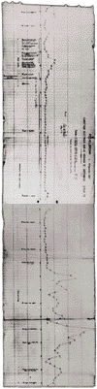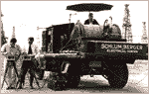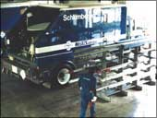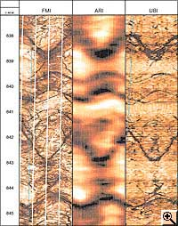
Figure 1: Evolution - First ES log , first logging truck, modern truck, modern image log.

The incredible and unpredictable growth of other technologies outside our industry also has had dramatic effects. Low-cost high-speed computers, powerful spreadsheet and graphics software, satellite data transmission, and group work via local area networks or the Internet have changed the way we do our work. The massive increase in data quantity brought about by these technologies threatens to overwhelm us, since training, corporate infrastructure, and management style can barely keep up. How much faster can computers run ever more complicated software with ever larger data sets?

To give you a sense of the progress in computer-aided log analysis, I wrote my first program in 1963 on an IBM 1401 computer to solve mineralogy and ore grade in the potash fields in Saskatchewan. The computer filled a room the size of this assembly hall and the program was about 100 lines long. Later, I programmed a desk-sized computer (an IBM 1130) then more room sized beasts (EMR 6050 and CDC 3300). In early 1976, I recognized the need to pursue a small portable solution, and after evaluating several rack mounted industrial machines, I settled on a desktop calculator/computer – the HP 9825. This became the first commercial log analysis system on a desktop - LOG/MATE – five years before IBM “invented” the PC. By the way, the original HP 9825 had only 4 Kilobytes of memory and the floppy disc held only 256 K. It cost 10 times more than today’s 500 MHz machine with 32MB memory and 10GB hard drive! We have clearly made progress here too.

IMAGES
So let’s take a look at what is new and developing in our field that will benefit the oil and gas industry. Three buzzwords summarize the current state of the art in well log analysis - imaging, resolution, and integration. Let’s look at these in turn.

Two logs provide a more or less complete image of the rock on the wall of the wellbore. One is the formation micro-scanner or micro-imaging log, a super-micro, multi-electrode, multi-pad resistivity log, an offshoot of the dipmeter tool. The log appears similar to a photograph; low resistivity is shaded a dark colour, high resistivity is white. The shading between colours is cunningly chosen so that stratigraphic features can be seen, usually with better resolution than can be seen with the naked eye on real cores. Fractures and bedding planes, along with their dip angle and orientation, are readily identified. Image enhancement software similar to that used for air photos can be applied to help bring out subtle detail.

This log also leads in the resolution category – it can visualize fractures of only a few microns in width. Further numerical processing leads to quantitative assessment of fracture intensity, fracture aperture, and fracture porosity. These results emphatically debunk much “conventional wisdom” regarding fracture aperture and porosity.

The second tool that gives a real image log is the acoustic imager, often called a televiewer log. It uses a rotating head that emits and receives an acoustic signal. Both sound amplitude and sound travel time are recorded, giving images proportional to acoustic impedance and borehole diameter respectively. Resolution is lower than the micro-scanner, although most significant bedding events and fractures can be seen in well consolidated formations. The log can be enhanced in image processing software.

To capitalize on the imaging concept, newer versions of the induction log, laterolog, and sonic log are presented in an image format as well as the usual wiggly curve format. The resistivity log image from the azimuthal resistivity log (a form of laterolog) is a coarser resistivity image similar in appearance to the micro-scanner. The azimuthal resistivities are very helpful in horizontal wells as curves looking upward into shale or tight cap rock or downward into a water zone can be isolated from the horizontally aimed curves.

The array induction log presents 5 resistivity curves of 5 different depths of investigation, as well as a coloured map of these values. This aids interpretation of invasion profiles. The array sonic log offers the usual three acoustic log curves, recorded at a multiplicity of spacings if desired, as well as a colour image of acoustic wavetrains. This allows visualization of the changes in amplitude and arrival time of the three acoustic waves and emphasizes interference patterns that indicate fractures.

Where can image logs go in the future? I hope “everywhere”! To do this, logging speed will have to increase and costs will have to drop. An article in Hart’s E&P magazine states that one-third of the world’s oil is locked up in low-resistivity laminated shaly sands. The high resolution of the micro-scanner and televiewer are the only logging tools available to determine net sand in this environment. Look forward to this revolution and be prepared to pay the price for logging, processing, and interpretation that comes with the huge data volumes.
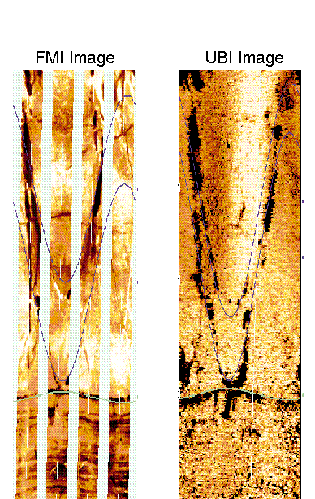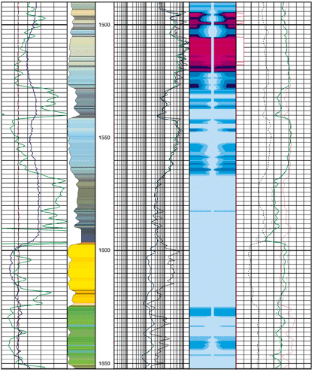
Figure 2: Image logs – Microscanner, televiewer, resistivity (saturation profile)

RESOLUTION
The last three tools described above also qualify in the thin-bed resolution sweepstakes, as they attempt to resolve beds to about 1/3 the thickness of previous tools. Combined with thin bed processing of the newer density, neutron, and gamma ray logs, we are now able to obtain more accurate porosity and water saturation in beds as thin as one or two feet instead of the more usual three to six feet. Unfortunately, little can be done for older logs that already exist in our file cabinets. The thin bed processing available today requires high density digital recording and this cannot be extracted from earlier data files or paper logs.

Unfortunately, high resolution logs look noisy. Many are filtered “to look nice” – this is a tremendous waste of data. In 1967, I delivered some of the first deconvolved seismic sections in Canada to a client. He was horrified because the data looked so noisy. Where would seismic processing be today without deconvolution? I have always been amazed at how slow the well logging companies have been in applying decon to log curves. Now, if we could just get them to square up the bed boundaries!

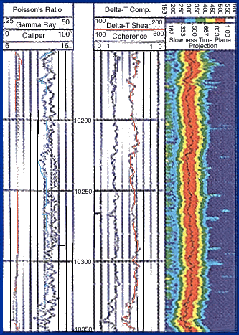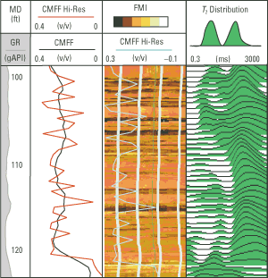
Figure 3: High resolution – Sonic wavetrain, microscanner, nuclear magnetic resonance

High resolution and imaging logs also require excellent borehole conditions. Management must ensure that drilling and mud engineers are part of the team.

These logs provide more megabytes of data than ever before. Fortunately computer speed, memory size, and data storage capacity of modern desktop computers have kept pace with this development. Hardware costs are much lower than fifteen years ago. However, log analysis software costs are higher than ever, partly because the software does more than it ever did and partly because we demand such attractive screen and printer images. The larger integrated software packages are ill-suited for casual users, so there is still a strong need for small easy-to-use packages.
Lower borehole signals, stronger signal sources, more sensitive receivers, and signal summation techniques will continue to improve resolution at a steady pace.

INTEGRATION
Integration means the cooperation and interchange of ideas, data, and results between the various geoscience disciplines involved in a pool study or reservoir simulation. Integration means that all team members have a common understanding of what the logs and log analysis indicate. Feedback between each group forces iteration and refinement of all results.

I am still asked to review projects where the log analysis has not been compared to core analysis, well performance, or sample description! I call this type of review a “Forensic Log Analysis” – it usually involves an autopsy, or at least major surgery, to find out what went wrong. Recomputation is inevitable when log analysis is done in isolation from the other disciplines. There is no point in performing a “Blind” log analysis; this is merely data processing, without ground truth control. As some of you may know, I am legally blind, so maybe that is why I am so sensitive about this issue.

Integrated projects require an extraordinary effort in communication between team participants. Many professionals are not good communicators – we talk a good line but we don’t listen well. Turf wars, ego, and seniority must be put aside. Team leaders must be adept at locating barriers to good communication. Team members must be willing to give up some independence in order to give and receive the knowledge needed for a successful project. This is never easy and I predict that there will still be many reservoir description failures caused by poor communication, not by lack of data or lack of effort.

Integrated exploration, development, and simulation software is readily available. This helps to share data and results, but does little to help share understanding unless those good communication skills are present.

Another form of integration is also taking place - corporate merger and acquisition by both logging service companies and oil exploration companies. The three major well logging service companies now have most field services (logging, testing, cementing, etc.) tied up under one roof, and have added geophysics, geology, engineering, simulation, production, and management services and software to offer one-stop shopping for the resource owner. They are now offering to run complete oil field operations from discovery, through production, to field abandonment.

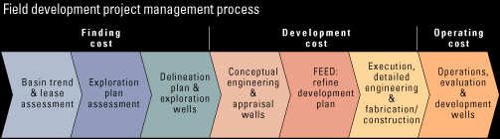
Figure 4: Integration - Project planning and implementation

It will take a major change on the part of the resource owner to monitor the performance of such a service. Instead of doing the work in-house, they will have to check and monitor others and request changes or improvements in performance. These are roles that many professionals are not ready for, so training and corporate infrastructure will have to change dramatically. The changes will have to be made well before such contracts are given out. Unless a resource owner is ready for contract development, I predict some very unhappy scenarios.

Finally, we should mention the Internet as an integrating as well as a liberating force. Databases are more easily accessible, results and reports can be transferred by email, and much work can be done away from the corporate office environment. Soon, major application software and technical learning centers will be widely available on the Net. I currently receive and deliver the vast majority of my work over the Internet. Although it is always nice to have face-to-face meetings with clients and co-workers, it is not necessary to overdo it. Many professionals complain that they spend too much time in meetings. Group work or consulting via the Internet reduces the need for many meetings.

Electronic mail beats “telephone tag” and gives a permanent record of what was really said. I see a great future for remote group work. The only perceived snags are data security and loss of control over employees, but these are capable of solution with a little effort.

ODDS AND ENDS
There are other areas of petrophysics where change will certainly occur. Controversy still rages over the best water saturation method. The ultimate water saturation equation has yet to be presented. Maybe someone in this audience will develop the perfect equation.

The nuclear magnetic resonance log dominates the technical papers submitted at conferences. After 30 years of development, the tool is just reaching adulthood. Customer resistance to previous hyperbole will gradually disappear. However, the small rock volume seen by the tool will continue to make it difficult to integrate this data with conventional logs. Some people see this tool as a panacea for all that ails conventional log analysis. This just isn’t true. For example, a claim is made that the NMR porosities are independent of lithology, yet the T2 cutoffs that determine porosity vary with lithology.
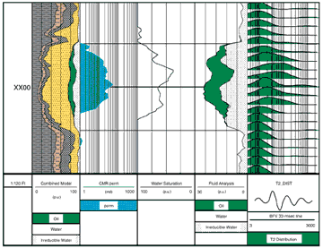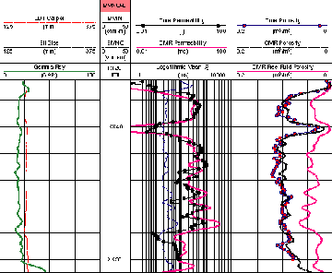
Figure 5: NMR – pay in high SW environment, porosity and permeability vs core

Geostatistics to predict petrophysical rock properties away from the well bore is growing in popularity. Good software exists and some successes have been published. Further integration of geostatistics with seismic attributes and seismic petrophysics is in its infancy. Lack of training and expense are the current holdups to more widespread use.

Seismic petrophysics, especially with long offset spreads, is on the rise. Again, 30 years have passed since seismic inversion was first practical and we are just now getting close to real petrophysical properties. Again much training is needed, since many practitioners seem to forget that sonic and density logs see an invaded zone and the seismic signal does not. How much longer will it take to learn this simple truth?

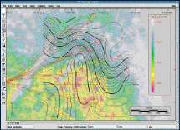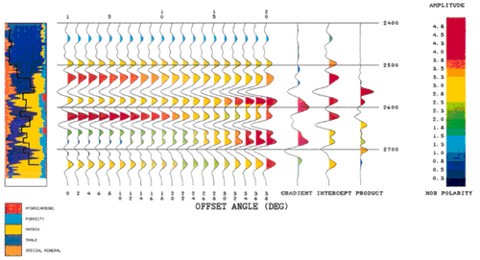
Figure 6: Geostatistical porosity distribution map, AVO seismic model from log analysis

We cannot ignore the tremendous strides in Logging While Drilling. Most conventional open hole measurements can be made near the bit, before invasion becomes too serious. Even the NMR is in an LWD test program. More deviated, deeper, hotter holes will require this technology. Reservoir description is enhanced because of the immediate acquisition of data and the reduced invasion profile.

Cased hole logs for reservoir description, completion integrity, and fluid flow evaluations are much enhanced over previous efforts. Casing, tubing, and cement image logs are readily available but seldom used to their full extent in solving well performance problems. Production logging is underutilized in remedial work. When they are run, interpretation skills are weak, especially in deviated, multi-phase flow. There seems to be no concerted effort to correct this lack of training.

With favourable cement bond, most open hole measurements including sonic, density, and resistivity, can be measured through casing. The resistivity log is being field tested by the major logging contractors as we speak here today. It’s about time – an independent Canadian company offered such a tool over 25 years ago. Not all that is new or useful comes from the major research centers – the “little guy” has an important role to play. NMR and highly focused induction logs both came from outside our industry and were pioneered by small independent research labs. Although I have no idea what the next important advance will be, it is likely that it will come from an unrelated field.

ARTIFICIAL INTELLIGENCE
Artificial intelligence is another buzzword that seems to have disappeared. In 1984 and 1985, I was head of a research team that was investigating the use of artificial intelligence to help reduce complexity in log analysis. The team had high hopes for this project. I would like to read a short passage from my textbook, “The Log Analysis Handbook” (Pennwell 1986), written as this project was about halfway completed:

“The future? It will probably involve artificial intelligence - the darling of the academic world in the 1980’s. Computer based expert systems will learn from experts in the field of log analysis, and will subsequently advise and consult with less expert users. As the expert system is increasingly used, its cleverness will heighten, until it is more intelligent than any single expert. Such hardware and software already exists, albeit for much simpler situations than log analysis. However, it is known that major service companies, oil companies, and consulting firms have embarked on research in this field, emphasizing log interpretation.

The success of a log analysis is judged by how well the analysis predicts the future performance of the completed zone. Many analysts and their managers are unaware whether their results were good or bad. Artificial intelligence with a learning data base, should provide the kind of "perfect memory" and the unbiased question/answer sequence needed to keep track of success and failure.

Hopefully we will learn how to do better work as time goes on, by studying the background to each success or failure, monitored automatically by the expert system.

The future holds the promise of a long sought goal in well logging - an automatic, universal interpretation program that never fails and adapts to change. Of course, this is just a dream, right?”

Fifteen years have passed since the above was written and the prediction seems no closer to fruition. This just goes to show how poor a forecaster I am! What happened to all that research effort and all those prototype systems?

OTHER SOFTWARE DEVELOPMENTS
I don’t want to end this talk on such a pessimistic note, so I would like to review the state of the art in log analysis software. In deterministic models, we have seen tremendous strides in the ability to handle user-defined algorithms and user-defined displays of results. Gone are the days of inflexible, hard-coded math that doesn’t quite suit the rock sequence. The newer, more flexible systems allow competent users to experiment with new ideas, add new log curves as they are invented, and present their own images to management – all this without re-writing the underlying software. We no longer have to “lie to the computer” or modify results outside the program to obtain rational results. These programs also have enhanced core handling capabilities, as well as annotation and reporting features, such as sample description and mud/gas log integration.

The multi-mineral and probabilistic models available today are more robust and the underlying tool responses are better known and more linear. It still takes considerable effort to tune the models for a particular rock sequence, so they are not a cure-all or an “automatic” log analysis solution. Other forms of data reduction, such as principal component, multi-variant, or least-squares regression analysis are also more practical, mainly due to faster computers and software packages that are easier to use.

Integration of deterministic models and user-defined algorithms with probabilistic or other hard coded models is not well developed. We are still forced to run these disparate models in relative isolation from each other, with the analyst left to iterate between them. By adding expert system and fuzzy logic concepts, I expect that these program designs will gradually be merged into a coherent whole. Software that incorporates neural network code may already be aimed in this direction. Unfortunately, I have no personal experience with neural network products, so I can’t vouch for their success.

CONCLUDING REMARKS
There is much happening in our field. Petrophysics is changing. The uses of petrophysics are changing. We will never be out of work!

In the face of continuous change, humans yearn for consistency. We normally resist change and strive instead for the traditional approach. Unfortunately, we will never optimize oil production this way. We must learn to accept the challenge of change, adapt to it, and in fact, lead the charge by innovation and invention of new solutions to the problem of data overload, complex reservoirs, and working with multi-discipline team members.

About the Author

Mr. Crain is a Professional Engineer with over 35 years of experience in reservoir description, petrophysical analysis, and management. He has been a specialist in the integration of well log analysis and petrophysics with geophysical, geological, engineering, and simulation phases of oil and gas exploration and exploitation, with widespread Canadian and Overseas experience. He has an Engineering degree from McGill University in Montral and is a registered engineer in Alberta. He wrote “The Log Analysis Handbook”, published by Pennwell, and offers seminars, mentoring, or petrophysical consulting to oil companies, government agencies, and consulting service companies around the world.

Ross is credited with the invention of the first desktop log analysis system (LOG/MATE) in 1976, 5 years before IBM invented the PC. He continues to advise and train people on software design, implementation, and training. For his consulting practice, he uses his own proprietary software (META/LOG), and is familiar with most commercial systems.

He has won Best Paper Awards from CWLS and CSEG and has authored more than 30 technical papers. He is currently building an Interactive Learning Center for petrophysics on the World Wide Web. Mr. Crain was installed as an Honourary Member of the Canadian Well Logging Society for his contributions to the science of well log analysis.

Acknowledgements
Presentation of this paper in Libya was supported by Teknica Overseas Services Ltd., Calgary. The encouragement and support of Mickey Abougoush, Al Jenik, Lothar Roseneger, and Denis Briere, all of Teknica, is much appreciated.

