Productivity Estimation in the Milk River Laminated Shaly Sand, Southeast Alberta and Southwest Saskatchewan

E. R. (Ross) Crain, P.Eng. Spectrum 2000 Mindware
D. W. (Dave) Hume, P.Geol. Rakhit Petroleum Consultants Ltd
Published in CWLS InSite Dec 2004
Abstract
We have developed an open hole log analysis procedure that permits semi-automatic analysis of wells in the Milk River formation in southeast Alberta and southwest Saskatchewan. The results include reservoir properties and a productivity estimate that can be used to aid in evaluation of shallow gas prospects in this area. Reservoir properties were calibrated to available core analysis and productivity was calibrated to actual initial production.

The Milk River is a laminated shaly sand and is not amenable to conventional log analysis because of the way that logging tools average laminated rock properties. These sands are classic low-resistivity pay zones. There are a number of unconventional methods, three of which were tested in this project. Only one model proved to be useful.

Various reservoir quality estimates were developed, such as net reservoir, pore volume, hydrocarbon pore volume, and flow capacity, as well as a few less well known parameters such as Hester’s quality number and a productivity estimate developed by one of the authors. All of these estimators correlated with normalized 3-month initial production with an R-squared between 0.837 and 0.906.

The laminated sand models do not distinguish water bearing from gas bearing zones very effectively, so hydrodynamics and geological mapping are used for this purpose.

This is a reconnaissance log analysis model designed to assist in resource estimates of large pervasive reservoirs. When high grade targets are selected, more detailed work must be performed to refine each potential gas interval.

Introduction
For several years we have been developing custom built software, nicknamed LOGFUSION, to perform semi-automatic log analysis for large shallow gas and coal bed methane projects. Since several thousand wells are involved in each project, with up to 60 separate stratigraphic horizons, individual log analyses are not practical. All of these projects involved conventional dispersed shaly sands in southern and central Alberta. The log analysis model for each project is prototyped in a spreadsheet and calibrated to ground truth. The parameters and model are then hard coded into our LOGFUSION software.

We have now extended this technique to include the laminated shaly sands of the Milk River formation in southeast Alberta and southwest Saskatchewan. The log analysis model is unique to this formation and no doubt will require re-calibration for other areas. A total of 28 wells were analyzed to prototype the models. Nine wells with a full log suite had considerable core data for calibrating log analysis porosity. Thirty additional wells had good core data, which was used to generate the porosity-permeability transform.
Seventeen wells (eight were cored) were selected that had a reasonable spread in 3-month initial production data and a full log suite. Nine of these were used to calibrate the log analysis results to production. The remaining 8 producing wells were used as test wells to see if “randomly” selected wells could be processed without changing the calibration parameters.

An estimated productivity index was calculated for all wells and compared to actual production on the 17 wells with IP data. There is a remarkable correlation between actual and estimated productivity, but only when using one of the three laminated sand models and only when a full suite of logs was available. The correlation between estimated and actual production had a correlation coefficient (R-squared) of 0.906.

Six other productivity indicators were tested, including a reservoir quality indicator proposed by Hester (1999), which gave R-squared values between 0.837 and 0.903. Average shale volume was also tested but the R-squared is only 0.296.

The core analyses had a total of about 600 valid porosity - permeability pairs. These were crossplotted to obtain a permeability from porosity transform. The best fit regression equation was:
- Perm = 10^(13.5 * PHIe – 2.10)

An eyeball best fit line that seems to be appropriate is:
- Perm = 10^(18.3 * PHIe – 3.00)

The second equation was used in the analysis. The locations of all cored wells are shown on Figure 1. A graph of the data with both regression lines is shown in Figure 2.

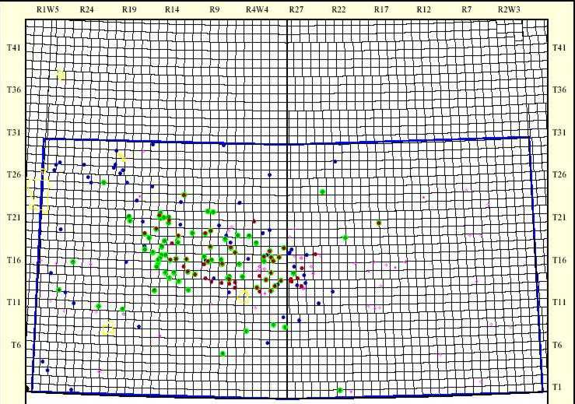
Figure 1: Area map showing wells cored in Milk River formation.

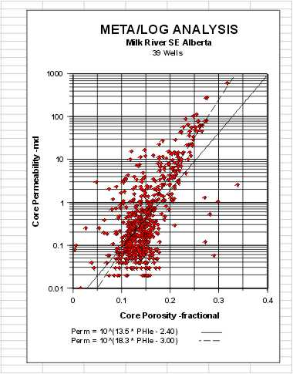
Figure 2: Core porosity – permeability crossplot

Log Analysis In Laminated Sands

The analysis models for laminated shaly sands are quite varied and none are perfect solutions. The problem lies in how logs average laminations that are thinner than the tool resolution. Most logs average the data in a linear fashion, but resistivity must be averaged as conductivity and then converted back to resistivity. This is the situation with most so-called “low-resistivity” pay zones around the world.

To illustrate, assume a laminated sequence with shale laminations equal in thickness to the sand laminations. This gives a shale volume (Vsh) averaged over the interval of 50%. Assume the porosity and resistivity values are as shown below:

* GR PHIN PHID RESD COND RESD from COND

Shale 90 0.45 0.15 4.0 250
Gas Sand 40 0.25 0.35 200 5.0
Average 65 0.30 0.25 102 122 8.1

* GR PHIN PHID RESD COND RESD from COND

Shale 90 0.45 0.15 4.0 250
Water Sand 40 0.30 0.30 5.0 200
Average 65 0.37 0.22 4.5 222 4.2

In the early days of log analysis, this phenomenon was attributed to many different, almost mystical, reasons because the parallel nature of the conductive paths was not understood by many analysts. Note, too, that the resistivity contrast between a water zone and a gas zone is small, so it may not be possible to recognize gas when it is present, especially if water resistivity varies between one hydrodynamic regime and another.

Comparison of Conventional and Laminated Shaly Sand Models
In this study, we have contrasted four different models, two of which were known in advance to be inappropriate or pessimistic in laminated shaly sands. They were run in order to emphasize the modeling problem and illustrate the quantitative differences in the methods.

MODEL A: Conventional Dispersed Shaly Sand Model
This model is the one we run in most shaly sands, but it is not appropriate for laminated shaly sands:
1. Vsh = Minimum from GR, Neutron-density crossplot, resistivity methods
2. PHIe = (PHID * PHINSH - PHIN * PHIDSH) / (PHINSH - PHIDSH)
3. Sw = Dual Water, Simandoux, or Buckles model if gas; Sw = 1.0 if not gas
4. Perm = porosity vs permeability transform from core data

Sums and averages for reservoir properties are determined in the usual way. The conventional model may fail to find any net reservoir unless cutoffs, especially shale cutoffs, are very liberal. Even if net reservoir is found, it will be smaller than the true net reservoir and rock properties are likely to be pessimistic. The model requires a full log suite.

MODEL B: Laminated Shaly Sand – Pessimistic Version
Most laminated shaly sand models use the shale volume from a conventional analysis averaged over the gross interval (VSHgross). Net reservoir thickness (NetRes) is then found by multiplying (1 – VSHgross) times the gross thickness. The model then derives everything else from empirical rules. One such set of rules is to use the rock properties (porosity, saturation, permeability) from the conventional analysis.

1. VSHgross = SUM (Vsh * INCR) / Gross
2. NetRes = Gross * (1 - VSHgross)
3. PHIavg, SWavg, PERMavg = Values from Conventional Analysis

Cumulative reservoir properties are found in an unconventional way:
4. PV = PHIavg * NetRes
5. HPV = PHIavg * (1 - SWavg) * NetRes
6. KH = PERMavg * NetRes

This model will usually find more net reservoir than the conventional shaly sand model, but rock properties and hence reserves are still pessimistic because they come from the conventional analysis. Some authors have used the density log porosity instead of the shaly sand crossplot porosity. Neither approach is recommended as they give pessimistic porosity values in laminated sands.

MODEL C: Laminated Shaly Sand – Realistic Version
A more realistic model uses different rules for finding the rock properties, usually based on shale volume rules or constants based on core analysis. These empirical rules can also be calibrated to core and then used where there is no core data. The PHIMAX porosity equation and Buckles water saturation equation given below are widely used in normal shaly sands where the log suite is at a minimum:
1. VSHgross = SUM (Vsh * INCR) / Gross
2. NetRes = Gross * (1 - VSHgross)
3. PHIavg = PHIMAX * (1 - VSHgross ^ 3)
4. SWavg = KBUCKL / PHIavg / (1 - VSHgross)
5. PERMavg = MIN (2000, 10^(CPERM * PHIavg + DPERM))
6. PV = PHIavg * NetRes
7. HPV = PHIavg * (1 - SWavg) * NetRes
8. KH = PERMavg * NetRes

The PHIMAX value is the critical factor. If a moderate amount of core data is available for the sand fraction of the laminated sand, this data can be mapped and used in a batch processing environment. The exponent on VSHgross in equation 3 also needs tuning and can range from 1.0 to 3.0.

A very minimum log suite can be used, since the only curve required is a gamma ray shale indicator, but only if there are no radioactive elements other than clay. This is not the case in the Milk River, so a minimum log suite will not work here. We have used the minimum suite successfully in laminated shaly sands in Lake Maracaibo.

In the current Milk River study, this model appears to be the most effective in predicting reasonable reservoir properties. PHIMAX was set at 0.20, based on core data, and KBUCKL was set at 0.040, based on experience. CPERM and DPERM were chosen as 18.3 and -3.00 respectively from the core data crossplot shown earlier.

MODEL D: Laminated Shaly Sand – Response Equation Version
Another model uses the linear log response equation to back-out the clean sand fraction rock properties from the actual log readings and the shale properties. The response equations are used on the average of the log curves over the gross sand interval. We still assume:
1. VSHgross = SUM (Vsh * INCR) / Gross
- PHINsand = (PHINavg – VSHgross * PHINSH) / (1 – VSHgross)
- PHIDsand = (PHIDavg – VSHgross * PHIDSH) / (1 – VSHgross)
- CONDsand = (CONDavg – VSHgross * 1000 / RSH) / (1 – VSHgross)
- PHIavg = (PHINsand + PHIDsand) / 2
- RESDsand = 1000 / CONDsand
7. NetRes = Gross * (1 - VSHgross)
8. PHIavg = PHIsand
9. SWavg = KBUCKL / PHIavg OR
SWavg = (RW / ((PHIavg^2) * RESDavg))^0.5
10. PERMavg = MIN (2000, 10^(CPERM * PHIavg + DPERM))

Summations are calculated as in Model C. Note that the (1 – Vsh) term is not included in the Buckles water saturation equation since the method has generated clean sand porosity. For the same reason, the Archie water saturation equation can be used instead.

This model has the advantage of using fewer arbitrary rules and more log data. The critical values are PHINSH and PHIDSH, which are picked by observation of the log above the zone. It can still be calibrated to core by adjusting these two parameters.

The layer average PHIDsand and PHINsand can be compared to see if they are close to each other. They could cross over if gas effect is strong enough. Our results showed a 0.02 porosity unit variation on the best behaved wells, indicating that the inversion of the response equations is working well. However, on some intervals in some wells, the results are not nearly so good. In some cases, nonsensical negative answers are obtained, and in others the porosity results are unrealistically high.

This model is very noisy and ill-behaved except in rare circumstances, so it is not recommended for this study. It may have application in the analysis of shorter discrete zones in individual log analyses but it is not appropriate for batch processing. CONDsand is quite sensitive to RSH and impossible negative answers can result if RSH is too low. In this project, we found that the RSH needed to obtain rational results was twice the value of RSH in the overlying shale. If one wished to do so, RSH could be optimized in a few iterations by giving some reasonable constraints on CONDsand.

The equations become unstable at very high values of VSHgross, so there should be a VSH limit above which the calculation will be bypassed. It might be better to use the Buckles approach to avoid this problem, but the chance of distinguishing gas from water zones will be lost.

It is important to eliminate pure shale beds from the gross interval of the laminated shaly sand by careful zonation; including them will distort the final reservoir volume. This is true for all three laminated sand models.

Reservoir Quality Methods for Laminated Shaly Sands
There are a number of ways to assess reservoir quality. In laminated sands, one approach is to correlate first three months or first year production with net reservoir properties from the laminated models described above. We chose to use the first 8760 hours of production (365 days at 24 hours each) divided by 4 (3 months of continuous production) as our “actual” production figure. This normalizes the effects of testing and remedial activities that might interrupt normal production.

A. Reservoir Quality from Net Reservoir Data
The normalized initial production was correlated with net reservoir thickness, pore volume (PV), hydrocarbon pore volume (HPV), and flow capacity (KH) from the laminated Model C. Correlation coefficients (R-squared) are 0.852, 0.876, 0.903, and 0.906 respectively. The correlation is made using data calculated over the total perforated interval. The other three analysis models did not give useful correlations nor did model C when only a single shale indicator was used. Results of the correlations are shown in Figure 7A and 7B.

Average shale volume was correlated with actual production but the correlation coefficient was only 0.296, although the trend of the data is quite clear.

B. Reservoir Quality from an Enhanced Shale Indicator
Another approach is to calculate a quality curve:
1. Qual2 = RSH * GR / RESD

This amplifies the shale indicator in cleaner zones and is scaled the same as the GR curve. A net reservoir cutoff of Qual2 <= 50 on this curve was a rough indicator of first three months production, but the correlation coefficient was as poor as for average shale volume. QUAL2 does make a useful curve on a depth plot as it shows the best places to perforate when density and neutron data are missing.

C. Reservoir Quality from Hester’s Number
Another quality indicator was proposed by Hester (1999). It related neutron-density porosity separation and gamma ray response to production, based on the graph in Figure 3.

This graph is converted to a numerical quality indicator (Qual1) in a complex series of equations that represents predicted flow rate. There is a flaw in Hester’s paper that can be cured. He does not account for zone thickness or attempt to find a net reservoir number. He uses only the average quality number over the zone, which presupposes that all perforated intervals are equal in thickness. To overcome this, we can use a quality cutoff and obtain a thickness weighted quality and correlate this to actual production.

A quality of 4.0 or higher reflects similar net reservoir thickness as the previous indicators. Graphs showing the correlation of actual production to net reservoir with QUAL1 >=5 and >=4 are shown in Figure 7B. The regression coefficients are 0.856 and 0.837 respectively. Although this looks pretty good, the low rate data is clustered very badly and other indicators work better in low rate wells.

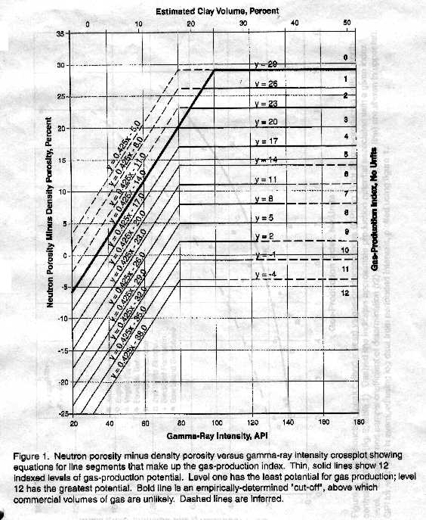
Figure 3: Hester’s reservoir quality indicator (QUAL1)

D. Reservoir Quality from Productivity Estimates
A productivity estimate based on a log analysis version of the productivity equation has been included on each summary table, as illustrated in Figure 5. The equation used was:
1. Est_Prod = 6.1*10E-6 * KH * ((PF – PS)^2) / (TF + 273) * FR * 90

The leading constant takes into account borehole radius, drainage radius, viscosity, and units conversions. KH is flow capacity in md-meters. (PF – PS) is the difference between formation pressure and surface pressure in KPa. A constant value of 1300 KPa was assumed for this study. Clearly, more detailed data could be used if time permits. TF was chosen constant at 20 degrees Celsius.

FR is a hydraulic fracture multiplier, chosen as 2.0 for this study, based on the 9 wells used to calibrate to 3-month initial production data. The constant 90 converts e3m3/day into an estimated 3-month production for comparison to actual. The 3 month numbers were chosen instead of daily rate as they have more “heft” and can be equated to income more readily.

The correlation graph is in the top left of Figure 7A. Note that the equation used is a constant scaling of KH, so the correlation coefficient is the same as the KH graph at 0.906.

Discussion of Results
The sample depth plot in Figure 4 shows typical results of the prototype analysis. The majority of the results are from the conventional analysis Model A, including the PayFlag. Some of the input curves are shown in Tracks 1 and 2. Hester’s quality factor (QUAL1) and the GR/RESD quality factor (QUAL2) are shown in Track 4. This is a gas producing well with an excellent set of perforations, shown on the right-hand edge of Track 2.

The conventional analysis, plotted in Track 5, gives a clear picture of why the conventional approach is so discouraging. Unfortunately, the laminated models do not create output curves that are consistent with a depth plot, so it is impossible to make pretty pictures of the results except in map form.

A sample Net Reservoir summary from the prototype program is shown in Figure 5. The changes in Net Reservoir and average rock properties between the models illustrate the need to find an appropriate model for laminated reservoirs. This work has been calibrated to core and production data, but the results shown here are still tentative. Each well can be tuned to match ground truth more closely.

A total of 10 reservoir quality indicators for each of 3 reservoir layers, plus the cored interval and the perforated interval are given for each of 4 different analysis models. The best model for predicting productivity is Model C, using the minimum of 3 shale indicators. The density neutron porosity separation indicator is essential to the success of Model C.

The best productivity indicator is the flow capacity (KH) or its equivalent productivity estimate in e3m3 for 90 days (1st 3 months production estimate). Five other indicators have strong correlations with productivity (Net Reservoir, PV, HPV, Hester’s QUAL1 >=5, and QUAL1 >=4). Hester’s number does not have much resolution at low flow rates, but clearly separates poor from good wells.

An important use of the summary tables is to determine whether a well is under-achieving due to limited perforation interval or a poor frac job. A comparison of the total KH for the Milk River compared to the KH for the perforated interval will point out any problem wells. Even if KH is badly miscalibrated, the comparison is useful. Over-achievers may be producing commingled, intentionally or otherwise, from deeper horizons or may point to log data or analytical difficulties.

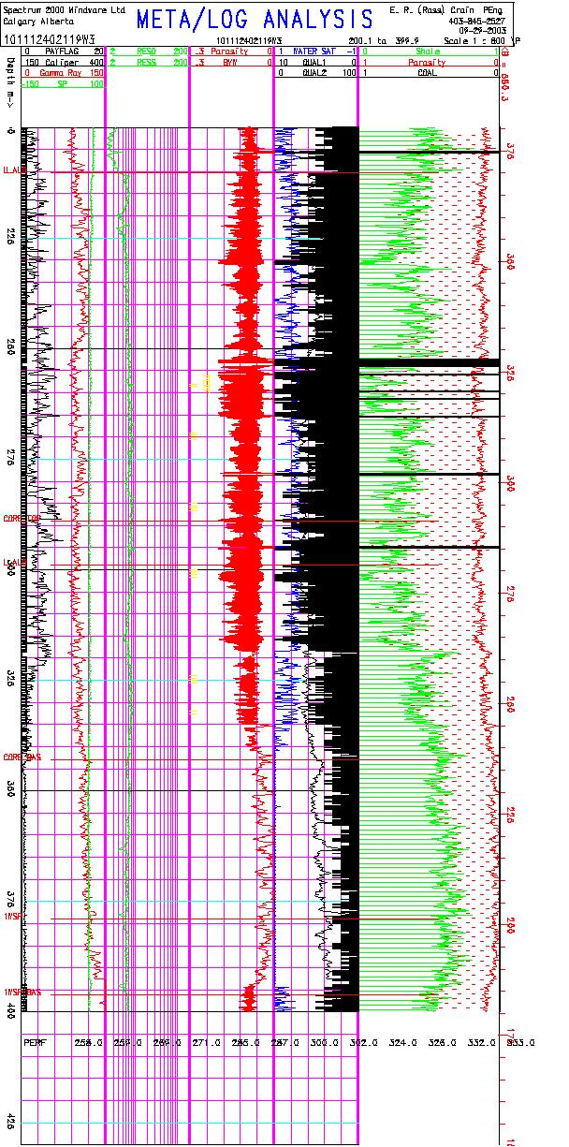
Figure 4: Depth plot showing Hester quality Factor in Track 4 (shaded black)
Figure 5: Sample Net Reservoir calculations for four shaly sand models.

The models can be used to generate a perforation list from Hester’s quality number or from VSHminimum. A portion of such a list is shown in Figure 6. An acceptance/rejection filter on the list will shorten it considerably. This will eliminate intervals that are too thin to bother with and group intervals that are close enough to be considered as single intervals.

Figure 6: Portion of unfiltered perforation list generated by the prototype program

Plots of first 3-month production versus various reservoir quality parameters are given in the graphs in Figures 7A and 7B for the 17 wells with production data and a full log suite. All graphs show a reasonable trend. Correlation coefficients were given earlier in this report.

The numerical data for these graphs is shown in Figure 8. These tables and the graphs in Figure 7 summarize the 17 wells with full log suites and reasonable initial production numbers. Results are based on the laminated shaly sand Model C using the minimum of three shale volume indicators, namely gamma ray, resistivity, and density-neutron separation. Results from the other three numerical models described earlier have not been summarized because the models are either inappropriate, pessimistic, or too erratic in their predictions.

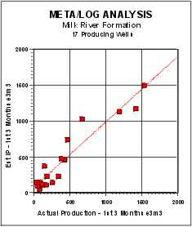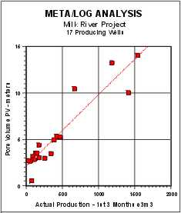

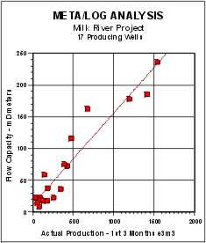
Figure 7A: Comparison of Actual 3-month initial production with reservoir quality indicators

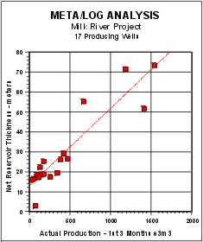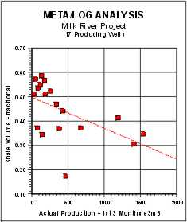
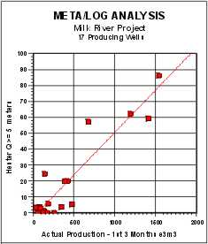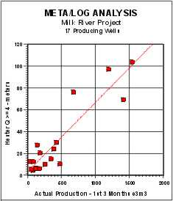
Figure 7B: Comparison of Actual 3-month initial production with reservoir quality indicators
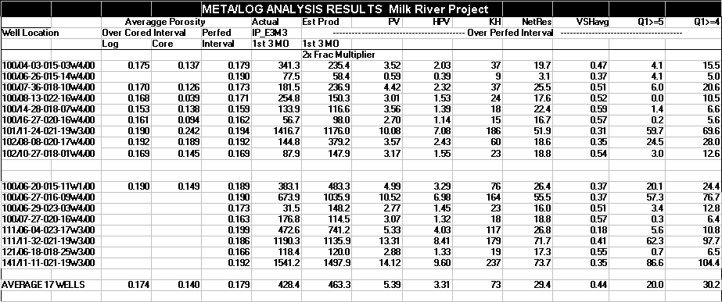
Figure 8A: Numerical data for initial production comparison

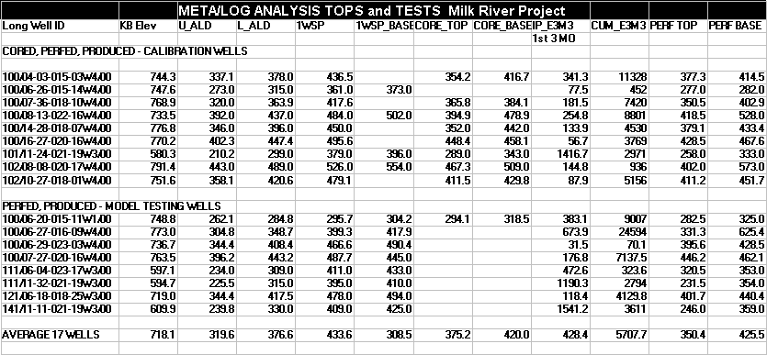
Figure 8B: Stratigraphic data for initial production comparison

Conclusions
The Laminated Sand Model C works very well with a full log suite, possibly because the gas effect on the density and neutron log curves enhances their ability to detect sands. It does not have any significant predictive capability with a minimum log suite, i.e. a suite missing both density and neutron log curves.

Because a full log suite was available in the 9 wells used for calibration, we have obtained the most likely shale volume (Vsh) result. The 8 wells held in reserve to test the model also showed very good agreement with initial production. One well that calculated an IP higher than actual can be brought into line with a small tune-up of the shale density parameter.

Hester’s quality number (QUAL1) is computable when a full log suite is present. It is a good visual indicator of reservoir quality on a depth plot. If we move to poorer log suites, Vsh from density neutron crossplot will not be available, nor will Hester’s quality number. This degrades results dramatically. Using the models with a minimum log suite is not recommended.

The most rigorous model, theoretically, is the Response Equation Model D. It requires a full suite of open hole logs but results were quite erratic. This model is not recommended for this project. The Conventional Shaly Sand Model A and the Laminated Model B should be avoided as the assumptions behind the models are inappropriate for this environment.

The log analysis results in the Milk River laminated sands from Model C should be considered as reasonable approximations for reservoir quality assessments and resource estimates. Considerably more detailed analysis may be required to refine the evaluation for individual wells after high-grade sweet spots are located.

References
Hester, T. C., 1999, An algorithm for Estimating Gas Production Potential Using Digital Well Log Data, Cretaceous of North Montana, USGS Open File Report 01-12

Acknowledgements
Thanks to Jerome Goodman for coding the LOGFUSION program in spite of some terrible data, Jason Johnson and Dan Block for locating and prepping the data used in the prototype analysis, and Kaush Rakhit for the inspiration to attempt this work in the laminated sand environment.

