A FUTURE History of Oil and Gas Development
Celebrating 150 Years of Oil In Canada
E.R. (Ross) Crain, P.Eng.
Spectrum 2000 Mindware Ltd
Published in CWLS InSite Dec 2008
Author’s Note: This article was written before the success of horizontal wells with massive frac jobs in unconventional reservoirs pushed the oil peak a little to the right. A couple of recessions also helped.
INTRODUCTION
The year 2008 marks the 150th anniversary of commercial oil production in Canada, and in North America, at Oil Springs, Lambton County, Ontario. The well was dug by James Miller Williams in 1858, a year before Edwin Drake’s discovery in Pennsylvania, USA. To celebrate, it might be worthwhile to look forward, instead of backward, to assess the “State of Oil”.
In the September 2004 CWLS InSite, I presented “A True History of Oil and Gas Development” to help set the record straight on who found what and when and where. The present article is intended to follow that development into the near future, hopefully to provoke intelligent thought and, possibly, action on the issue of “Peak Oil”.
By 1958, a hundred years after the Williams well in Ontario, most of the world's largest on-shore oil discoveries had been found. You can thank British Petroleum, Shell, and Standard Oil for that. They did a good job, too, considering the seismic and logging technology of the era.
New countries were born, borders were moved, wars were fought (and are still being fought), to accommodate or protect oil production. Major international oil conglomerates exploited these tremendous, apparently limitless, resources. National oil companies took back "their" resources in many places, but relied on the multi-nationals for technical expertise and markets. The details would be too boring for words.
What is interesting, and pertinent, is the state of oil today, a mere 150 years after Williams’ discovery. The exponential rise in use of oil over the past 50 years has placed civilization on a slippery slope of climate change (maybe), declining production capacity (probably), in the face of sky-rocketing long-term energy demand (certainly). To add a further complication, we are nearing or just past "Peak Oil". We'll know for sure very soon.
The very recent decline in oil price and oil demand in the fall of 2008 is only a temporary blip caused by the economic crunch in the USA. We go through these recessions every 10 to 12 years, as regularly as the sun spot cycle. I have lived through six of them: 1947-48, 1959-60, 1970-71, 1982-88, 1994-96, 2007-09. By 2012, we will be back on top of the economic roller coaster ride. A recession is only a temporary respite from our gluttonous appetite for oil and gas
PEAK OIL
M. King Hubbert developed the concept of peak oil in 1956 (Reference 1) and predicted the peak oil year for the USA (1971, Figure 1) and peak gas (1973-74, Figure 2) quite accurately. His prediction for the world’s conventional oil peak was the year 2000, shown in Figure 3. Since he was unaware of deep water reserves, such as North Sea, west coast Africa, and deep Gulf of Mexico, he could be forgiven a 5 to 10 year bust in his estimate, but he appears to be very close to the truth.
Hubbert’s thesis was that the world’s proven discoveries, plus new discoveries postulated from previous experience, would be produced at a rate that followed a Gaussian distribution (bell curve). The shape of the curve was set to fit annual production rates to date. The area under the curve would equal the sum of production-to-date plus remaining reserves, plus reserves yet to be discovered. The peak date could then be predicted by observation of the graph. He demonstrated that his concept was true for several depleted basins in the USA, then extended the concept to the entire USA, then to the whole world (as known to Shell, his employer, at the time).
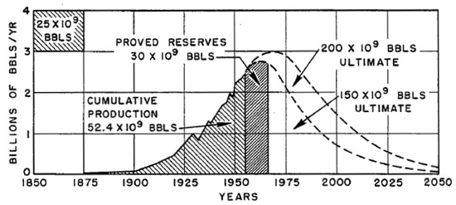 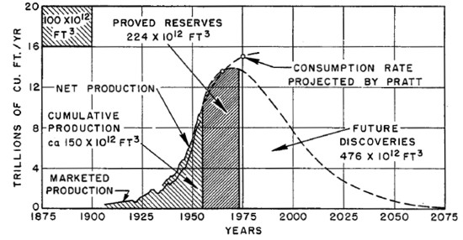
Figures 1 and 2: Hubbert’s original peak oil and peak gas graphs for USA from
Reference 1, 1956
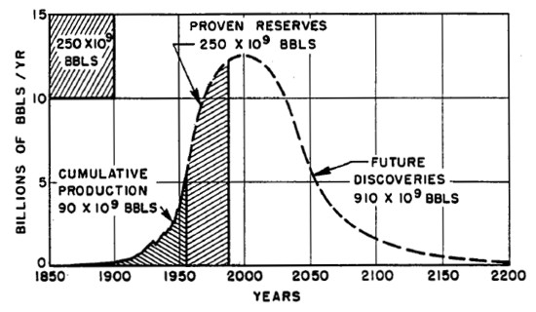
Figure 3: Hubbert’s 1956 peak oil graph for the world (Reference 1). Compare to 2006
graph in Figure 4.
The record for the last 100+ years’ production has been plotted by major supplier in Figure 4, showing peak oil rate occurring around the year 2000. The flat top may indicate that so-called “swing producers” such as Saudi Arabia may not be able to produce more than they currently do to supply latent demand. This would explain the rapid rise in oil price starting in 2002, shown in Figure 5.
Although Hubbert’s paper spends 47 of its 57 pages discussing peak oil, peak gas, and peak coal, the purpose of the paper was to demonstrate the need to develop nuclear power to offset future declines in fossil fuel availability. That need has not disappeared, but we are 52 years further along the slippery slope than Hubbert was. No major oil company has yet integrated horizontally to include nuclear, wind, or solar technology to augment their depleting reserve base, not even Shell, which had paid Hubbert for his research.
Hubbert’s professional reputation was seriously harmed by this presentation. Most professionals of the era though oil was virtually inexhaustible. Today, most of the world’s 6.5 billion people either feel this way too, or have never thought about the problem at all.
Price and production rate are highly linked, of course, and production quota limits set by OPEC tend to distort near-term trends. But the historical data is pretty revealing (Figure 5). The cost of living (price index) and rate of inflation (Figure 6) are strongly related to oil price and production rates, because everything we buy (from food to housing to clothing) has an energy component in manufacturing, delivery, or use.
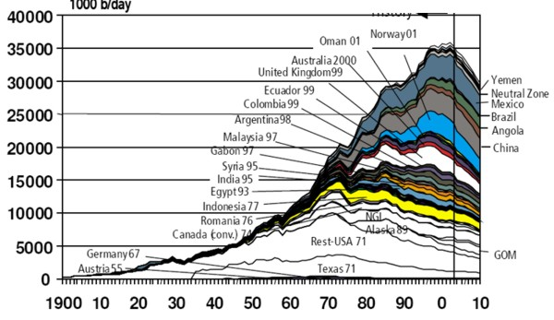
Figure 4: The current Peak Oil graph (from www.hubbertpeak.com) excludes unconventional oil, such as Canadian tar sands, but these can only add a few million barrels per day. Improving recovery factor (world average is only 36%) would offer another source of added reserves. Both come at higher cost than conventional oil.
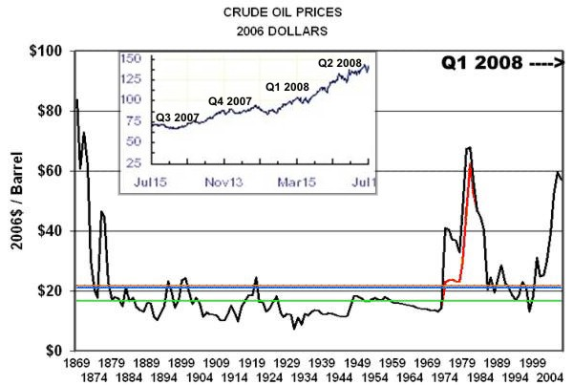
Figure 5: Oil price, in 2006 dollars, shows the median to be a little over US$21 (www.wtrg.com), but the current excursion exceeds US$140 (2nd Quarter 2008 – see inset at top left). Notice the major bumps: 1973 (OPEC oil embargo), 1979 (Iran revolution), and 2003 (Iraq war), all of which provided unnatural restrictions on oil supply. Price bumps for the 1st and 2nd World Wars are pretty minor due to rationed demand. The red line represents an ill-fated attempt at price-control by the USA.
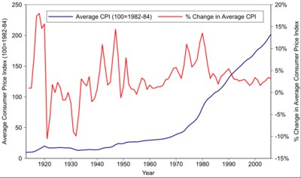
Figure 6: Price Index (blue) and Inflation Rate (red) for comparison to oil price changes in Figure 5
Compare the red curve in Figure 6 to the oil price curve shown in Figure 5. Substitution, alternate renewable energy sources, conservation, and moral choice may reduce the impact of the Peak Oil problem, which has not yet appeared on Figure 6, which ends in 2003.
OTHER PEAKS
Peak natural gas curves are harder to predict, but they probably follow the general outline of the coal curves (Figure 7) if unconventional gas is included, at a price yet to be determined. Conventional gas in the US peaked in 1973, and in 2006, it took over 10,000 new wells in Texas just to maintain 2005 production rates in the USA. How long can this continue?
Only politicians, economists, and madmen believe that perpetual growth is possible in a finite world.
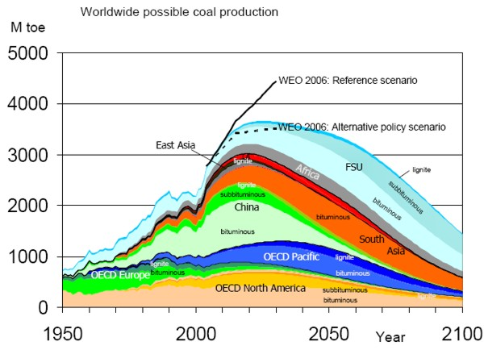
Figure 7: Coal production peak (from www.hubbertpeak.com ) is about 25 to 50 years after oil and the peak is much broader. Higher price has a better chance to stretch the coal curve than the oil curve.
PEAK PARADOX
The First Paradox of Peak Oil is that we have to move faster on alternate energy sources now, even if we think the peak is far away. Alternatives to oil and gas take energy and time to build: nuclear, hydroelectric, clean coal, wind, and solar plants are energy intensive during construction, reconstruction, and repair. Steel, aluminum, plastic, concrete, and copper all require great amounts of energy to produce. Even enhanced recovery and in-fill wells will reach their economic limit in time. If we wait too long, there won’t be enough energy left to build alternatives. Hubbert’s graphs predicted this in 1956 and we have learned little since.
The Second Paradox is Society’s unwillingness to face up to its responsibility to future generations. NIMBY rears its ugly head for most alternate energy sources. This is highly irrational. Dangers from the automobile far outweigh dangers from nuclear accidents or bird deaths from wind turbines. Automobiles and trucks kill 10 million birds a year in the USA, wind turbines only 70,000. Esthetic objections border on the insane – just look at urban sprawl, suburban outlet malls, or the downtown core of many cities if you want to see Ugly.
Traffic accidents take 45,000 and firearms take 30,000 lives each year in the USA alone. These CDC stats don’t count deaths from auto or coal pollution or industrial accidents at mines, drilling rigs or refineries (or the “oil wars” in Kuwait, Iraq, Sudan….). Multiply by 50 or 100 to estimate energy related deaths for the world.
By comparison, nuclear looks pretty safe at about 4000 deaths total across more than 50 years, all associated with Chernobyl in 1986, which was a primitive, inherently unsafe design. There were no deaths at Windscale (UK, 1957) or Three Mile Island (USA, 1979), the only other civilian reactor failures. A grand total of 4 deaths have been reported at military research reactors in the USA due to nuclear accidents.
The Third Paradox is irrational Government and Industry response to “junk” science. For example, there is no “hydrogen economy”. There is no natural source of hydrogen – it has to be manufactured using other forms of energy. The energy Output to Input Ratio is 0.7, so the process is always below its economic limit. There is no Free Lunch or Perpetual Motion Machine. The corrosive and explosive nature of hydrogen, and its low energy density, makes its economical storage, distribution, and delivery to vehicles virtually impossible.
Bio-fuels from crops are merely breakeven on energy inputs. Soil degradation of mono-culture and land diversion from food crops are negative factors. Bacterial extraction of ethanol from bio-waste appears to be economic inside the plant gate, with an IOR of 7, but trucking in and out has not been counted.
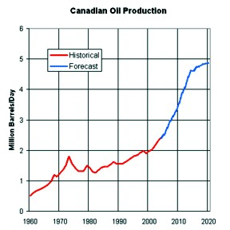
The Fourth Paradox is Canada’s continued increase in oil output (Figure 8), which tends to divert attention locally away from Peak Oil. Canada's conventional oil production peaked in 1974, but tar sands production has reversed the decline. Current capacity in the tar sands has brought Canadian production to more than 2.6 million barrels per day, with a target of 5 million by the year 2020 (equal to Iran, and double Venezuela or Iraq).
Figure 8: Increasing Canadian oil production is due to tar sand production and is expected to reach 5 million barrels per day by 2020.
Although tar sands are the current darling of the Canadian oil industry (and so they should be), increases beyond 2020 are unlikely. There is not enough gas in North America or water in Alberta to produce all known reserves.
Canada's steady increase in production contrasts markedly with production declines in nearly every other major oil-producing country. For example, before and after the 1st Gulf War in 1991, Kuwait’s Greater Burgan Field produced 2 million barrels per day, but cannot get past 1.4 million today. Most giant fields of the Middle East and Russia are in the same boat, according to investment banker Matthew Simmons (reference 2), with current decline rates between 5 and 10% per year. Simmons’ recent (Feb 2008) presentation to the US Pentagon was pretty scary. If the Pentagon understood him, it might get scarier still.
The majority of Canadian production is exported to the United States by pipeline. Canada is the largest single supplier of US oil needs, a fact not well appreciated by US citizens or the rest of the world. “Offset” oil from the Middle East is imported into Eastern Canada – this paradox may need some re-thinking in the near future.
Aside from the tar sands, another significant reason for increased production in Canada is that independent oil companies, operating under a favourable free-enterprise tax system and rule of law, are content to produce from thin, low productivity, low quality reservoirs. The risk of political upheaval or confiscation is very low, as is exploration and development risk.
Policies, politics, and egos (not economics) make production from poor quality reservoirs difficult in most other regimes, except in the continental US and Western Europe on-shore. There is no magic bullet to cure the world's addiction to oil, so the exploitation of lower quality reservoirs will have to become "standard operating practice" very soon in the rest of the world.
Put 500 Canadian independents into Saudi or Venezuela, with Canadian rules and royalties, and the production rates would double in no time!
PEAK CRITIQUE
Critics complain that peak oil predictions are just plain wrong (oil is inexhaustible), or that decisions can be delayed (peak oil is 25 to 50 years away). The first complaint is physically impossible and the second is becoming more and more improbable. Either way, the result will be the same, sooner or later. Oil and gas will not last forever, no matter how much wishful thinking we do. It is not a question of “IF”, but a question of “WHEN”. Just to maintain constant production at the current rate, we need to find and develop a new “North Sea” every year. What do you think the odds are for that happening?
When the peak will occur is open to considerable debate. Princeton Professor of Geology Kenneth Deffeyes (reference 3) thinks it happened in December 2005. Matthew Simmons thinks it happened in 2007 – Figures 4 and 9 bears this out.
There is a more basic flaw in Hubbert’s Peak Oil concept, perpetuated by Deffeyes and Simmons and most major oil companies. That flaw is the Giant Oil Field Fallacy. Both the US and Saudi Arabia have giant oil fields. The US also has thousands of small fields and Saudi has none. The US has 521,000 active producing wells, Saudi has only 1560. Does Saudi have no small fields?
Of course not. There are thousands of small fields in the Middle East. Oman has developed quite a few. But most Middle East national oil companies have not developed small fields, or the nooks and crannies of large fields, because to-date they haven’t needed to. If we assume that nature distributed small fields in the Middle East as it did in North America, then there is more oil to be found, at a cost and effort to be determined.
But it will take a serious paradigm shift in National oil companies to start the process. It will not prevent Peak Oil, but it will skew the Hubbert bell-curve to the right and stretch the peak to some degree. It will only take a couple hundred thousand new wells!

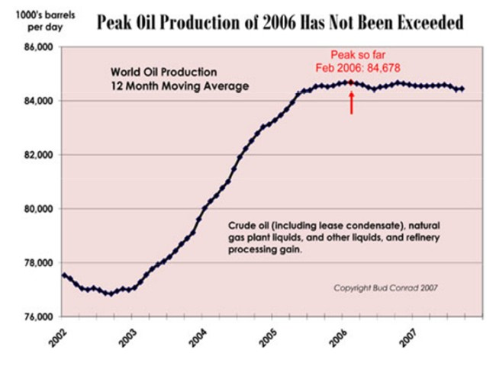
Figure 9: Detailed running average production of liquid hydrocarbons for the world shows the peak oil plateau extending from early 2005 to the present (www.caseyresearch.com). This graph includes all forms of liquid hydrocarbons; Figure 4 included only conventional crude oil. Saudi Arabia has promised (July 2008) to increase production by 200,000 barrels per day – less than ¼ of 1 % of the current demand. Such a trivial increase will do nothing to reduce prices.
As we enter the 21st century, the developed world is in a trance of self-deception and denial, avoiding any rational discussion of long-term energy supply. Unless we start to act, energy security will rank well above military intelligence on the Oxymoronic Index.

FIXING PEAK OIL
Well, you can’t actually fix Peak Oil. It’s going to happen. But, like software bugs, there are work-arounds.
Let’s assume Plan A is to do nothing and fritter away our dwindling heritage of easy energy. I have two tame squirrels who can do better than that – they store nuts every day even though an inexhaustible supply is always on the feeder.
A variation of Plan A is to develop small fields and attic oil in the Middle East, Russia, and Venezuela to stretch the peak. This will take a serious price–driven propaganda exercise by consumers, and major oil company negotiations with nationalized oil agencies.
Business leaders, with or without the help of political leaders, have to come to grips with the Peak Oil issue immediately and establish plans whereby renewable energy can be built and installed, using oil and gas as needed, before this option runs out or becomes too expensive to be effective. Some may be doing this now, but they have been diligent in hiding the fact.
So Plan B might be to think beyond the short-term of share-price and move on to longer term planning, using some of the windfall from $140 oil to grease the skids. Every option can be considered, including clean-coal, nuclear, wind, solar, waves, tides…. It’s called “thinking outside the box” or “widening the envelope”.

Who is better qualified to do this than existing oil and gas companies? We have conquered the frigid Arctic, deep oceans, and super-hot geothermal terrains. How tough can a wind farm or nuclear reactor be? Or would you prefer a Dot-Com startup to do it for you?
By diverting oil and gas from electric generation (replacing it by alternate sources), the available hydrocarbon reserves will allow personal transportation to survive a little longer. Without hydrocarbon diversion and replacement by renewables, the automobile and airplane are a fast-dying breed, as well as suburbia, office towers, and possibly a civil society.

“Oil Companies” must become “Energy Companies”, in practice as well as in name. Any oil or gas company that ignores Peak Oil will not be here 20 years from now. Energy companies of the future will be integrated horizontally across energy forms, instead of vertically across exploration, production, and marketing. Horizontal integration is the only sane solution for stretching the peak.
If existing oil and gas companies don’t do it, someone else will. Oil company directors will have to explain to shareholders why they own a warehouse full of buggy-whips when all the horses are dead.
REFERENCES
1. “NUCLEAR ENERGY AND THE FOSSIL FUELS”
M. KING HUBBERT
Presented before the Spring Meeting of the Southern District
Division of Production, American Petroleum Institute
Plaza Hotel, San Antonio, Texas, March 7-8-9, 1956
www.hubbertpeak.com/hubbert/1956/1956.pdf
2. www.simmonsco-intl.com/ Click on Matthew R Simmons >> Speeches
3. www.princeton.edu/hubbert/index.html Links to Amazon.com

Further Reading:
http://en.wikipedia.org/wiki/Peak_oil . (contains more than 150 references)
Hubbert's Peak: The Impending World Oil Shortage by Kenneth Deffeyes
Beyond Oil: The View from Hubbert's Peak by Kenneth Deffeyes
Twilight in the Desert: The Coming Saudi Oil Shock and the World Economy by Matthew Simmons
The Party's Over: Oil, War and the Fate of Industrial Societies by Richard Heinberg
The Coming Economic Collapse: How You Can Thrive When Oil Costs $200 a Barrel by Stephen Leeb Ph.D.
The Long Emergency: Surviving the End of Oil, Climate Change, and Other Converging Catastrophes of the Twenty-first Century by James Howard Kunstler
A Thousand Barrels a Second: The Coming Oil Break Point and the Challenges Facing an Energy Dependent World by Peter Tertzakian
Energy: Physical, Environmental, and Social Impact by Gordon J. Aubrecht
Fueling the Future: How the Battle Over Energy Is Changing Everything by Andrew Heintzman, Evan Solomon
The Final Energy Crisis by Andrew McKillop

