UNICORNS IN THE GARDEN OF GOOD AND EVIL
PART 7 – LAMINATED RESERVOIRS
E. R. (Ross) Crain, P.Eng.
Spectrum 2000 Mindware Ltd
Published in CSPG Reservoir, May 2011
Unicorns are beautiful, mythical beasts, much sought after by us mere mortals. The same is true for petrophysical models for unconventional reservoirs. This is the seventh in a series of review articles outlining the simple beauty of some practical methods for log analysis of the unusual.
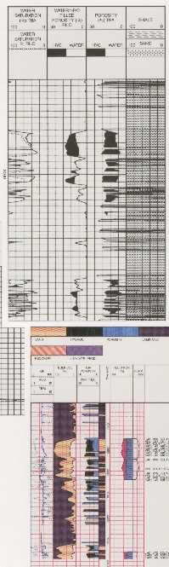
LAMINATED RESERVOIRS
Porosity and water saturation in laminated shaly sands, and in other cases of anisotropic reservoirs, are a special case, not amenable to conventional petrophysical solutions. Isotropic reservoirs are those in which the physical properties are the same regardless of the direction of measurement. Anisotropic reservoirs have one or more properties that vary with direction.
The best known anisotropic property is resistivity, which can vary by a factor of 100 or more, depending on whether the measurement is made parallel to the bedding or perpendicular to it. This is the situation that exists in most so-called "low resistivity pay zones". These are usually laminated shaly sands but can also be sandstones or carbonates with thinly bedded variations in porosity. In resistivity log analysis, anisotropy is present when the bedding is thinner than the tool resolution and is sometimes described as a "thin-bed" problem.
Rocks of this type are called transverse isotropic; there is little horizontal anisotropy, so resistivity differs between only two axes - vertical and horizontal. Channel sands with significant cross bedding and other linear depositional features could be anisotropic on all three axes.
There are no logs that measure resistivity in 3 orthogonal axes at the same time. The newest induction logs measure horizontal and vertical resistivity (directions relative to tool axis). Azimuthal laterologs read in eight directions (perpendicular to the tool axis)
Figure 1: Thin bed Rt log used to shape final log analysis (courtesy Baker Hughes)
and could be used to look for horizontal anisotropy in semi-vertical wells.
The newest thin bed tool is described as a thin bed Rt tool. It is a microlaterolog type of device with a bed resolution of 5 cm and a depth of investigation between 30 and 50 cm (12 to 20 inches), about 2 to 3 times deeper than earlier microlaterologs. If invasion is shallow, the resistivity approaches a deep resistivity measurement. This is very useful in laminated shaly sands where the laminae are relatively thick.
Other thin bed logging tools are the microlog, microlaterolog, proximity log, and micro spherically focused log. These tools measure 3 to 12 centimeters of rock but have a depth of investigation of similar dimensions. In some laminated sands, these tools can be used to determine net to gross sand ratio.
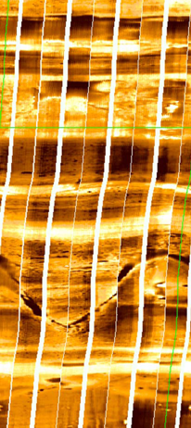
The electromagnetic propagation log measures in the order of 6 cm but it is a porosity and shale indicator tool, not a deep resistivity tool. Some sonic logs can be run with a 15 cm (6 inch) bed resolution.
The resistivity microscanner can see beds as thin as 0.5 cm and fractures as thin as 1 micron. The acoustic televiewer can resolve beds to 1 or 2 cm. Accurate net to gross ratios can be determined, but again the resistivity of the sand fraction beyond the invaded zone cannot be determined from these tools.
Figure 2: Resistivity image in laminated shaly sand (courtesy Schlumberger)
None of the tools listed above provide a useful deep resistivity value when laminations are thinner than the tool resolution, so unconventional log analysis models are needed.
Resistivity in Anisotropic Reservoirs
The problem lies in how resistivity logs average laminations that are thinner than the tool resolution. Most logs average the data in a linear, thickness weighted fashion, but induction and laterologs average conductivity and then convert it to resistivity. In shaly sands, the conductivity of the shale laminations is usually much higher than the gas or oil sand laminations, the resulting conductivity is high (resistivity is low). This makes the zone look like a poor quality reservoir, maybe so poor that it will not be tested, thus bypassing considerable oil or gas.

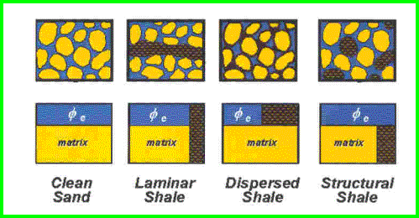
Figure 3: The physical model for a laminated shaly sand compared to a clean sand and conventional shaly sands. The high conductivity of the shale lamination (black shading) strongly influences the net conductivity measured by resistivity tools.

A similar problem exists in laminated porosity. The low porosity laminations have higher water saturation than oil or gas bearing higher porosity laminations. The measured resistivity of the laminated hydrocarbon bearing reservoir is often close to the truth, but the calculated water saturation of water zones may be misleading.
To illustrate the simplest case, assume a laminated shaly sand sequence with shale laminations equal in thickness to the sand laminations. This gives a shale volume (Vsh) averaged over the interval of 50%. Assume the porosity and resistivity values are as shown below:
GAS SAND | GR | PHIN | PHID | RESD | COND | RESD from COND
Shale | 90 | 0.45 | 0.15 | 4.0 | 250
Gas Sand | 40 | 0.25 | 0.35 | 200 | 5.0
Average | 65 | 0.30 | 0.25 | 102 | 127 | 7.9

WTR SAND | GR | PHIN | PHID | RESD | COND | RESD from COND
Shale | 90 | 0.45 | 0.15 | 4.0 | 250
Water Sand | 40 | 0.30 | 0.30 | 5.0 | 200
Average | 65 | 0.37 | 0.22 | 4.5 | 222 | 4.2

Table1: In a laminated shaly sand with 50% shale volume, the average of 4 ohm-m and 200 ohm-m is a little less than 8 ohm-m - pretty scary, but that is what real induction and laterologs do!
The upper part table shows that the average resistivity of a 50:50 mix of 4 ohm-m shale laminations with 200 ohm-m sand laminations is 7.9 ohm-m, based on the measured conductivity. If the sand laminations are wet, as in the lower part of the table, the average resistivity is close to that measured by the conductivity log. Note, too, that the recorded resistivity contrast between a water zone and a gas zone is small, so it may not be possible to recognize gas when it is present, especially if water resistivity varies between one hydrodynamic regime and another.
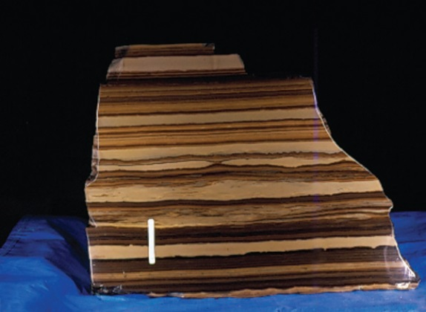
Figure 4: Photo of laminated shaly sand – white bar is 1 cm (USGS photo)
Water saturation based on the measured resistivity will be very misleading, often showing the zone to be wet when it is not. We will see later how we might overcome this and maybe even find out the true sand lamination resistivity of 200 ohm-m. The correct SW comes from the 200 ohm-m resistivity, not the 7.9 ohm-m measured by the standard logging tool.
In the early days of log analysis, this phenomenon was attributed to many different, almost mystical, reasons because the parallel nature of the conductive paths was not understood by many analysts.
The case of laminated porosity is slightly different. The resistivity contrasts are smaller than the laminated shaly sand case. The resistivity of the higher porosity streaks with low water saturation may be close to that of the low porosity streak with higher water saturation. But water zones may look pretty resistive, again giving misleading water saturation.
Assume equal thicknesses of high and low porosity with the porosity and resistivity values as shown below:
OIL or GAS CASE – LAMINATED POROSITY
 | RW |  | PHIe |  | Sw | RESD | COND | RESD from COND
Layer 1 | 0.050 |  | 0.200 |  | 0.200 | 31.3 | 32.0
Layer 2 | 0.050 |  | 0.030 |  | 0.800 | 86.8 | 11.5
Averages | 0.050 |  | 0.115 |  |  | 59.0 | 21.8
SW From COND ==> |  |  |  |  | 0.287 |  |  | 46.0
SW From BVW / PHIe => |  |  |  |  | 0.278
WATER CASE
 |  | RW |  | PHIe | Sw | RESD | COND | RESD from COND
Layer 1 |  | 0.050 |  | 0.200 | 1.000 | 1.3 | 800.0
Layer 2 |  | 0.050 |  | 0.030 | 1.000 | 55.6 | 18.0
Averages |  | 0.050 |  | 0.115 |  | 28.4 | 409.0
SW From COND ==> |  |  |  |  | 1.244 |  |  | 2.4
SW From BVW / PHIe ==> |  |  |  |  | 1.000
Table 2: The “RESD from COND” column shows the value a real logging tool would read in the laminated porosity. It can be higher or lower than the thickness weighted average of the two individual resistivities, depending on the porosity and water saturation of the two layers. The correct SW is derived by calculating PHIe times Sw for each layer, adding them up, and dividing by the average PHIe.

Modeling laminated shaly sands or laminated porosity with a spreadsheet is the only way to understand the resistivity response and resulting water saturation – usually counter-intuitive, always surprising. A spreadsheet for these models is available as a free download on my website at www.spec2000.net .
3-D Induction logs
Some newer induction logging tools provide a vertical conductivity measurement as well as the usual horizontal measurement. If the beds are still parallel to the horizontal induction log signal, the vertical induction signal will give an average of the resistivity of the beds instead of averaging the conductivity. This is because the normal induction averages the beds in a parallel electrical circuit and the vertical induction sees a series circuit.
Assume a laminated shaly sand with horizontal bedding, a vertical borehole, and a logging tool that can measure both vertical and horizontal conductivity:
1. CONDhorz = VSHavg * CONDshale + (1 - VSHavg) * CONDsand
2. RESvert = VSHavg * RESshale + (1 - VSHavg) * RESsand
3. REShorz = 1000 / CONDhorz
4. CONDvert = 1000 / RESvert
5. AnisRatio = RESvert / REShorz
OR 5. AnisRatio = CONDhorz / CONDvert
6. AnisCoef = AnisRatio ^ 0.5
Where:
AnisRatio = anisotropic ratio
AnisCoef = anisotropic coefficient
CONDhorz = horizontal conductivity (mS/m)
CONDvert = vertical conductivity (mS/m)
CONDsand = sand lamination conductivity (mS/m)
CONDshale = shale lamination conductivity (mS/m)
REShorz = horizontal resistivity (ohm-m)
RESvert = vertical resistivity (ohm-m)
RESsand = sand lamination resistivity (ohm-m)
RESshale = shale lamination resistivity (ohm-m)
VSHavg = shale lamination volume within the interval measured by the logging tool (fractional)
Equations 5 and 6 are as defined by Schlumberger in 1934. Some authors invert the equations so the coefficient is less than or equal to 1.0.
Equations 1 and 2 can be solved simultaneously for any two unknowns if the other parameters are known or computable. For example, we can solve for RESsand and RESshale if RESvert and REShorz are measured log values and VSHavg is computed from (say) the gamma ray log over an interval. Alternatively, we can solve for RESsand and VSHavg if we assume RESshale = RSH from a nearby thick shale:
8. CONDsand = CONDvert * (CONDshale - CONDhorz) / (CONDshl - CONDvert)
9. VSHavg = (CONDhorz - CONDsand) / (CONDshale - CONDsand)
If you prefer to think in Resistivity terms:
10. RESsand = REShorz * (RESvert - RESshale) / (REShorz - RESshl)
11. VSHavg = (RESsand - RESvert) / (RESsand - RESshale)
RESsand is then used in Archie's water saturation equation, along with porosity from core or from a laminated sand porosity method, for example:
12: PHINsand = (PHIN - VSHavg * PHINSH) / (1 - VSHavg)
13: PHIDsand = (PHID - VSHavg * PHIDSH) / (1 - VSHavg)
14: PHIsand = (PHINsand + PHIDsand) / 2
15: SWsand = (A * RW@FT / ((PHIsand^M) * RESsand))^(1/N)
Where:
PHINsand = neutron porosity of a sand lamination
PHIN = neutron log reading in the laminated sand
PHINSH = neutron shale value in a nearby thick shale
PHIDsand = density porosity of a sand lamination
PHID = density log reading in the laminated sand
PHIDSH = density shale value in a nearby thick shale
PHIsand = effective porosity of a sand lamination
SWsand = effective water saturation of a sand lamination
RW@FT = water resistivity at formation temperature (ohm-m)
A, M, and N = electrical properties of a sand lamination
Equations 10 through 15 can be plotted versus depth, but this may be misleading since only some of the interval has the porosity and water saturation that is displayed – some of the reservoir interval is nearly pure shale. Oil or gas in place must be adjusted by the net to gross ratio based on the average shale volume:
16: Net2Gross = (1 – VSHavg)
17: NetSand = (1 – VSHavg) * GrossSand
Vertical resistivity logs are still very rare, but are the tool of choice for laminated shaly sands. An example is shown in Figure 5. Notice the large difference between Rv and Rh on the raw log and the difference in Sw on the computed log.
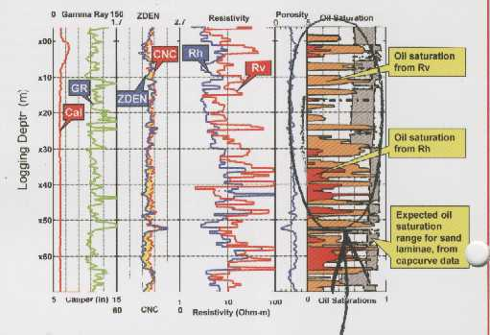
Figure 5: Example of vertical and horizontal resistivity in laminated shaly sand (courtesy Baker Hughes)

3-D Induction logs IN DIPPING BEDS
The example given above involved a laminated shaly sand with bedding perpendicular to the borehole axis (horizontal bedding, vertical borehole). When beds dip relative to the borehole, the situation becomes more complicated. The relative dip is the important factor and takes a bit of thought when the borehole is not vertical.
Dipmeter results are presented as true dip angle and direction relative to a horizontal plane and true north. To obtain dip and direction of beds relative to a logging tool in a deviated borehole, you need the borehole deviation and direction from a deviation survey. This is often obtained at the same time as the dipmeter, but may come from some other deviation survey, either continuous or station by station. You need to rotate the true dips into the plane perpendicular to the borehole to get the final relative dip.
For a conventional induction log, the apparent conductivity is:
18. CONDlog = ((CONDhorz * cos(RelDip))^2 + CONDvert * CONDhorz * (sin(RelDip))^2)^0.5
Where:
CONDlog = conductivity measured by a log in an anisotropic rock (mS/m)
ReLDip = formation dip angle relative to tool axis
When relative dip is 0 degrees (horizontal bed, vertical wellbore), the conventional log reads CONDhorz, as we know it should. However, if relative dip is 90 degrees, as in a horizontal hole in horizontal laminated sands, the log reading is (CONDhorz * CONDvert) ^0.5. This is a surprise, as we might have expected the tool to measure CONDvert.
If two deviated wells are logged through the same formation (at considerably different deviation angles), two equations of the form of equation 18 can be formulated and solved for CONDhorz and CONDvert. RESsand and VSHavg can then be calculated as in equations 10 and 11.
AlternAte MODELS – Laminated Shaly SandS
In the absence of a vertical resistivity measurement, we can make some assumptions and use a non-conventional analysis model. These models do not generate log curves that can be plotted versus depth. Instead, they look at stratigraphically significant layers and generate the average properties for each layer.
MODEL 1: An obvious solution is to use the math for the vertical resistivity model (equations 10 through 17 given earlier) with assumed values of RESsand (based on a model of a clean sand) and Vsh (based on the GR log). The results would give an indication of the reservoir quality of the individual layer analyzed. Permeability, pore volume (PV), hydrocarbon pore volume (HPV), and flow capacity (KH) are calculated from the above results, just as for conventional sands, bearing in mind that the results apply only to the NetSand portion of the gross interval. No depth plot would be available as the results apply to the whole layer.
MODEL 2: Another model uses rules for finding the rock properties based on shale volume, along with constants derived from core analysis. These empirical rules can be calibrated to core and then used where there is no core data. The PHIMAX porosity equation and Buckles water saturation equation given below are widely used in normal shaly sands where the log suite is at a minimum, and are equally useful in the laminated case:
18: VSHavg = average Vsh from GR or density neutron separation over the layer’s gross interval
19: Net2Gross = (1 - VSHavg) or from core, televiewer, or microscanner
20: NetSand = (1 - VSHavg) * Gross
21: PHIsand = PHIMAX
22: SWsand = KBUCKL / PHIsand
OR 22: SWsand = (A * RW@FT / ((PHIsand^M) * RESsand))^(1/N)
Where:
PHIMAX = maximum porosity expected in the clean sand laminations
KBUCKL = Buckle’s number, product of porosity times water saturation expected in a clean sand lamination
This model presupposes that the laminated sand is hydrocarbon bearing. Again, permeability, pore volume (PV), hydrocarbon pore volume (HPV), and flow capacity (KH) are calculated from the above results, just as for conventional sands, bearing in mind that the results apply only to the NetSand portion of the gross interval.
The PHIMAX value is the critical factor. If a moderate amount of core data is available for the sand fraction of the laminated sand, this data can be mapped and used to control PHIMAX spatially. RESsand can be assumed from a nearby clean hydrocarbon bearing sand or by inverting the Archie equation with reasonable values of PHIMAX, RW@FT, and SW. KBUCKL is usually in the range 0.035 to 0.060, varying inversely with grain size of the clean sand fraction.
A very minimum log suite can be used, since the only curve required is a gamma ray shale indicator, but only if there are no radioactive elements other than clay. This is not the case in the Milk River, so a minimum log suite will not work here. We have used the minimum suite successfully in laminated shaly sands in Lake Maracaibo.
MODEL 3: This model uses the linear log response equation to back-out the clean sand fraction properties from the actual log readings and the shale properties. The response equations are used on the average of the log curves over the gross sand interval. We still assume:
23: VSHavg = average Vsh from GR or density neutron separation over gross interval
24: Net2Gross = (1 - VSHavg) or from core, televiewer, or microscanner
25: NetSand = Gross * Net2Gross
26: PHINsand = (PHINavg – VSHavg * PHINSH) / (1 - VSHavg)
27: PHIDsand = (PHIDavg – VSHavg * PHIDSH) / (1 - VSHavg)
28: PHIsand = (PHINsand + PHIDsand) / 2
29: CONDsand = (CONDavg – VSHavg * 1000 / RESshale) / (1 - VSHavg)
30: RESDsand = 1000 / CONDsand
31: SWsand = KBUCKL / PHIsand
OR 31: SWsand = (A * RW@FT / ((PHIsand^M) * RESDsand))^(1/N)
Where:
XXXXavg = log value averaged over a discreet laminated sand interval, thicker than the tool resolution
This model has the advantage of using fewer arbitrary rules and more log data, including resistivity log data. The critical values are RESshale, PHINSH, and PHIDSH, which are picked by observation of the log above the zone. It can still be calibrated to core by adjusting these parameters. If the Archie water saturation equation is used, it might distinguish hydrocarbon from water. The Buckle’s saturation presupposes hydrocarbons are present.
The layer average PHIDsand and PHINsand can be compared to each other to see if they are similar values – they should be if the parameters are reasonably correct. They could cross over if gas effect is strong enough. Our results showed a 0.02 porosity unit variation on the best behaved wells, indicating that the inversion of the response equations was working well. However, on some intervals in some wells, the results were not nearly so good.

Reservoir Quality Indicators frOM Laminated Shaly Sand MODELS
There are a number of ways to assess reservoir quality. In laminated sands. One approach is to correlate first three months or first year production with net reservoir properties from one of the laminated models described above. The following example used Model 3 and is from “Productivity Estimation in the Milk River Laminated Shaly Sand, Southeast Alberta and Southwest Saskatchewan” by E. R. (Ross) Crain and, D.W. (Dave) Hume, CWLS Insite, Dec 2004.
We chose to use the first 8760 hours of production (365 days at 24 hours each) divided by 4 (3 months of continuous production) as our “actual” production figure. This normalizes the effects of testing and remedial activities that might interrupt normal production.
The normalized initial production was correlated with net reservoir thickness, pore volume (PV), hydrocarbon pore volume (HPV), and flow capacity (KH). Correlation coefficients (R-squared) are 0.852, 0.876, 0.903, and 0.906 respectively. The correlation is made using data calculated over the total perforated interval. Average shale volume was correlated with actual production but the correlation coefficient was only 0.296, although the trend of the data is quite clear. Correlation of actual production versus the various reservoir properties are shown in Figures 7 through 11.
Productivity estimate based on Model 3 results and a log analysis version of the productivity equation can be used as well. The equation is:
32. ProdEst = 6.1*10E-6 * KH * ((PF - PS)^2) / (TF + 273) * FR * 90
Where:
KH = flow capacity (md-meters)
(PF - PS) = difference between formation pressure and surface back-pressure (KPa)
TF = formation temperature (degrees Celsius)
FR = hydraulic fracture multiplier (usually 2.0 to 5.0)
The leading constant takes into account borehole radius, drainage radius, and units conversions, and the constant 90 converts e3m3/day into an estimated 3-month production for comparison to actual. A correlation between estimated and actual 90 day production is shown in Figure 6. Note that the equation used is a constant scaling of KH, so the correlation coefficient is the same as the KH graph at 0.906.
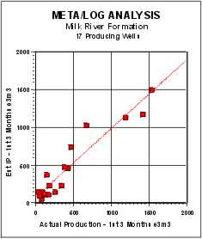  Figure 6: Estimated Productivity vs Actual Initial 90 Day Production | 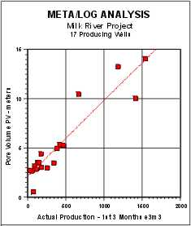  Figure 7: Pore Volume (PV) vs Actual Initial 90 Day Production
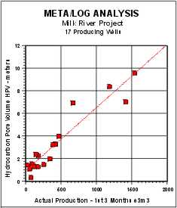  Figure 8: Hydrocarbon Pore Volume (HPV) vs Actual Initial 90 Day Production | 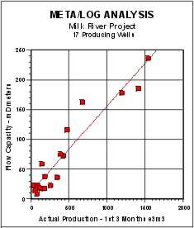  Figure 9: Flow Capacity (KH) vs Actual Initial 90 Day Production

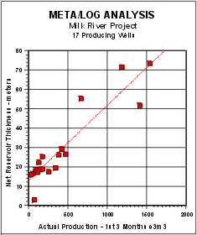  Figure 10: Net Sand vs Actual Initial  90 Day Production | 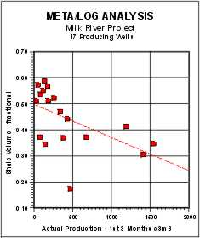  Figure 11: Shale Volume (Vsh) vs Actual Initial 90 Day Production
Because a full log suite was available in the 9 wells used for calibration, we have obtained the most likely shale volume (VSHavg) result. The 8 wells held in reserve to test the model also showed very good agreement with initial production. One well that calculated an IP higher than actual can be brought into line with a small tune-up of the shale density parameter.
Reservoir Quality from an Enhanced Shale Indicator
Another approach to assessing laminated shaly sands is to generate reservoir quality curves that can be plotted versus depth, to assist in choosing perforation intervals. One such curve is an enhanced GR modified by the resistivity contrast between reservoir and shale values:
33. QualGR = RSH * GR / RESD
Where:
QualGR = enhanced gamma ray quality indicator (API units)
RSH = resistivity of a nearby thick shale (ohm-m)
GR = gamma ray log reading (API units)
RESD = deep resistivity log reading (ohm-m)
This amplifies the shale indicator in cleaner zones (higher net sand) and is scaled the same as the GR curve. A net reservoir cutoff of QualGR <= 50 on this curve was a rough indicator of first three months production, but the correlation coefficient was as poor as for average shale volume. The QualFR cutoff varies from place to place and can be as high as 100 or more. QUALGR does make a useful curve on a depth plot as it shows the best places to perforate when density and neutron data are missing.

Reservoir Quality from Hester’s Number
Another quality indicator was proposed in “An Algorithm for Estimating Gas Production Potential Using Digital Well Log Data, Cretaceous of North Montana”, USGS Open File Report 01-12, by T. C. Hester, 1999. It related neutron-density porosity separation and gamma ray response to production, based on the graph in Figure 12.
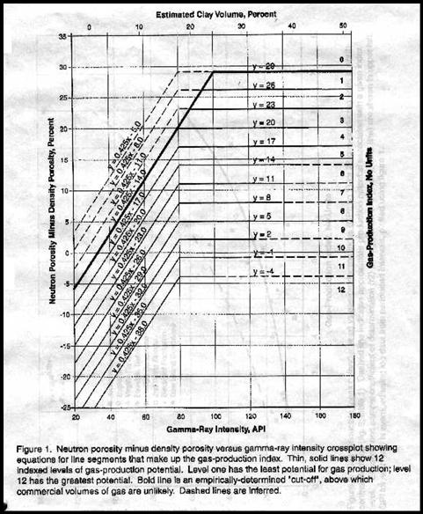
Figure 12: Hester’s reservoir quality indicator (Qual1)
This graph is converted to a numerical quality indicator (Qual1) in a complex series of equations that represent predicted flow rate. An Excel and Lotus 1-2-3 spreadsheet for solving this graph is available free from the downloads page on my website at www.spec2000.net .
Hester’s paper only looked at the average quality of a laminated reservoir and did not consider the thickness of a particular quality level. To overcome this, we can use a quality cutoff and obtain a thickness weighted quality and correlate this to actual production, similar to a net pay flag using porosity and saturation cutoffs:
1: IF Qual1 >= X
2: THEN PayFlagQ1 = “ON”
3: AND PayQ1 = PayQ1 + INCR
Where:
X = 4.0 or 5.0
PayQ1 = accumulated pay thickness based on Qual1>= X
A Hester quality of 4.0 or higher reflects reservoir rock that is worth perforating, and gives similar net reservoir thickness as the previous indicators. Graphs showing the correlation of actual production to net reservoir with Qual1 >=5 and >=4 are shown in Figures 13 and 14. The regression coefficients are 0.856 and 0.837 respectively. Although this looks pretty good, the low rate data is clustered very badly and other indicators work better in low rate wells. Some of these wells were not perforated optimally and the Qual1 pay flag is helpful for workover planning.
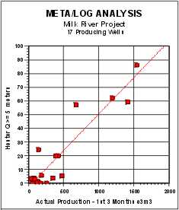  Figure 13: Hester Number (Q1 >=5) vs Actual Initial 90 Day Production | 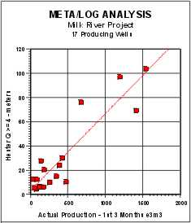  Figure 14: Hester Number (Q1 >=4) vs Actual Initial 90 Day Production

LAMINATED SAND EXAMPLE
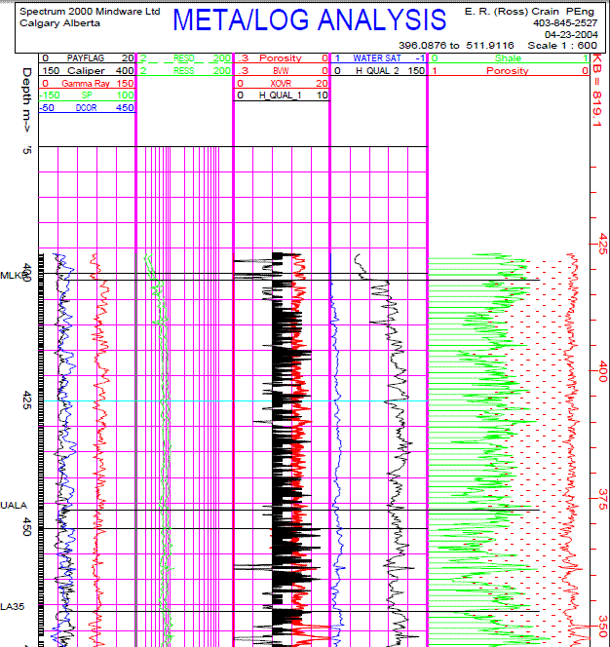
Figure 15: Depth plot showing Hester quality factor in Track 3, shaded black where Qual1 >= 4. Zones with Qual1 >= 5 are worth perforating in this area. Enhanced GR quality curve (labeled Qual_2 here) is shown in Track 4. Values of QualGR <= 100 show better quality rock. This is a good well, so nearly all the interval passes these cutoffs. The balance of the analysis is from a conventional shaly sand analysis. Porosity and gas bulk volume (red shading in Track 3) show the best intervals to perforate, but the actual values do not represent the reservoir properties.

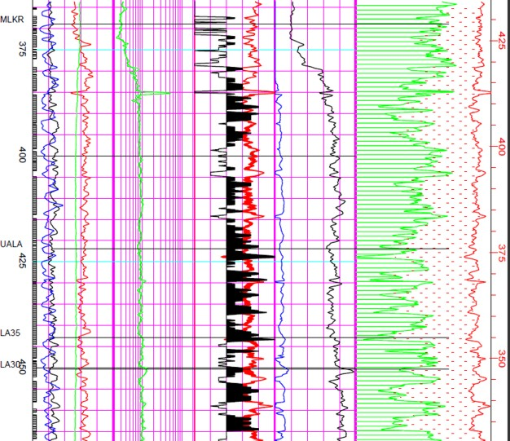
Figure 16: Laminated shaly sand example showing poorer quality interval with Qual1 less than 5 that are not worth perforating. Scales and header information are the same as the previous illustration.

