Facies, Environments, Diagenesis, Sequence tratigraphy, Stress and an Oil Migration Model for the Bakken Petroleum System of the Williston Basin
David W. Hume, PGeol. Canadian Discovery Ltd
Graham R. Davies, PhD, PGeol. Graham Davies Geological Consultants Ltd
Kaush Rakhit, MSc. PGeol. Canadian Discovery Ltd
E. Ross Crain, PEng. Spectrum 2000 Mindware
Presented by Dacid Hume and
Graham Davies at PBS-SEPM Luncheon Talk 21 Feb 2012

Resource Starfish
(Ophiura ophiura)

Source Rock Composition and Maturity
(In-situ, migration)

Geomechanical Properties (Natural Fractures, Fracability)

Hydrodynamics
(Overpressuring, Aquifers)




Stress
(Minimum Principal Stress Gradient)
Reservoir Characterization (Sequence Stratigraphy, Petrophysics)
From: Hillewaert, 2005

Outline/Key Points

• The five components of a successful resource play

• Reservoir and Facies
– 10 Facies, 21 subfacies
– Residual structure mapping and facies distribution
– Facies Interpretations and depositional models
– Porosity by facies depth ‐ dolomite implications

• Hydrogeology, migration modeling
– Source rock maturity from temperature data
– Force vector modeling of water and oil
– Hydrogeological play types

Outline/Key Points

• Petrophysical model
– Confirmation of hydrogeological model

• Preliminary stress analysis
– Minimum principal stress measurements from Fracs
– The effects of stress on drilling and production

• Conclusions

FACIES

Study Area

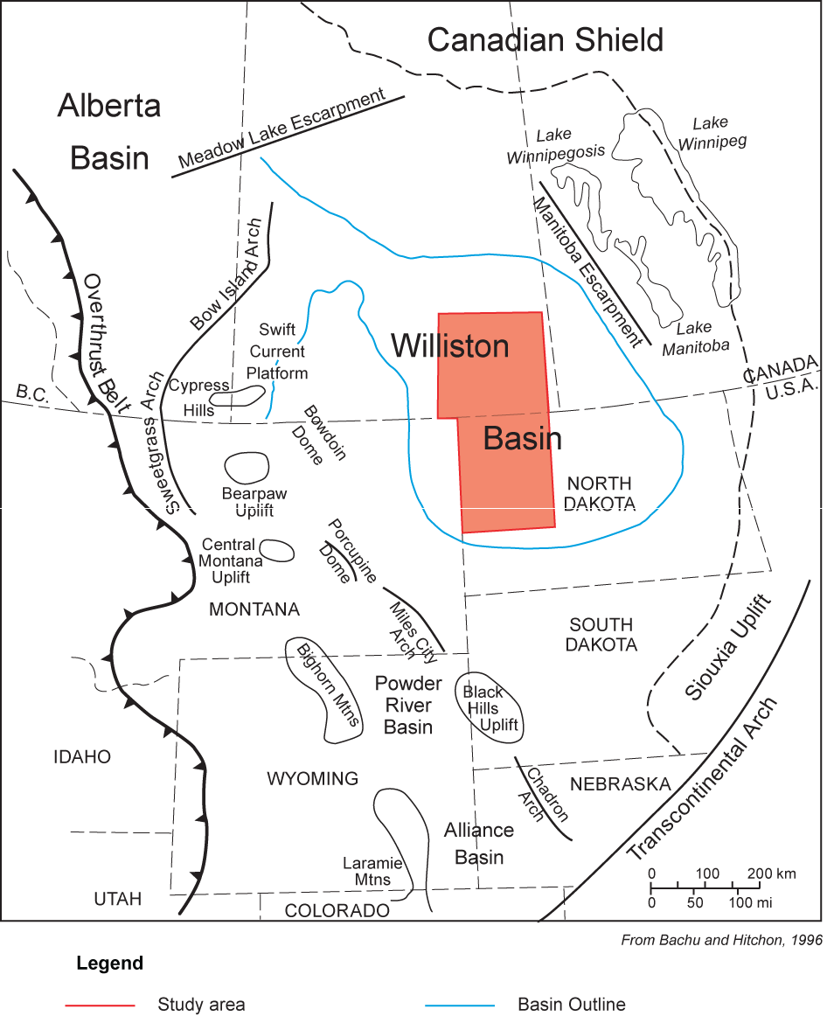
• 95 Cores
• 2916 Wells
• 151 Thin Sections
• 352 DST’s
• 30 SEM, TOC, XRD

Bakken Facies

10 Major Facies, 21 Subfacies
North Dakota

Max=

4m

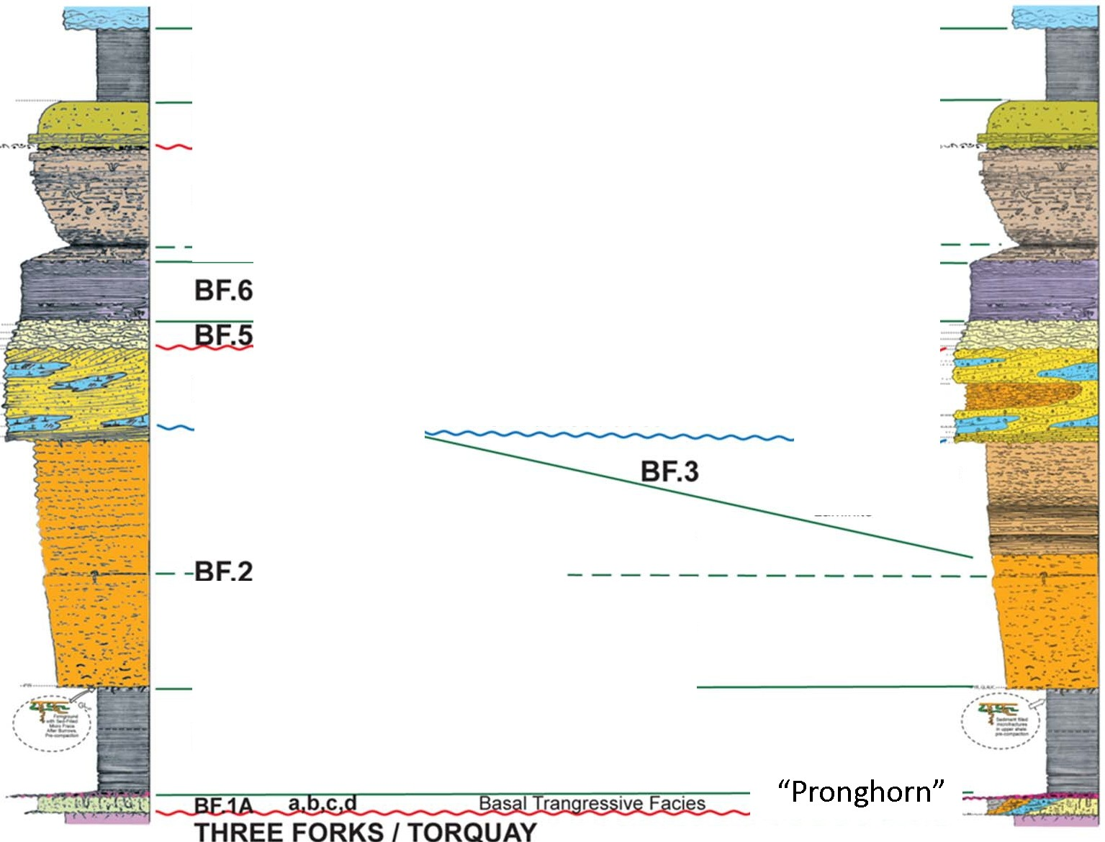
LODGEPOLE

BF.9 'Upper Shale'

Max=

5.5m

2m BF.8 Silty Dolomudstone w/Chondrites

4m Burrowed Argill. Dolosiltstone
1.5m

2.5m

BF.7 b
with Storm(?) Event Beds

4.2m

a, b Graded Dolosiltstone Laminite 2m

2m Ri led Dolosandst w/ 'Black S ecks'

1.6m

3.5m

BF.4

a,b,c,d,e
(NO)
Cross-Bedded Microbioclastic Sandy
Ooid Grainstone/Oolitic Sandstone,

4.5m

var Tidal Subfacies

13m

b Upper
------- Lower
Siltstone
a w/Nereites
Lower

c 'Fiaser' Dolosilts
b Rippled Dolosilts/Silt a Dolosiltstone/Sst
Laminite

5.2m

15m


9.5m

1.7m

BF.1B
c
b 'Lower Shale'
a

17m

9m

Bakken North Dakota:
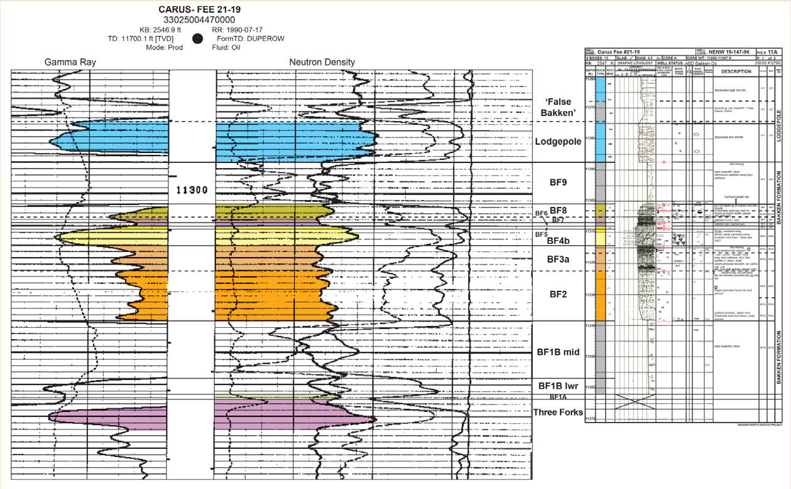
Log-Core Correlation

3rd Order Residual Structure
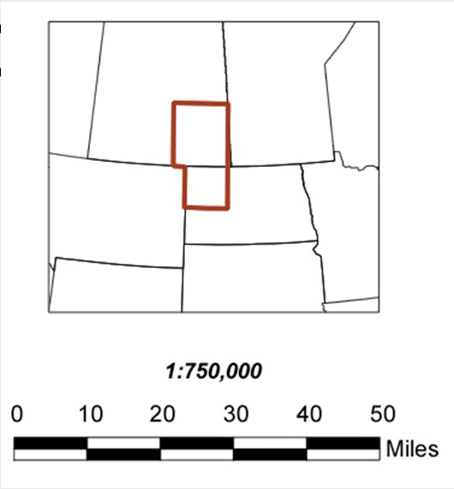
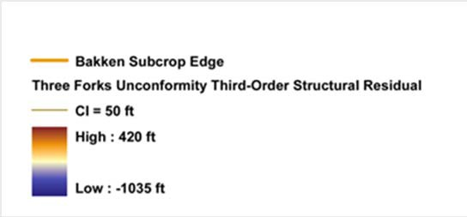
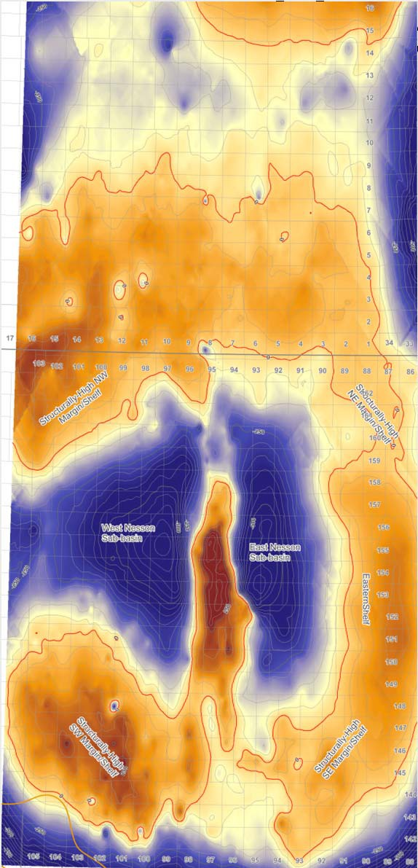
Map of Three Forks o
Unc
nformity

Basal Transgressive Facies of
Bakken – “Pronghorn Member”
Or Big Valley‐Margin Facies?? (But Unconf. On Torquay)
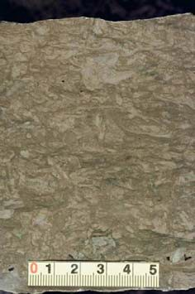
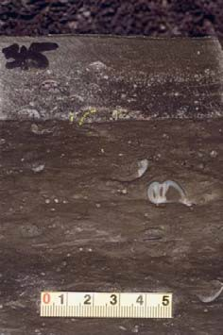
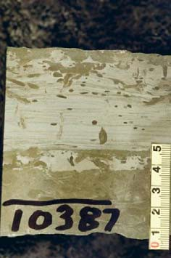
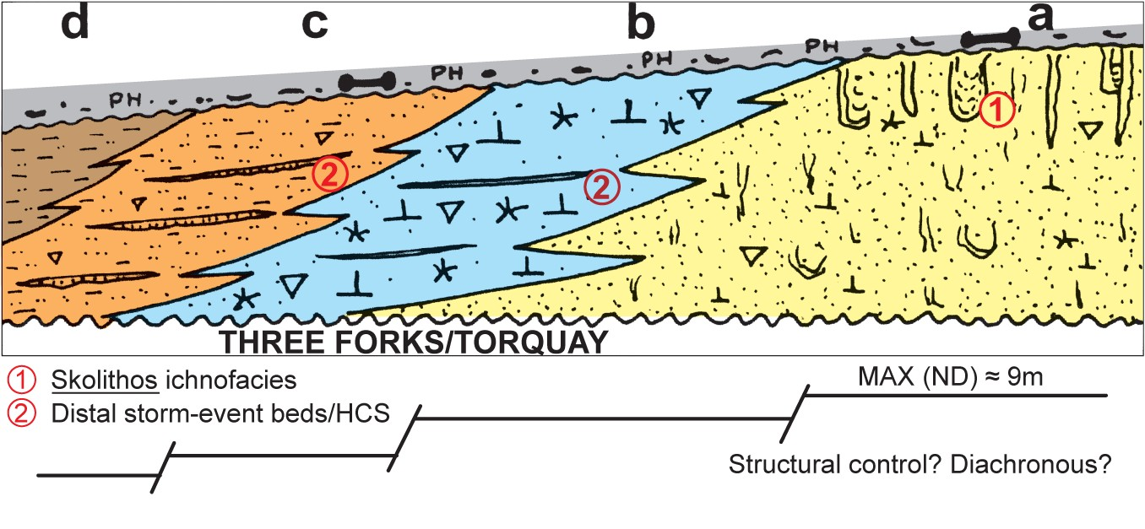
BF.1A: Subfacies a, b, c, d

Stratified Basin Model for
Bakken Black “Shales”
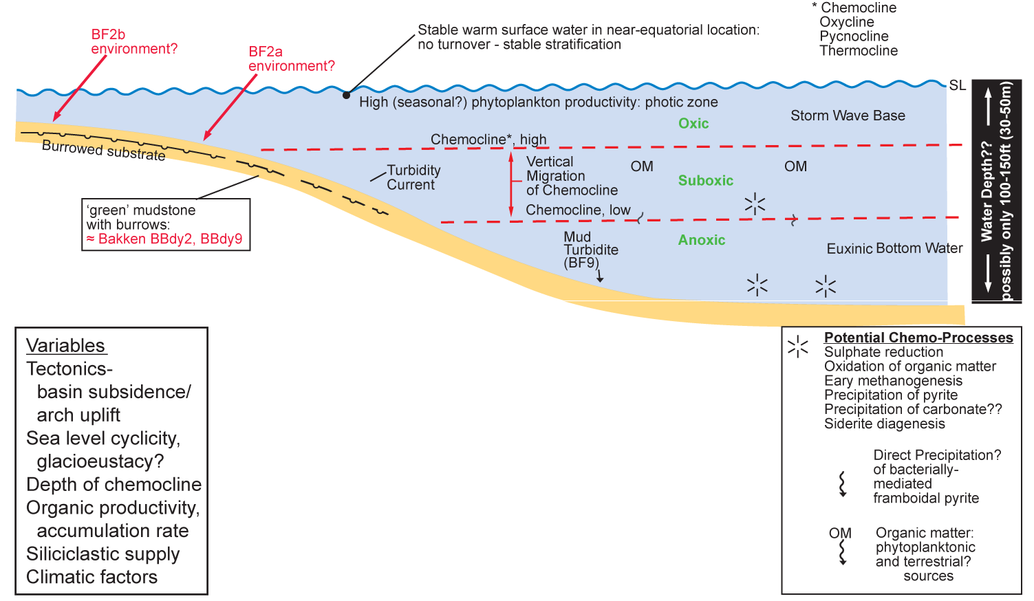

Oxidization of organic matter-high alkalinity, high pH: favorable
to precip’n of fine cryst. dolomite?
= Bakken BF.8, other.

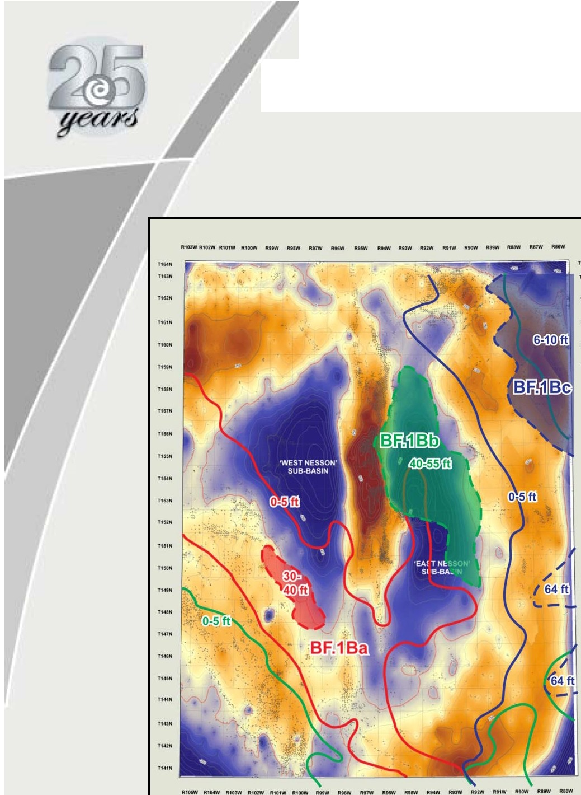
Bakken BF.1B "Lower Shale"

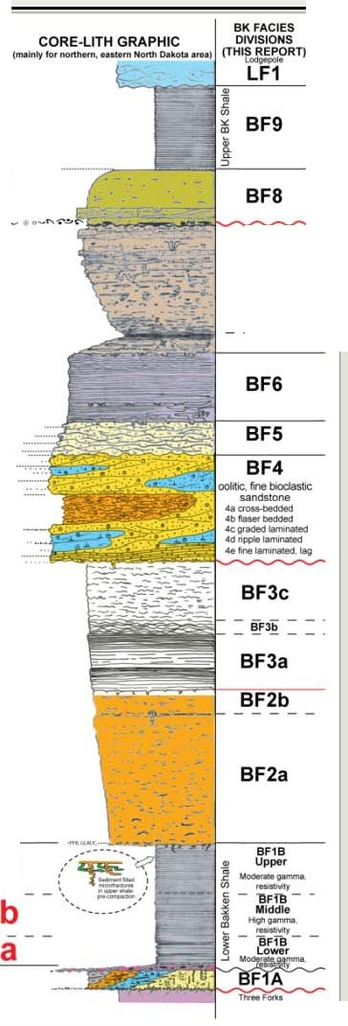



Bakb nPenetrations
Thf'HFOI"ks Unconformity Structure
Thlrd.Otder RHidua1

-- Cl= 50ft
High :637ft

Low :-745ft

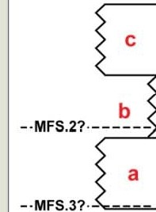

------·---

a, c: lower TOC, higher QTz, feldspar, lower
total clays
pyrite, intermed gamma, resistivity

b:higher TOC, =::s
lower QTz,
feldspar, higher total clays pyrite, high gamma, resistivity

BF7

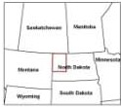
c
BF1B

TF1

Bakken BF.2 “Lower Siltstone”
Selected Trends and Calcite Cement (N. Dakota)
(on Third‐Order Residual Structure)
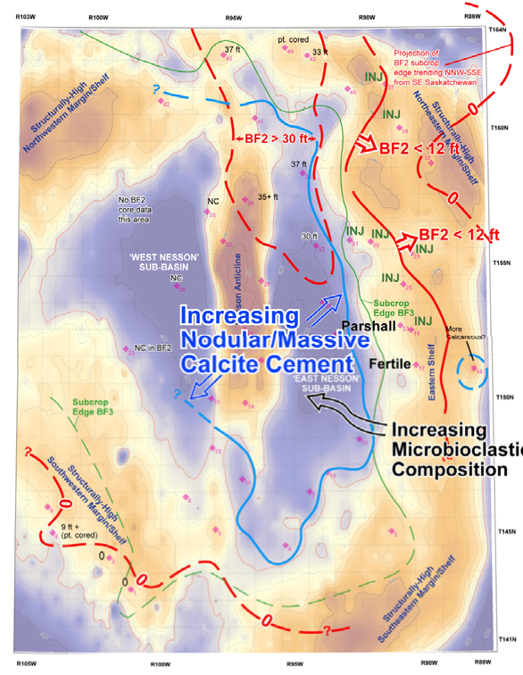
• Thins/pinches out onto
‘Eastern Shelf ’
• Thickest in Northern
“East Nesson” Subbasin
• Increased microbioclastic content (or preservation?) into
‘East Nesson’ Subbasin, off eastern shelf

= Increased nodular/massive calcite cement (core data only)

= Reduced poroperm

INJ: Sediment‐infilled injection
structures in BF 1B

Bakken Siltstone (BF 2/3)
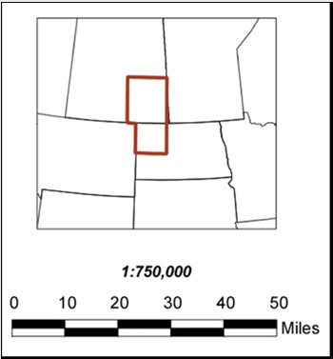
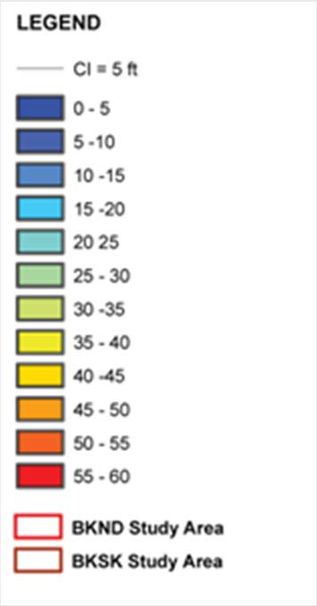
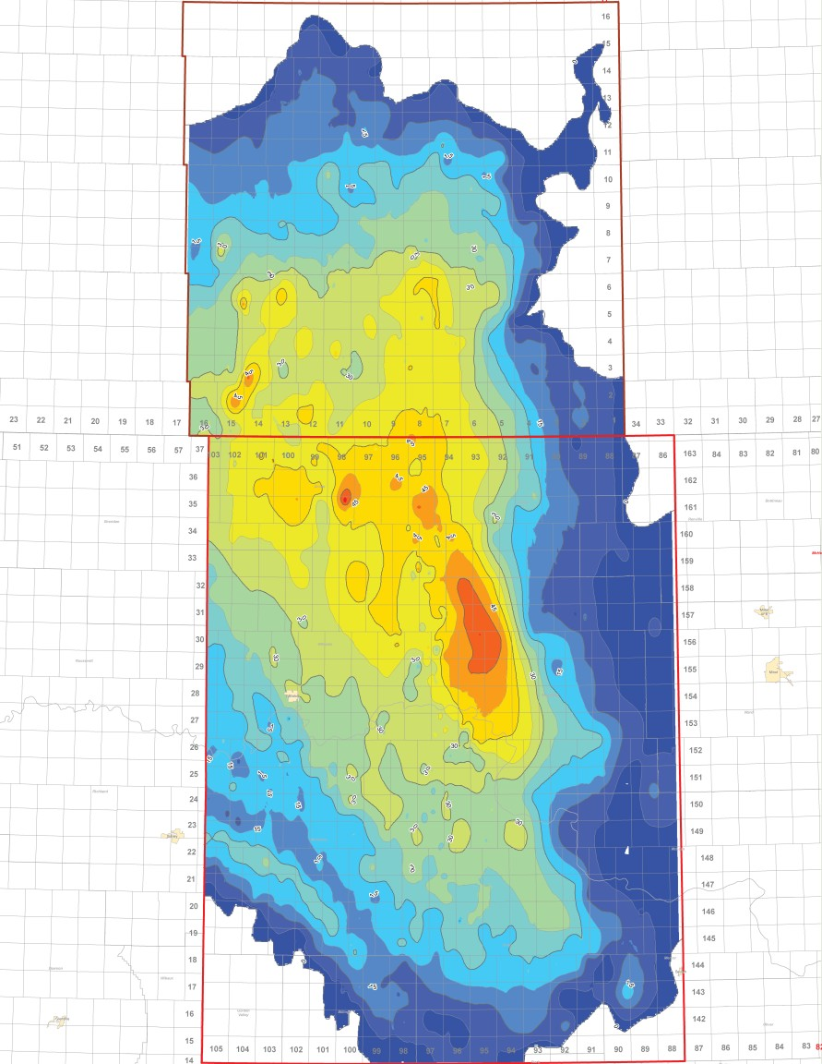
Isopach

Bakken Facies 3:
Laminite to Rippled Silt/Sand -
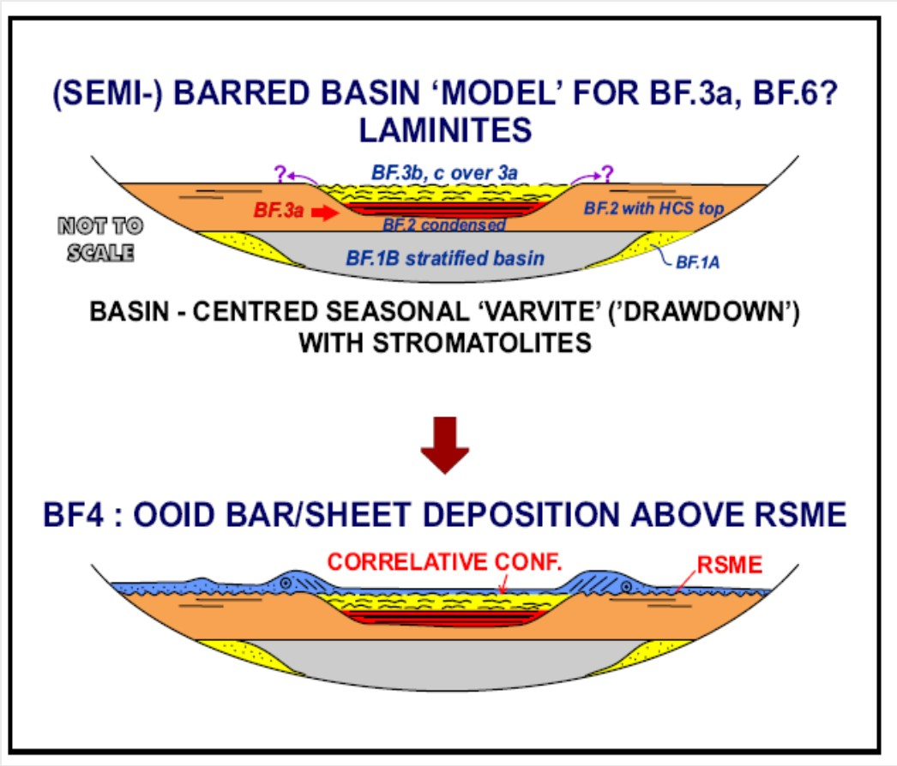
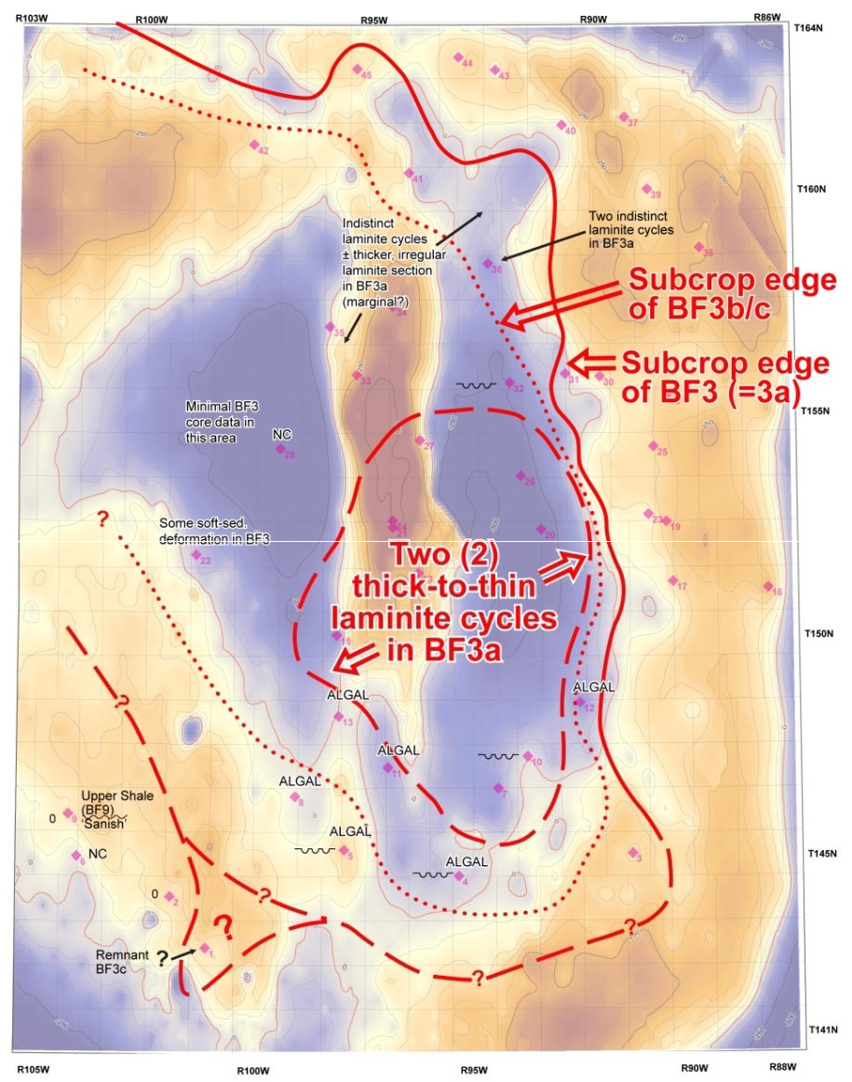
Distribution & Subfacies Trends

Event Bed Depostion, Bakken
Facies 7,8

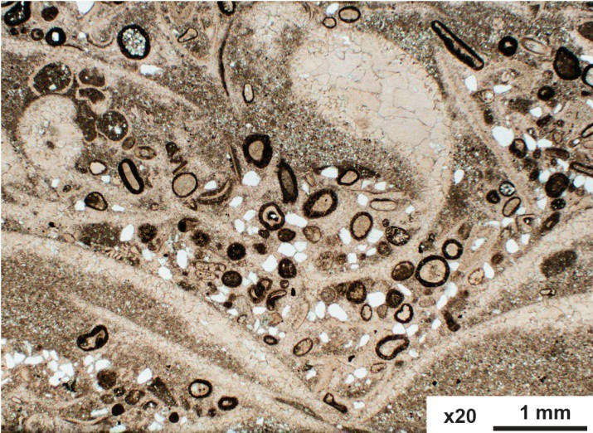
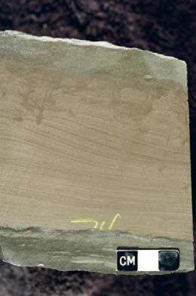

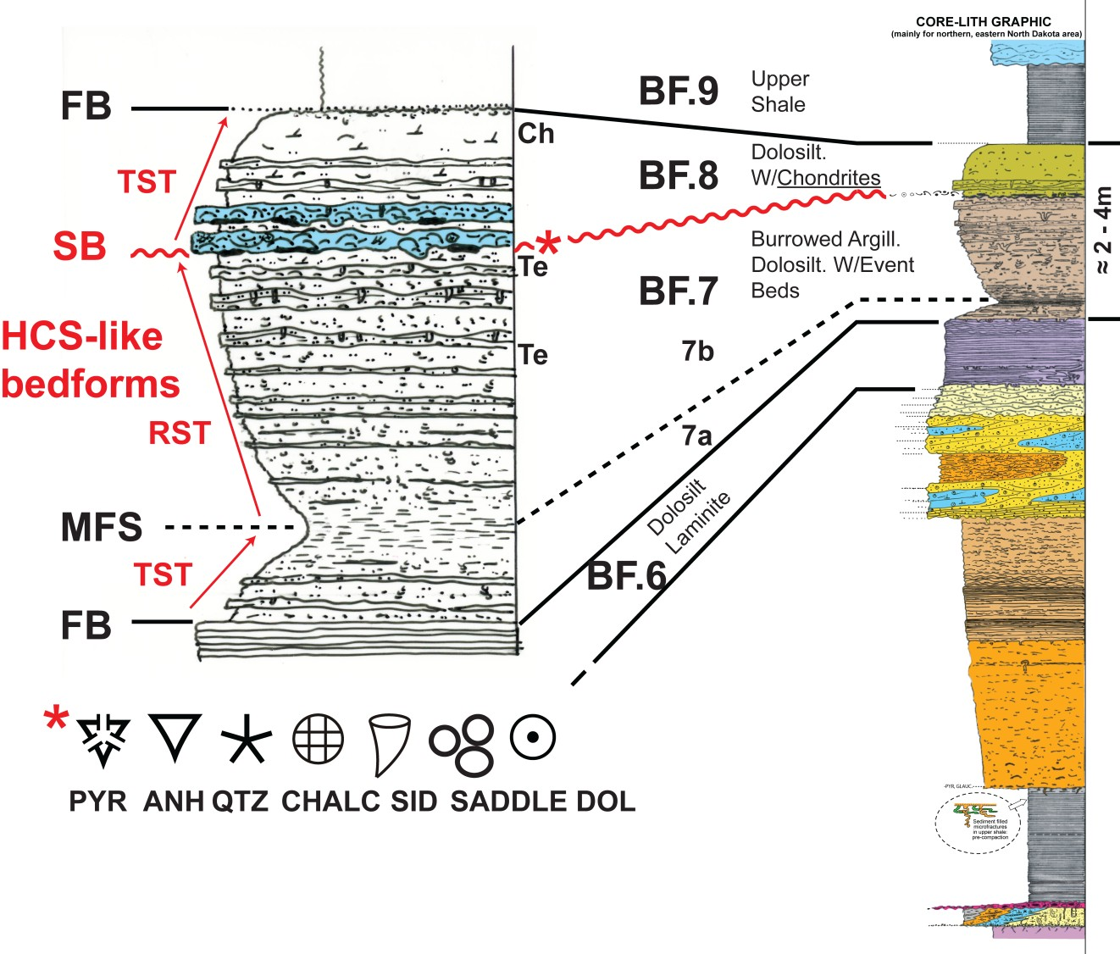

Violet Olsen, 9,974.5 ft

BF 7, Base 8:
Depositional Trends of
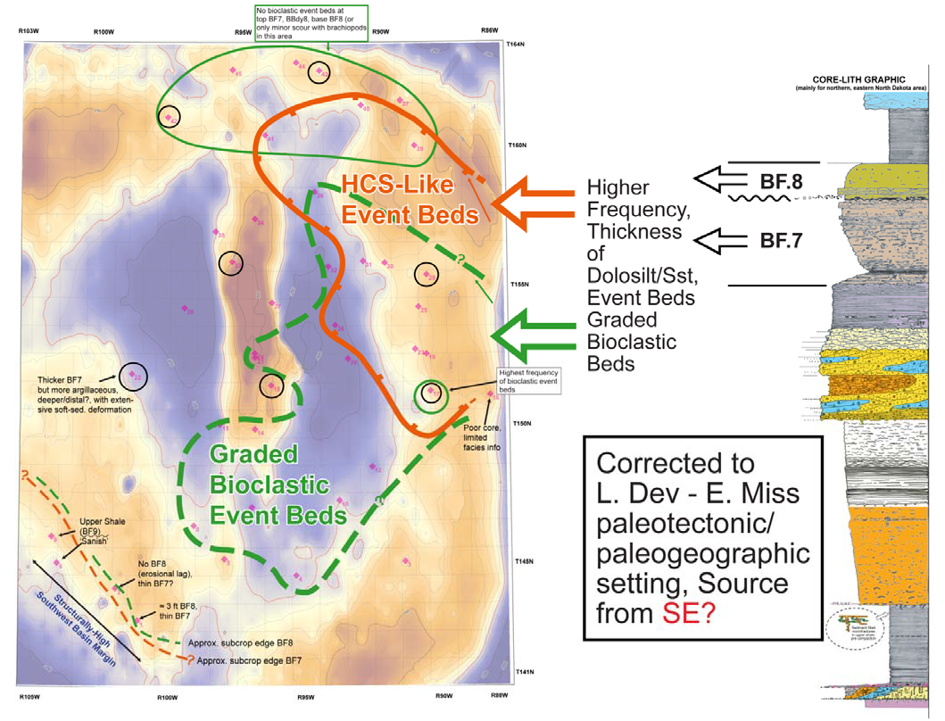
Storm? Event Beds

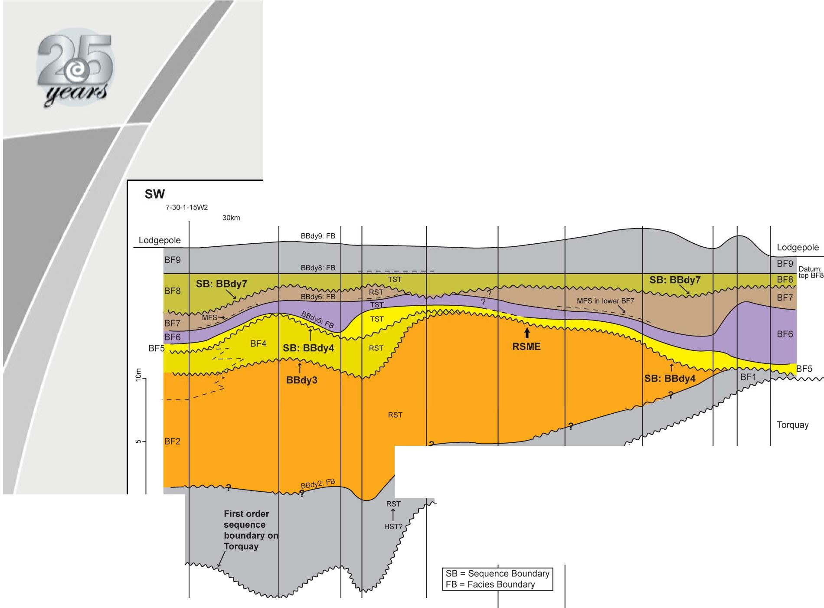
Internal Bakken
Unconformities

14-25-3-11W2

1-3-10-2W2
ENE

8-20-4-14W2
5-7-5-12W2
1-2-7-11W2
4-29-7-8W2 13-21-9-7W2
12-5-11-5W2
5-21-11-3W2 16-10-10-1W2

17km 23km
31km 24km 22km 23km 22km
19km 10km

BF1
/ .......-..-.' ,1
_,/ .- ] r ,---'-------'- -,,_._,'-_,-s,,.,,i_,,_-:"'-E-N--,E
_, / ST
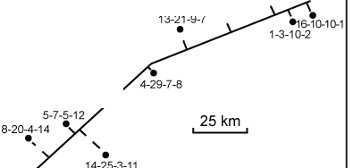
,../V'VV""-"-"-'Iv'""' "- 'V" 'V' _J' e\ •
1-2.-7-11

Torquay s
.
7-30-1 -1 5

Line of Section

Linear Distance ::: 160 km

RESERVOIR

Bakken Composition: BF.2
Siltstone

• Very high dolomite comp
Ave. by Point Count % *
(Excluding burrows)
Quartz | 43
Feldspar | 7
Musc. Mica | 1
Heavies | 1
Clay/Mx | 0
Dolomite (Detr/Auth) | 46
Pyrite | 2
Macro‐Porosity | 28
n=4
* Contrex Consulting

• Very early diagenetic
emplacement (pre‐comp.) of auth. dolomite
• Some on detrital dolo. nuclei
(= Montney)
• Some ≈ syndepositional – reworked into event beds
• Density, Pe impact
• Reduced compaction??
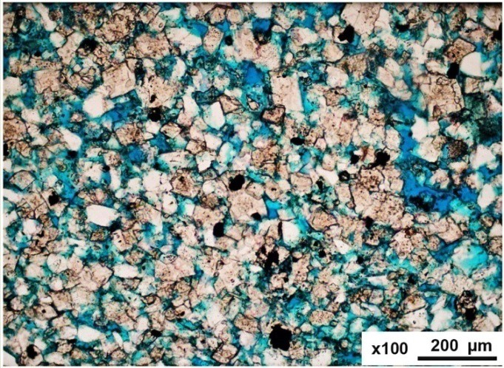

1‐2‐7‐11W2
1,711.1m

BF.2
Bakken:
Porosity-Perm by Facies: 1
BF.3

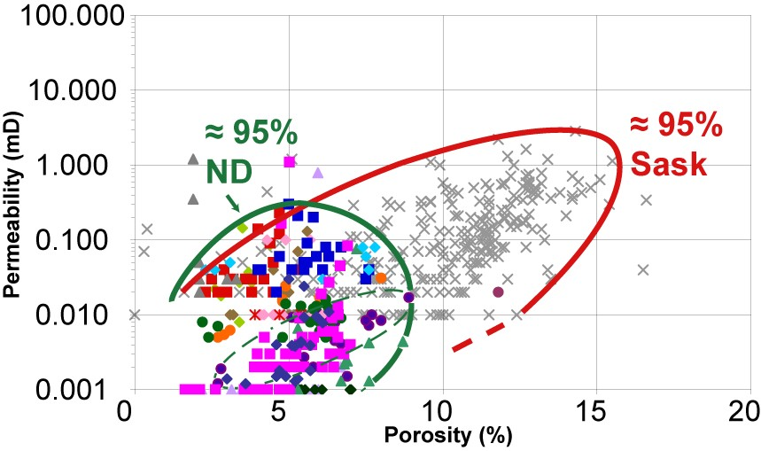

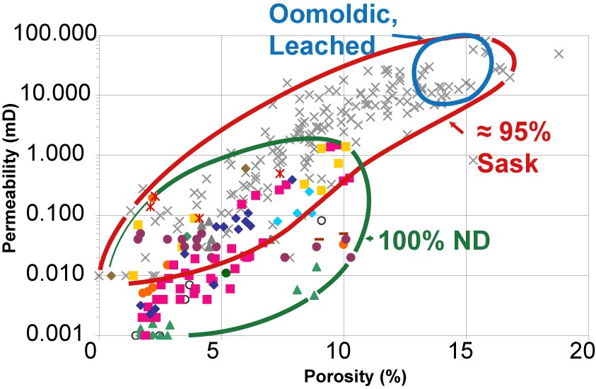
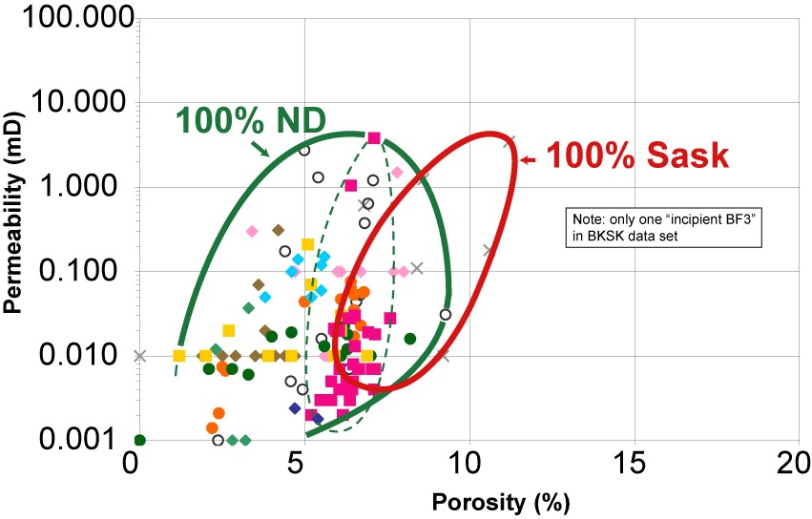
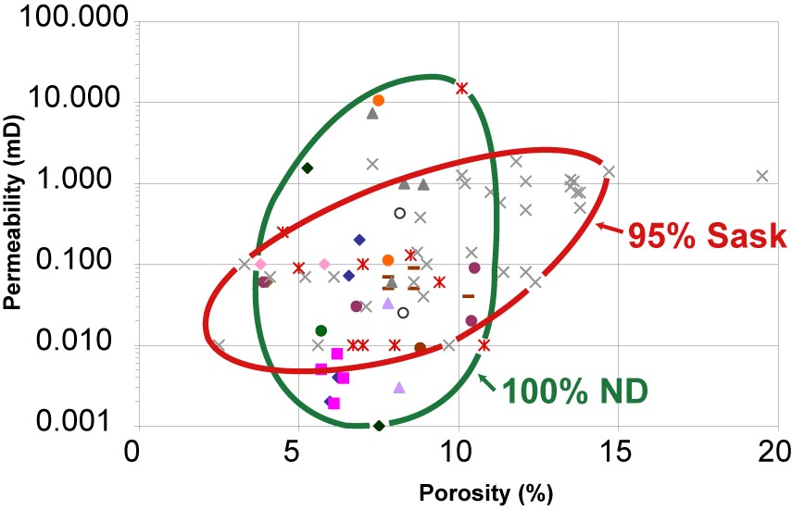
BF.4 BF.5

Bakken:
Porosity-Perm by Facies: 2

BF.6
BF.7

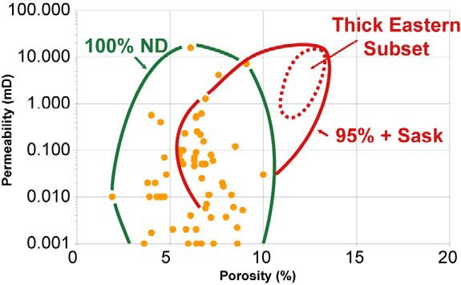

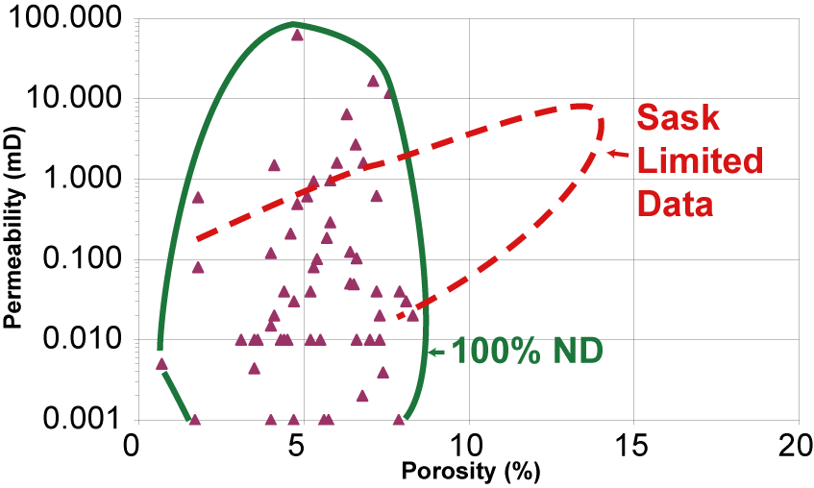
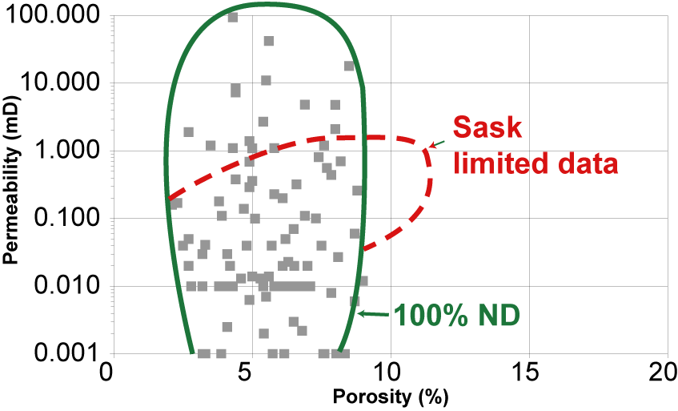
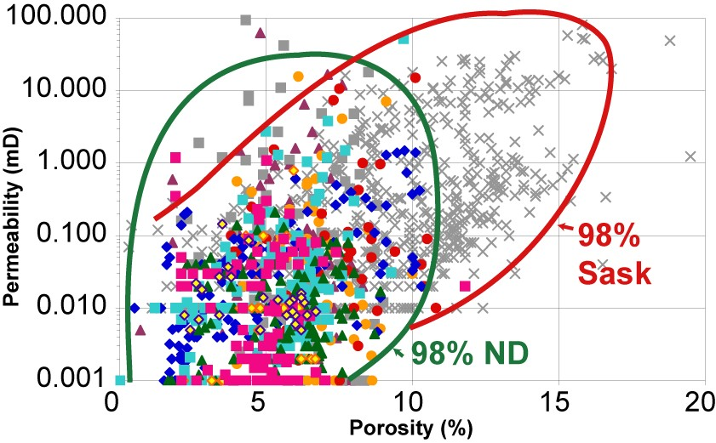
BF.8 All Facies

Bakken • Porosity vs Depth,
•

1000 -------------------------------.
DOLOMITIC SILTSTONES
BF.2b
FOR DESCRIBED CORE WITH ANALYSED BF.2b (n > 3)

E
-

c w
1-
(.)
2000
0::
0
(.)
z
-
::)

J:

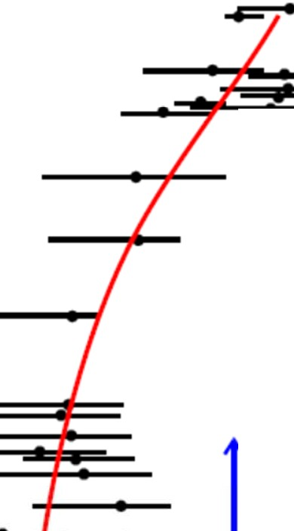
lS.E. SASK
IN.DAKOTA
AVERAGE • RANGE--

BK TREND vs WCSB PORO-DEPTH

0

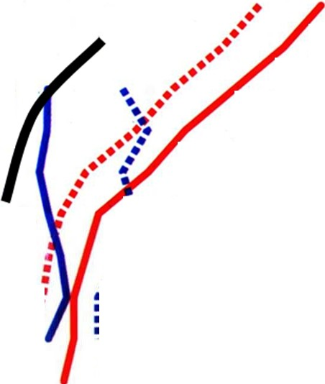
..·.
••••
••
2 •
•

1-
0w..
c

3000

- -+......-*
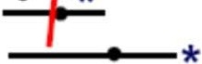
= *- *

INCLUDES THINNER
'CONDENSED' BF2a/b
var. more
microbioclastic, calc.
•
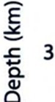
••
••
•
•
•••
•
4 •
• •
•
• •
....
••
••
..•••••
...
••••••
••••
• •

•
•

* NODULAR TO MASSIVE CALCITE CEMENT
5 • •• ••
•
• •
- Sandstones
- Carbonates

0 5 10 15
CORE POROSITY %

20 0 10 20 30 40
Porosity (%)
from Ehrenberg & Nadeau, 2005

HYDROGEOLOGY AND

MIGRATION MODELING

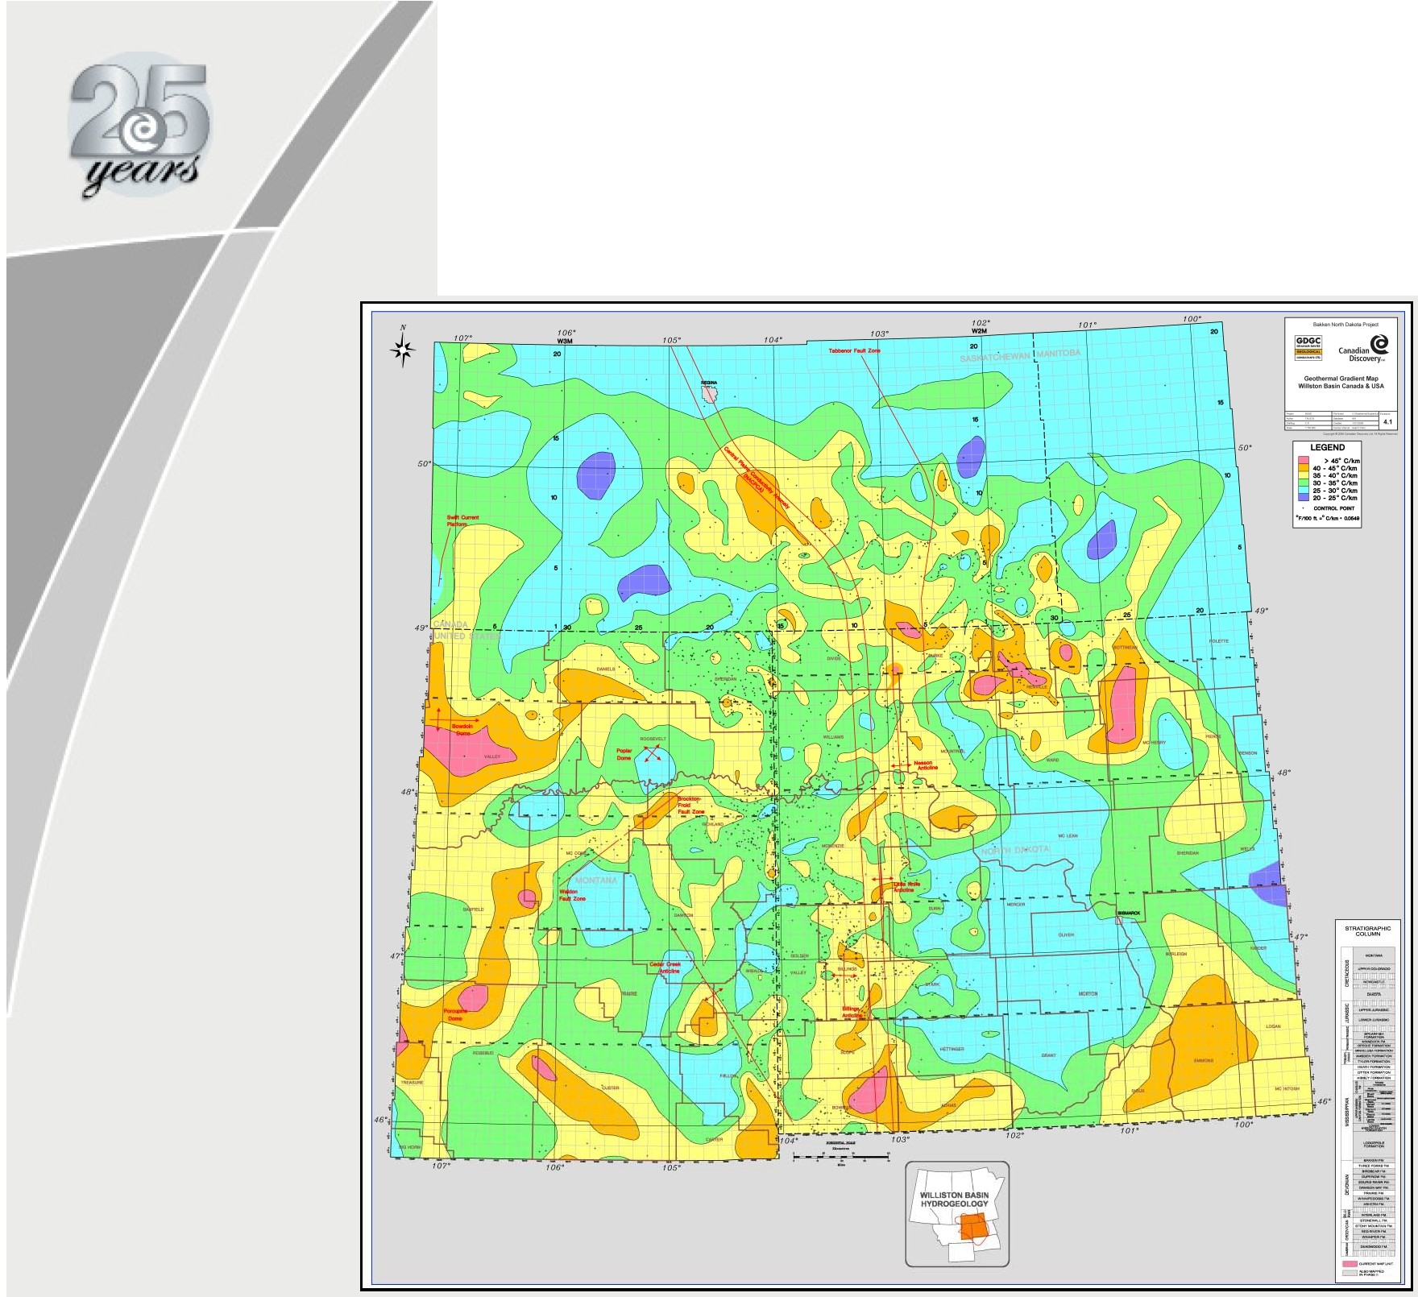
Geothermal Gradient Map

Mature Source Rock Map

_ _..
. __.._·_-

... -..,·_

" ---
·=· -===...

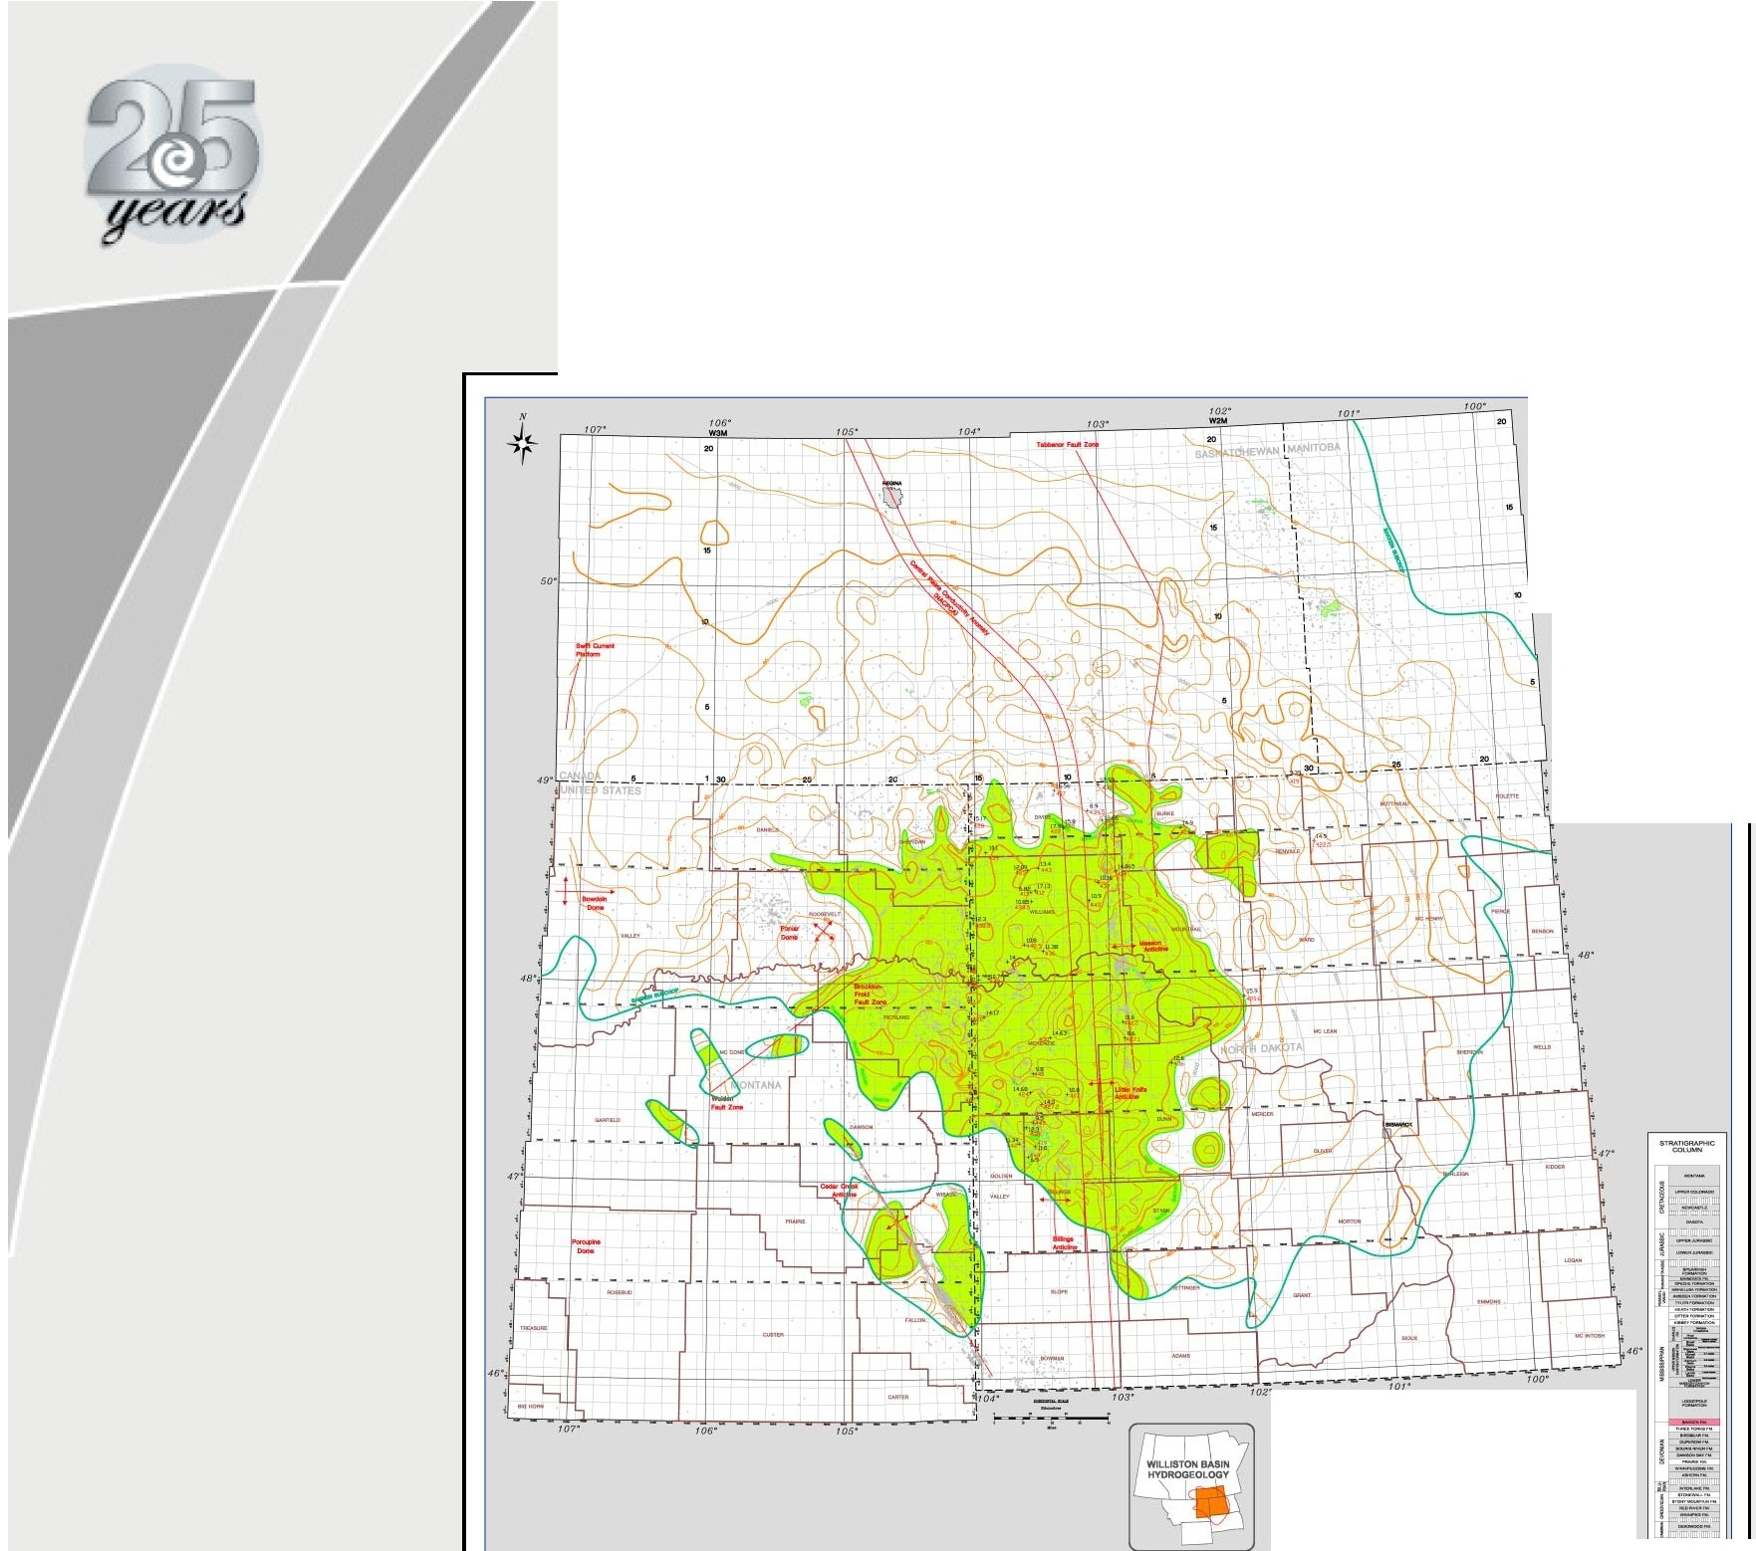
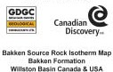
1 -k·--.;--1
e - =- :::w

-==---:--


Fresh Water Head Map

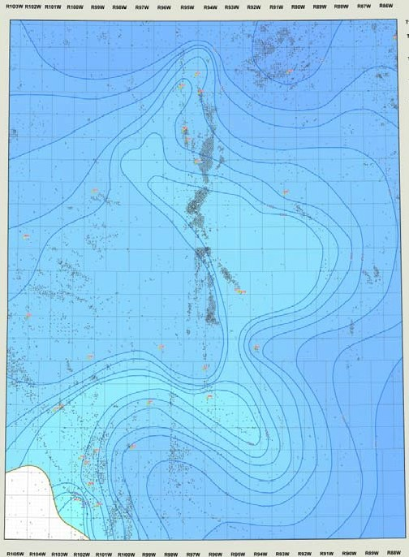
-
m
-

--____....
-

------·----

Bakken Salinity Map

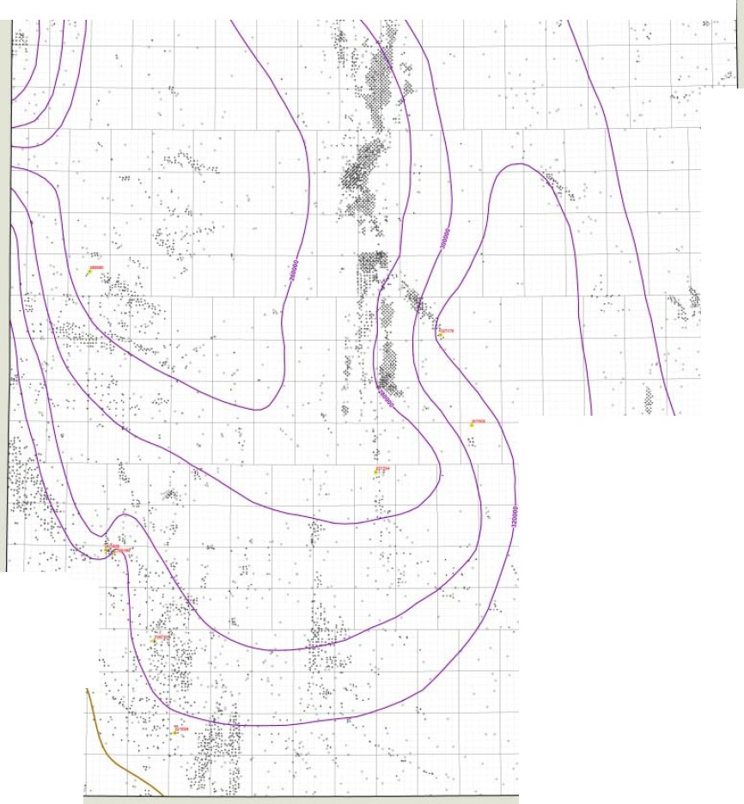
"""

11:103W R102W Rl01W R100W RttW RMW Rt7W RMW Rt5W W RtJW RtZW Rt1W RtOW R8tW RNW Rt7W RIIW

Tli)H
1 I 1

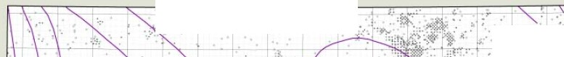
I?

y
"""
I- \

T11 1H "<
,;Tt..,N
- L

1:75(),000

mtH

n""

TUSH

"''" "'"'

"""

TI48N
,,.,.

T147N

"-

.....

.r-

"''"
0 10 20 30 40 50
Miles

T1411H :·
·'
c_
"""
'"'"
"""

Tl4:)H

T14ZH

IU05W Rt04W R103W RtOZW R101W RIOOW RftW Rt1W RIJW RttW RtSW RS4W RtlW RIZW RttW RIOW RIIW RIIW

Three Forks Structure Map

R103W R102W R101W RtOOW RNW RISW RNW RtlW RIM Rt1W RtOW Rttw R&IW RI1W RMW 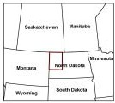

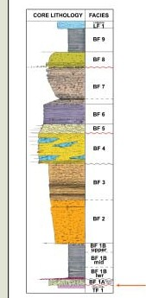
- -----""'

"""

_._ , _

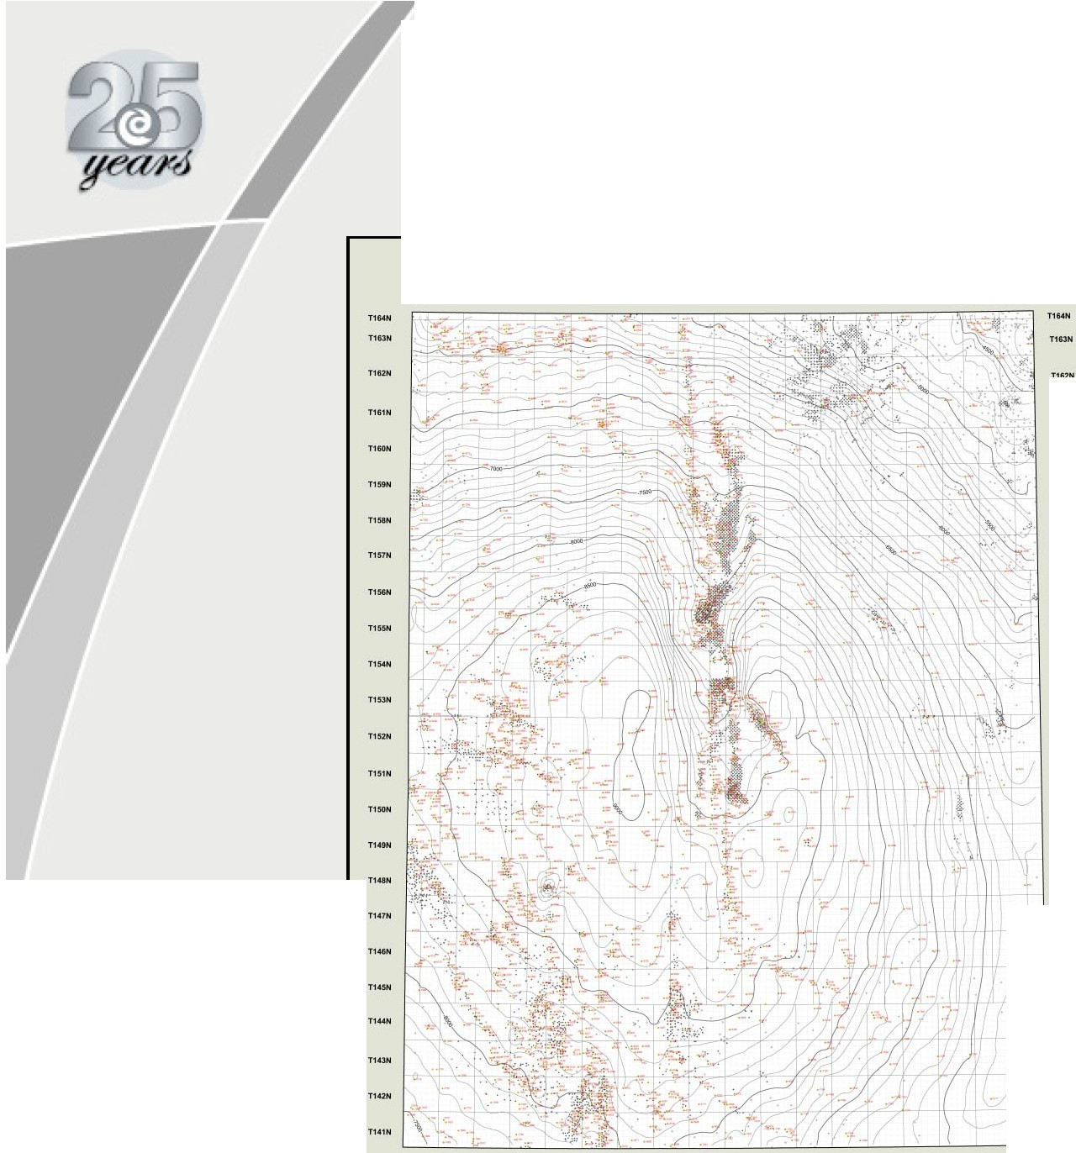


/

R104W fi:10:SW Rt$W RNW RtlW RUW Rt1W RtOW RnW R88W
@
Canadian
Discovery...

Three ForbUnconformity
Structure Map

..----- -- 5.3

Water Impelling Force Vector
Calculation

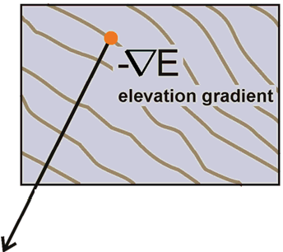
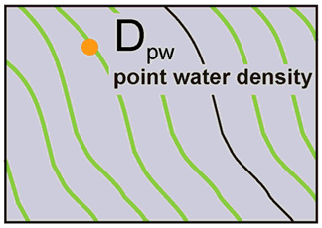
FRESHWATER HEAD MAP WATER DENSITY MAP STRUCTURE CONTOUR MAP (BASE OF RESERVOIR)

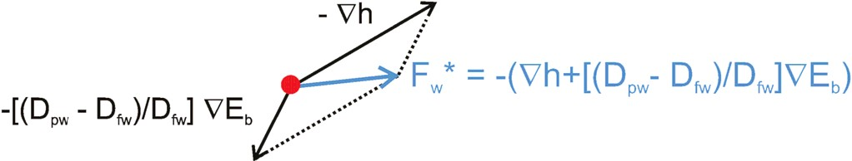
Dpw = point water density Dtw = freshwater density h = freshwater head
V = gradient operator
Eb = elevation of confining surface
• = grid node

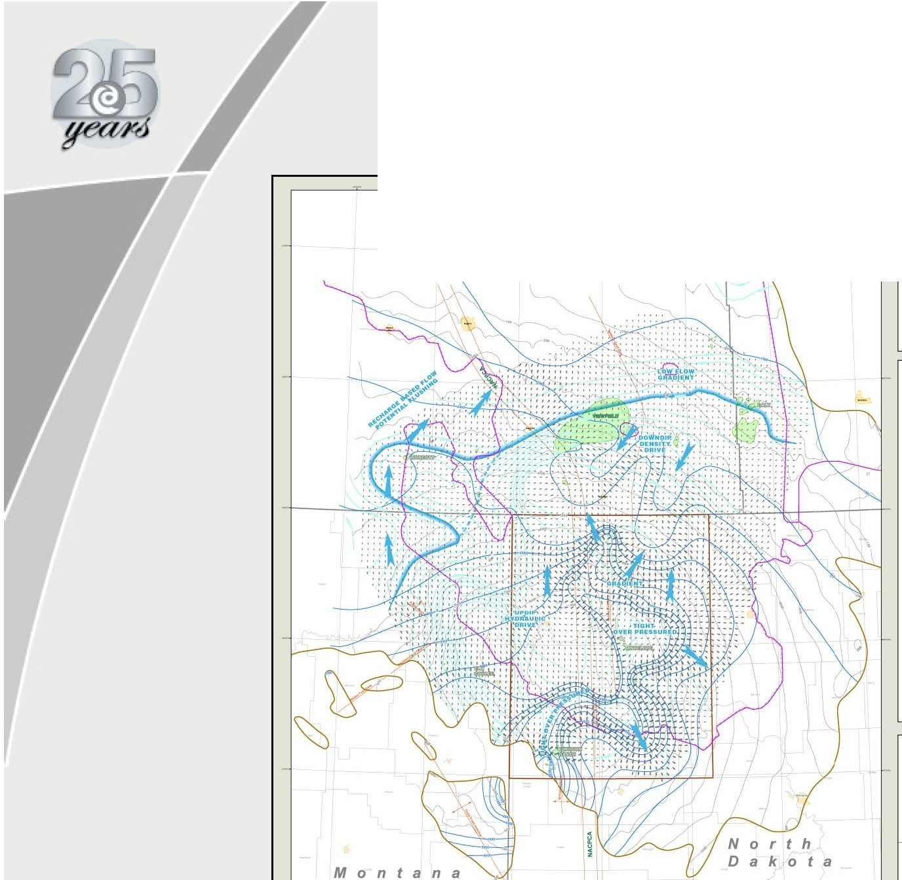
Water Migration Map

Saskatchewan -

Man

t o b a


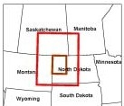
,,.,,.,(1(10
0 10 20 JO <10 50
Milft

·
o---­-·"--
t·-·-..
- - IC • fl,l
-....... ......-
o---

Ehlkken NorthO.kotlProjen

@
Canadian
Discovery..

Dynamic Water Migration Model

s 0 u t h Dakota 4.4

Oil Migration Map

Saskatchewan - Man 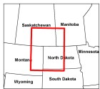

0...... 10 20 30 40 50
--. ".",_­

-_-_ 0-. - _
---- IC.''""I ...
-
==::.:.::
o--­
=:=.'=.."'::=..--
o--·

@
Canadian
Discovery••

Dynamic OilMigration Model

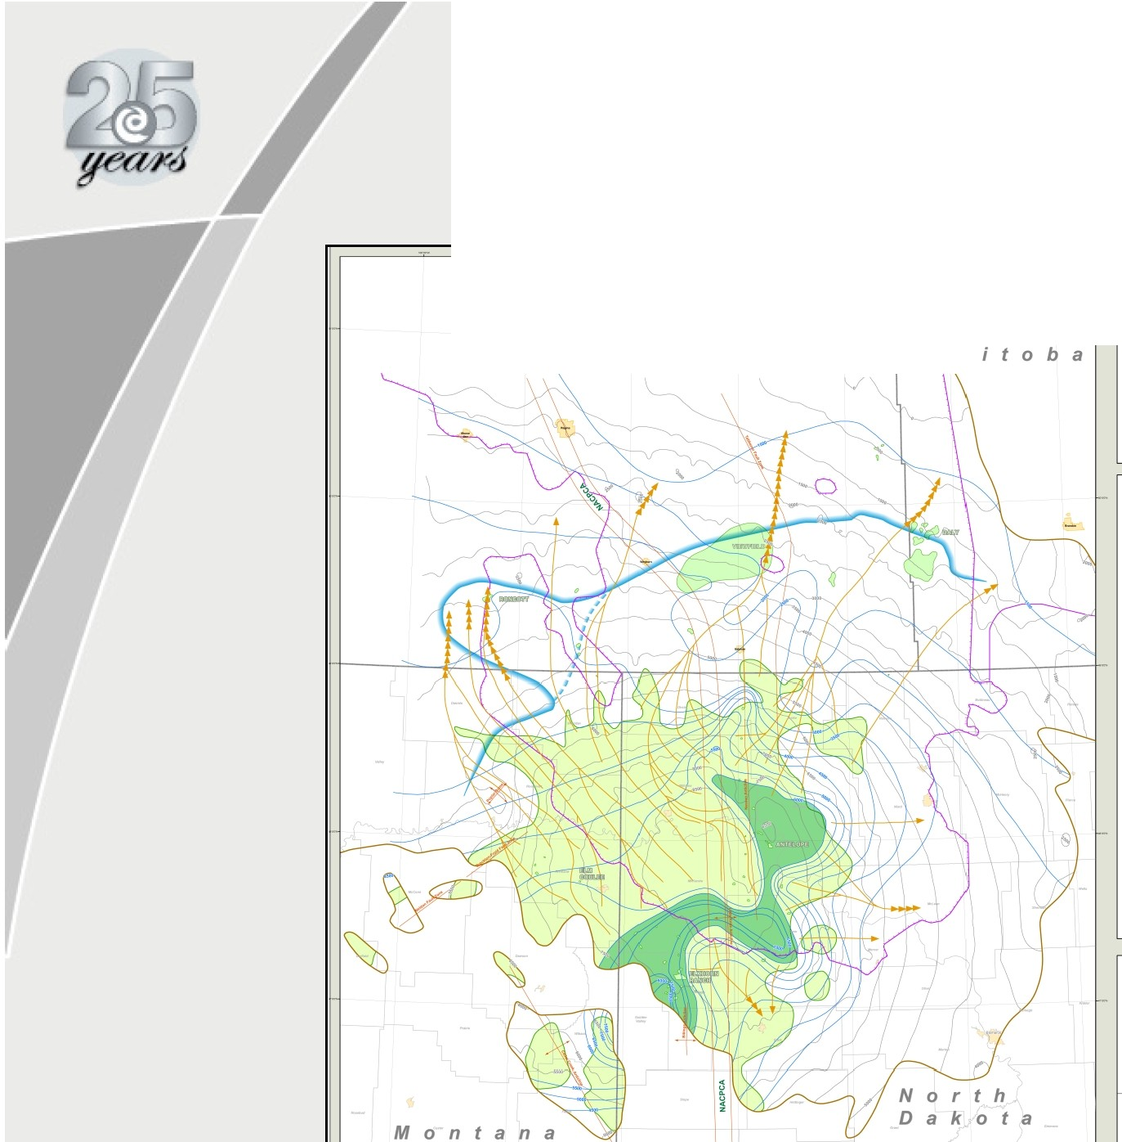

South
Dakota

Bakken Play Types

107" 106° 104°
1oo•

t
N
+ 50°

so· 0 60 km
I I
0 40 mi
I

+Flow
49° - Charge Potential
- h = 3,400 ft
+- - Bakken Subcrop
e Mature Source Rock
48°
•
48° Oil Pool

47°

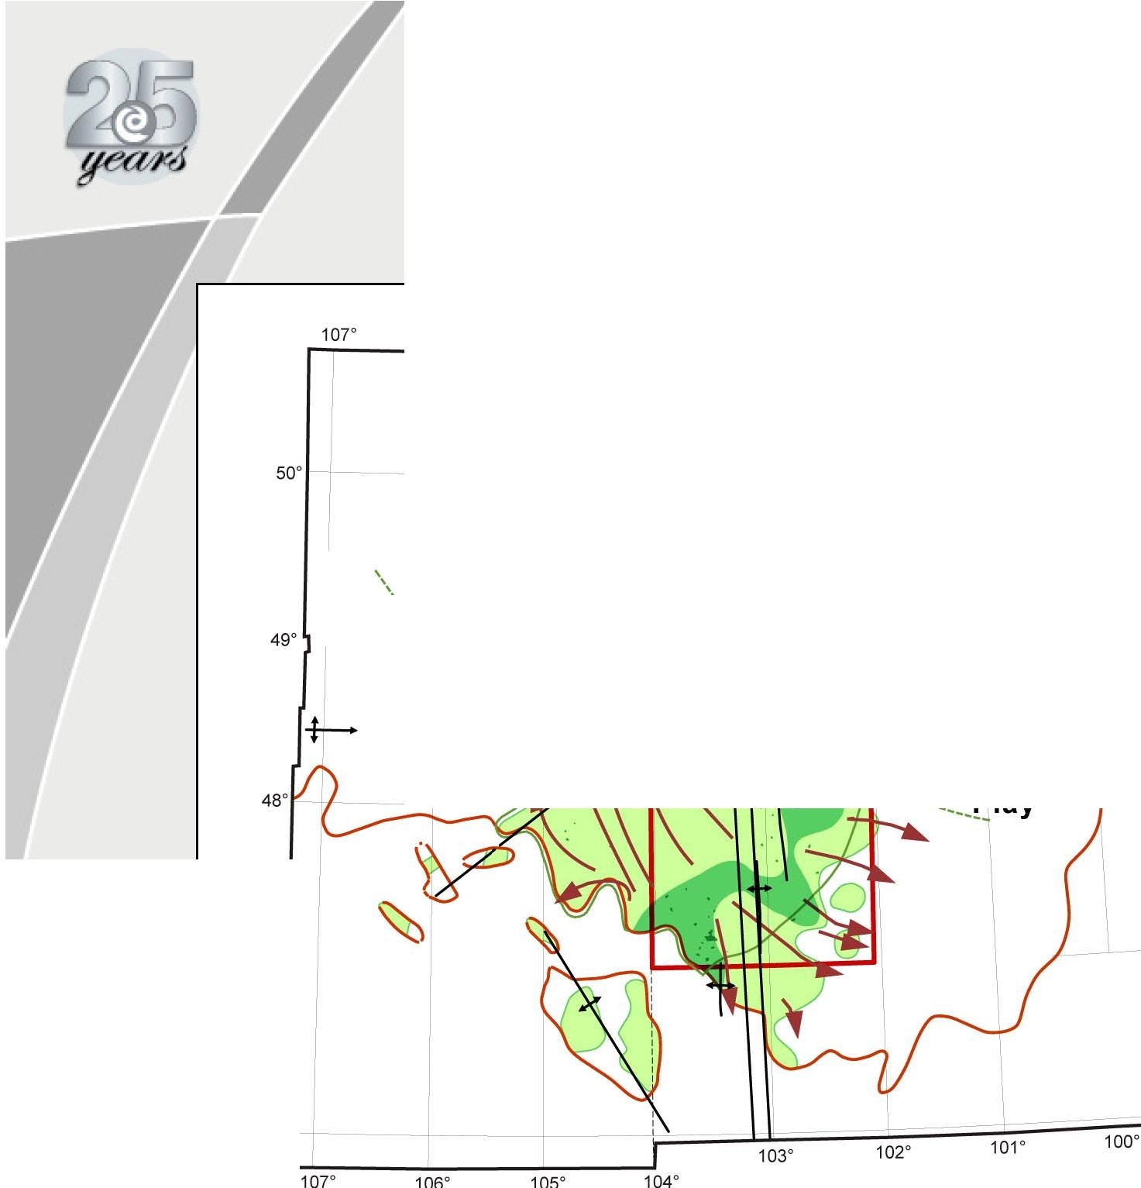
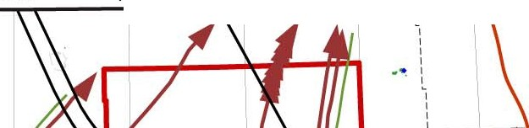
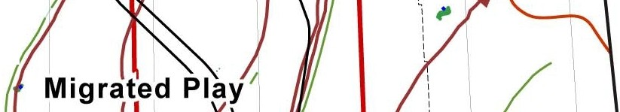
46°
46°

PETROPHYSICS

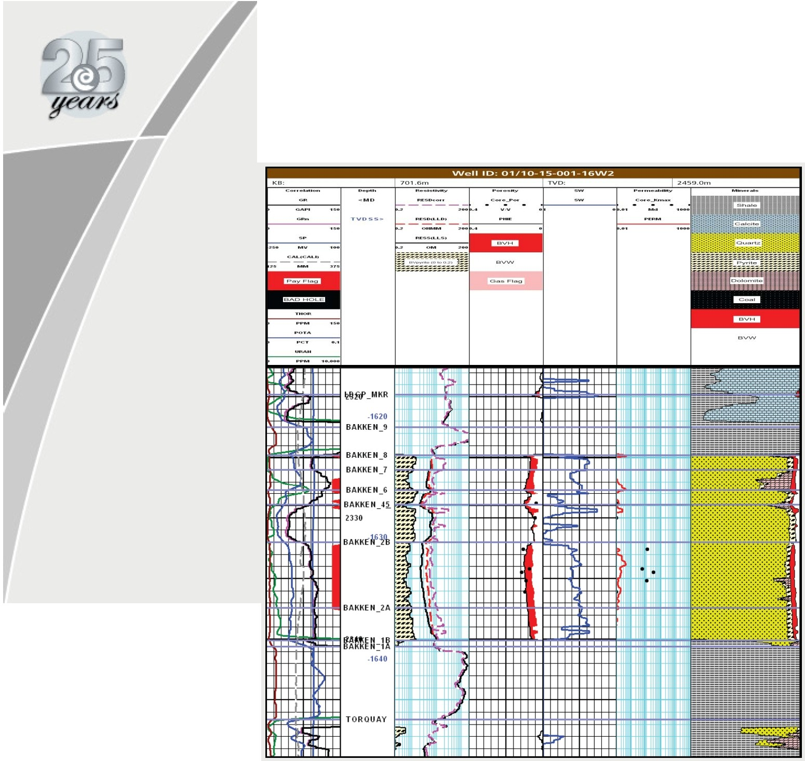
Petrophysical Answer Log

SW Map Bakken Sandstone

(BF4/5) Facies
m

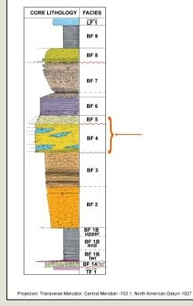
fUI»W R102W RIOIW R1GOW RttW AMW Rt1W RMW RMW A"'W Rt)W Rt2W Rt1W Rt0W Rltw ANW AI7W RMW
..... -

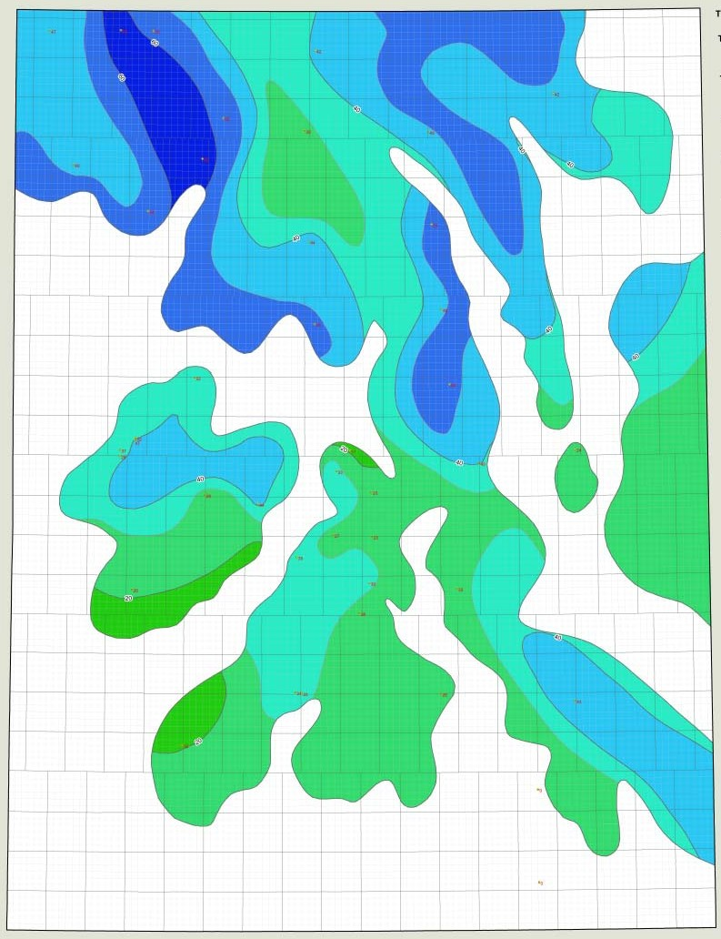
.....
0 10 20-
:--::
==

Bakken Facies 415
Average Water Saturation Map
(Porosity >•6%)



RIOSW AICHW AI03W R102W A101W AIOOW RHW RHW Rt7W RHW RMW RMW Rt3W Rt2W RtiW Rt0W AHW RIIW

.,
-.12

PRELIMINARY STRESS ANALYSIS

Frac Pressure Curve

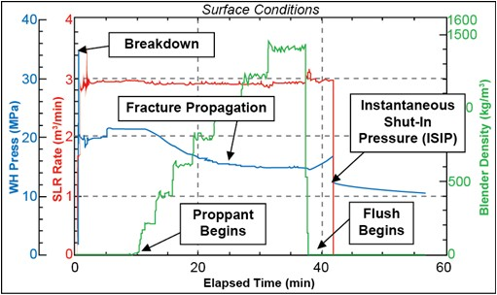

• Minimum Principal Stress can be derived from ISIP
• Fracture closure pressure is a fraction of the ISIP
• Variable but usually 0.8‐0.9 of ISIP
• Fracture closure pressure is equivalent to the Minimum
Principal Stress

www.fracdatabase. com

WELL COMPLETIONS &
FRAC DATABASE

Client Login

NOT YET A CLIENT? Contact our Sales Team (403) 269-3644
info@canadiandiscoverv.com
The Well Completions & Frac Database,brought to you by Canadian Discovery Ltd.and engineering partner lntrospec Energy GroupInc.,provides industry with a trac and completions data set that is:

Searchable - predefined and custom queries Reliable - engineering QAIQC,source documents Comprehensive - resource plays across Western Canada Analysis Ready - reports,lists,graphs,exportable

---
---·
-- --


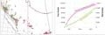
-- (:::!:§! Download Br:>chure (l.6llB PDF)

·Support-ed bto'o\-sers: lot.met ExpJor7 &8. Firefox 3.8 and hig.and Safari 50. and Ng: .

E&P Cofi'C.*\Y
tOMw.tl FIIH)
Pt'ftO E.tpiOI.I\101\
$-an Otlto tncll U¥ot" II
(m-1 (M rn/dd Yml Roport
e112120® •oA)01200920

lndlvldul Stage Ott311S

Sl>QO

iF£
Canadian ®

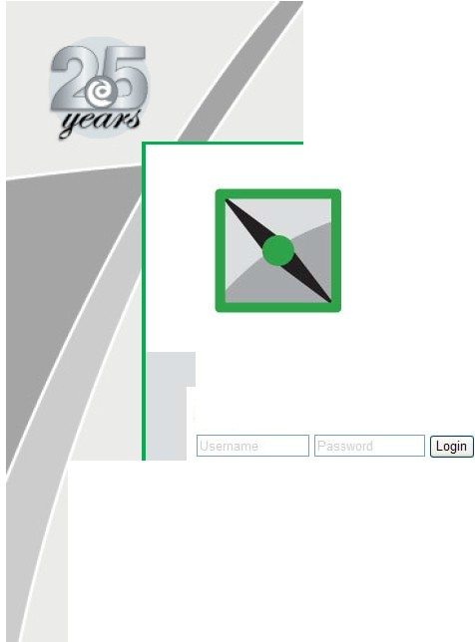
Top
ff'-tiC Dill• o.pth
SC"aQt eorroa.ny fottnfltiOt'l (m)(mK9t
1 t 9J Sttw• C.-r4tum 9f1Q/2:000
t 2 Sd'llulfiUt Cordium Df'l
. lntrospe<: Energy Group Inc.
Petroleum CQnsutlants
WNW.introspec-energy.ca
Discovery ltd.
integ rated geoscience s
www.canadiandiscoverv.com

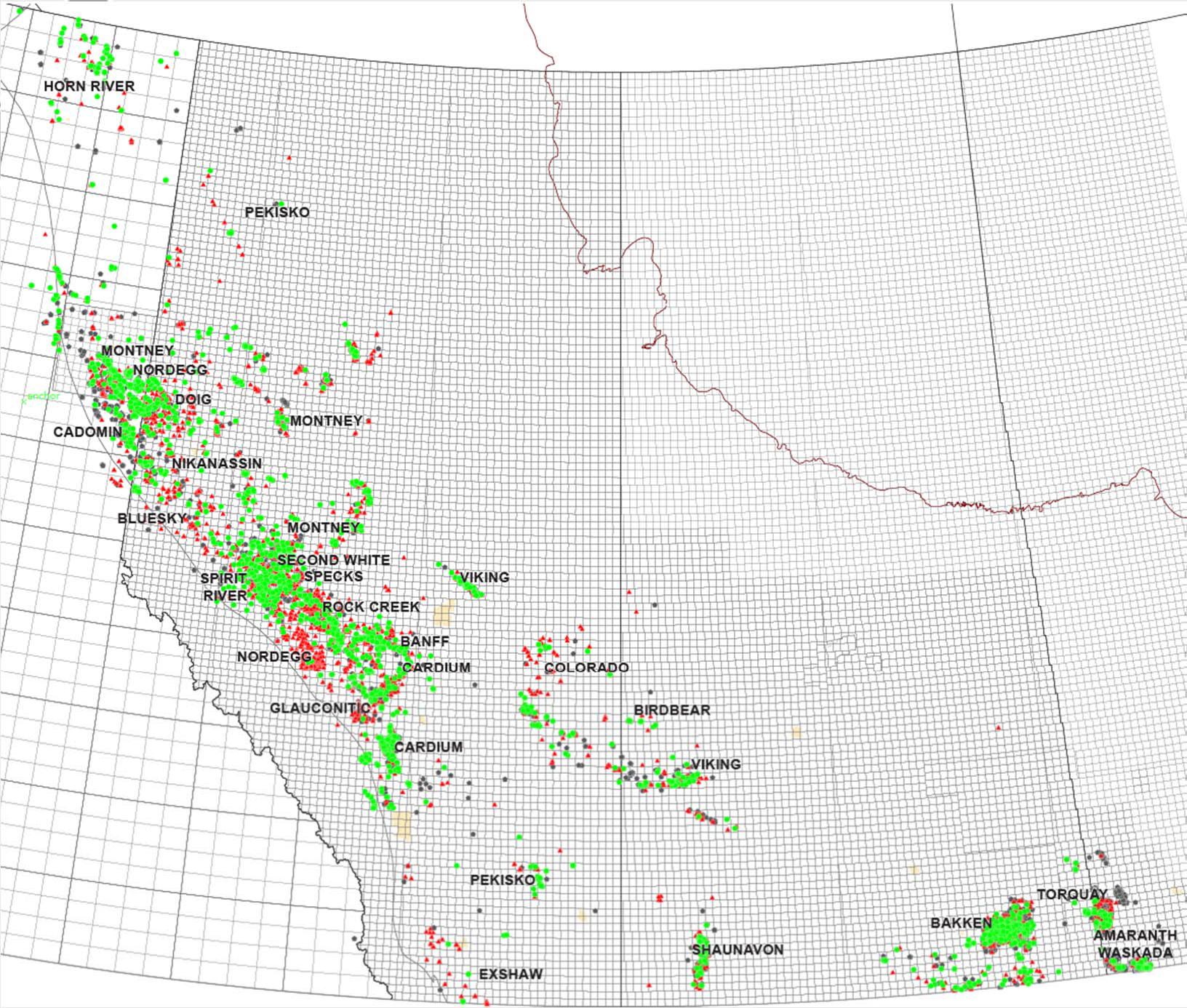

Analyzed / Reviewed
(~ 3,000)

Key Data (~ 9,000)

PDF Acquired


(~ 10,000)

Parshall Bakken 12 Month
Cum Oil vs Number of Stages

1,000

100
=
0
Q)
·,>:;
nJ
:::s
E
:::s
u

•
•
• *

.... ....

..J.:, 10
c::
0

N
....t

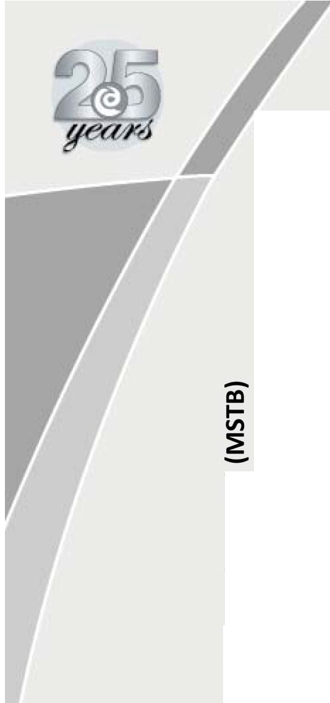
1
0 5 10 w m
Number of Stages

35 40
N=17

Parshall Bakken 12 Month
Cum. Oil vs Wellbore Length

1,000

= 100

...

I••+

• •

0
cu
>
'+I

E T
::::s
u
.., 10
s::::::
0

N.....

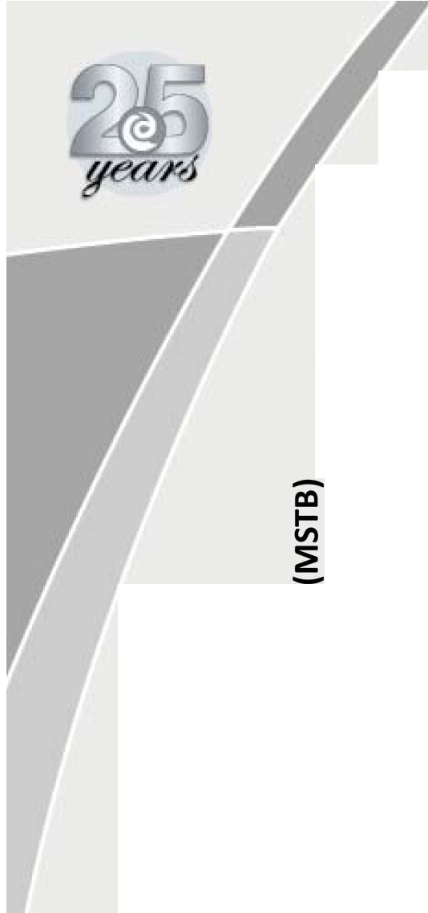
1
4,000 5,000 6,000 7,000 8,000 9,000 10,000
Horizontal Wellbore Length (feet)

11,000 12,000
N=17

Parshall Bakken IP Oil vs Avg.
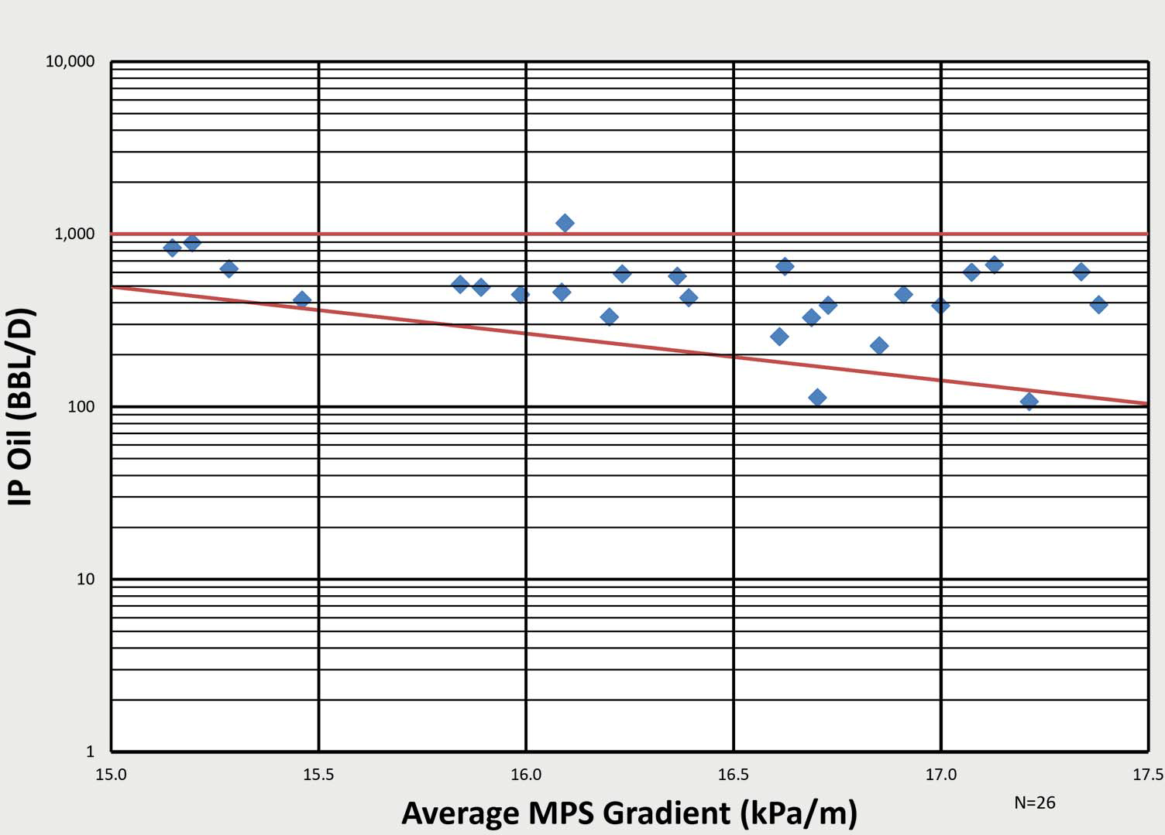
MPS Gradient

Parshall Bakken IP Oil/Stage
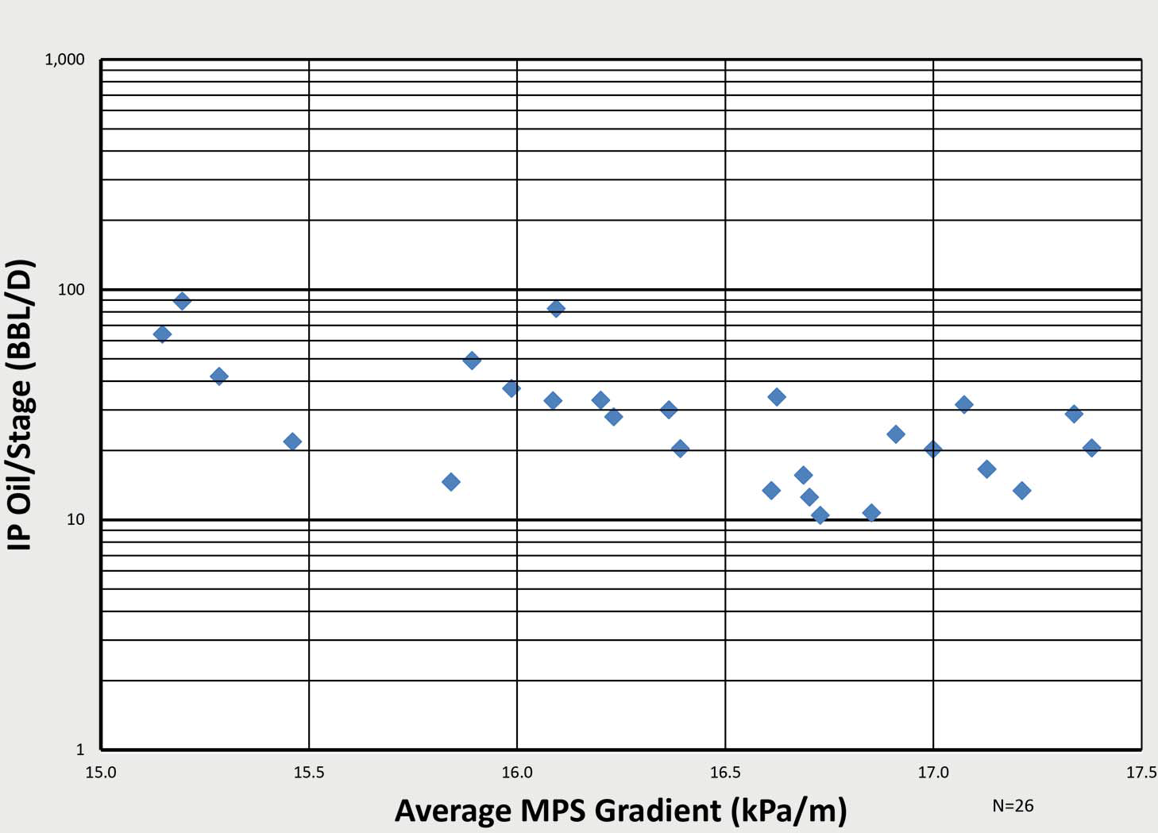
vs Avg. MPS Gradient

Parshall Bakken 12 Month
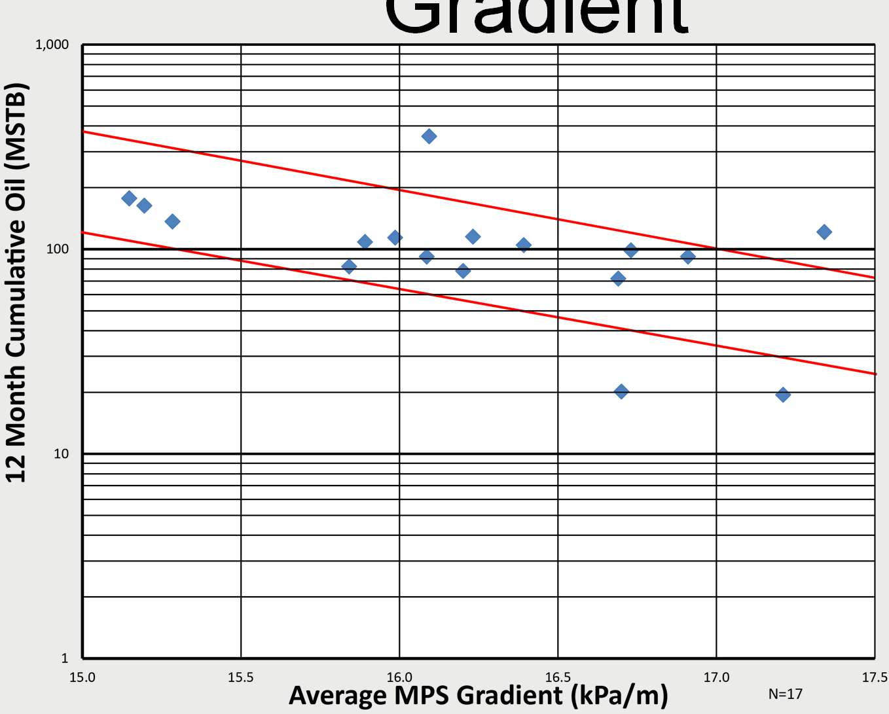
Cum. Oil vs Avg. MPS
Gradient

Parshall Bakken 12 Month
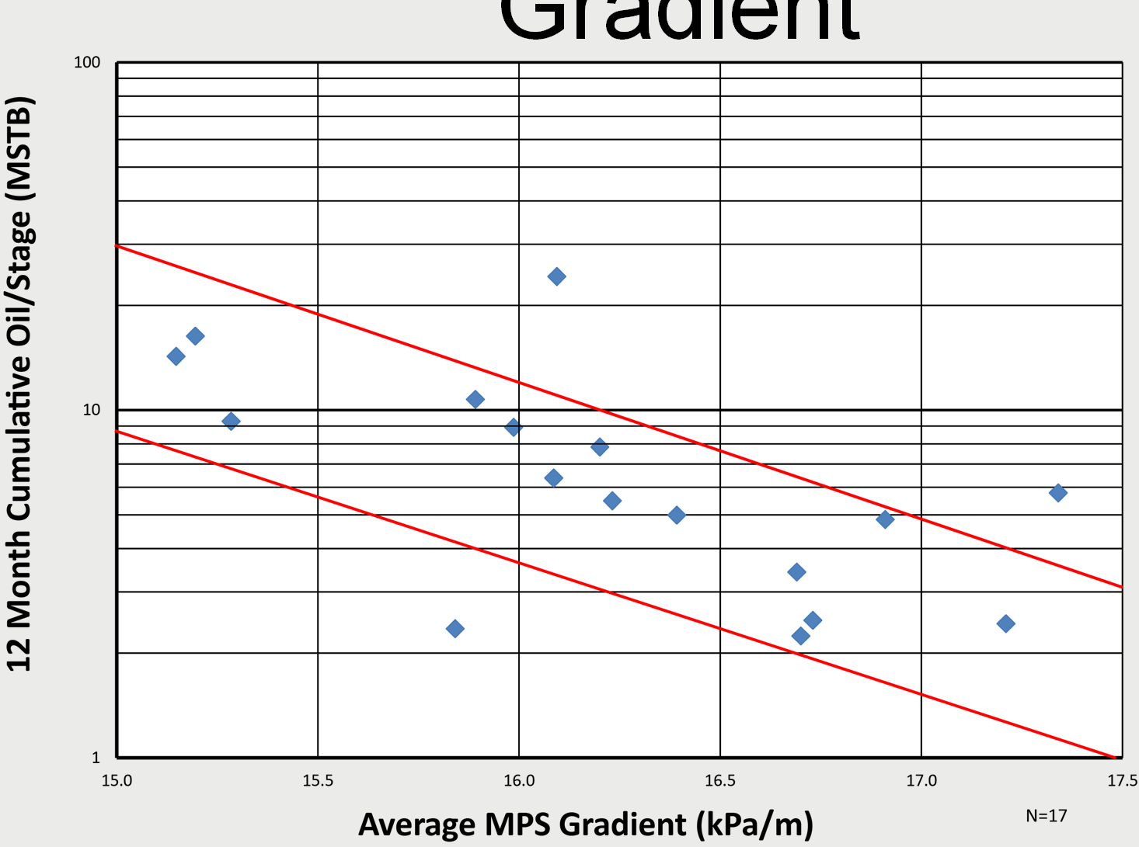
Cum. Oil/Stage vs Avg. MPS
Gradient

Parshall Bakken 12 Month
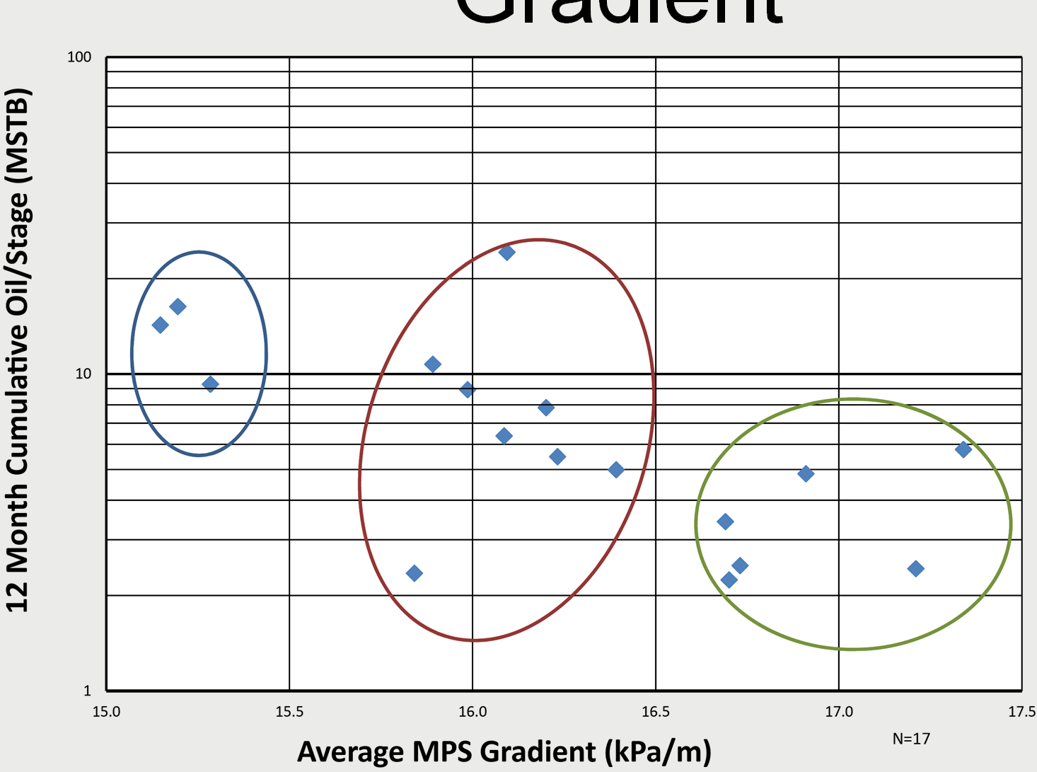
Cum. Oil/Stage vs Avg. MPS Gradient

Parshall Bakken First 12
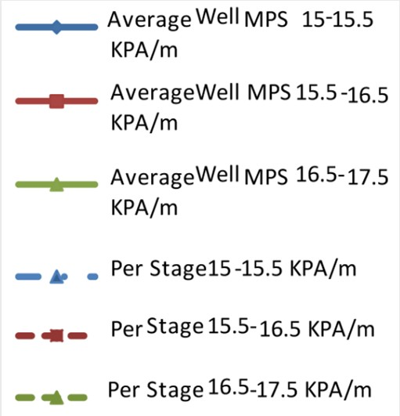
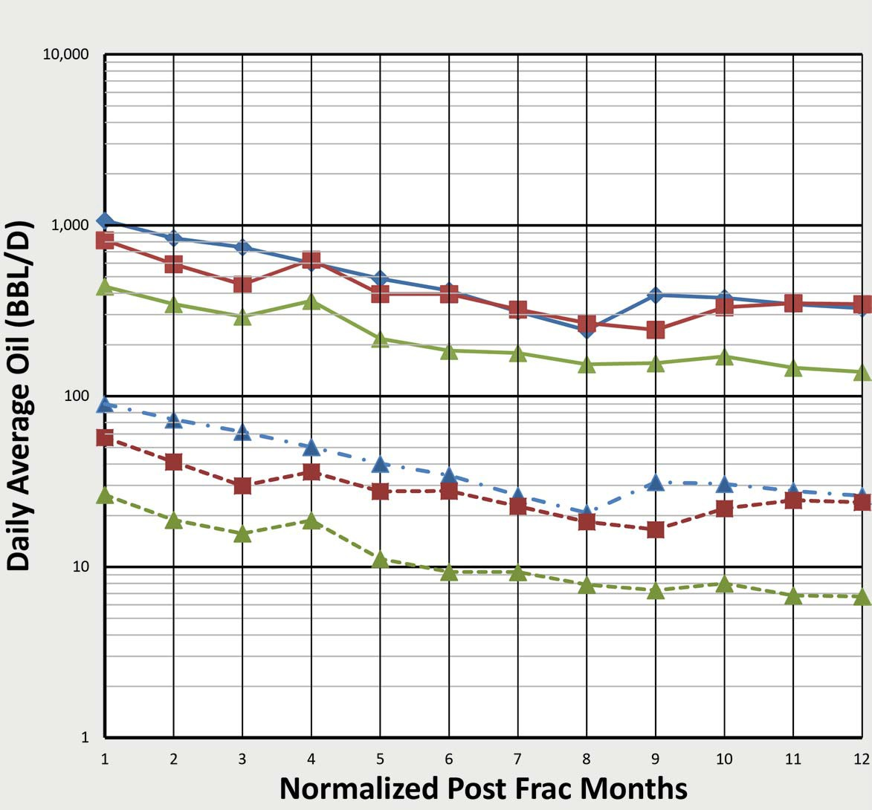
Month Avg. Rate/Well vs MPS Gradient

Conclusions

• There are five key components to a resource play that should be addressed.
• The Bakken has complex facies trends and a diagenetic overprint reflecting tectono‐eustatic controls.
• Bakken reservoir quality is a function of facies variations and depth.
• Geochemistry, hydrogeology and migration modeling can be used to identify three play types.
– A highly overpressured oil rich resource play.
– An overpressured less oil rich resource play.
– A normally pressured conventional (migrated) play.
• Petrophysics confirms the migration model.
• Stress regimes, derived from frac data, appear to have a significant impact on productivity in the Parshall area.

